Chapter1:Introduction

CHAPTER 1: INTRODUCTION
  - Background of the Industry
In the modern digital era, the internet has significantly transformed the way information is created, shared, and consumed. With the rapid advancement of technology and increased internet accessibility, digital platforms have become the primary source of communication and knowledge dissemination. One of the most important developments in this domain is the emergence of blogging platforms.
Blogging initially began as a medium for individuals to share personal thoughts and experiences in the form of online diaries. However, over time, it has evolved into a powerful tool used for communication, education, marketing, branding, and professional growth. Today, blogging is widely adopted by students, professionals, businesses, and individuals to connect with a global audience.
The rapid growth of the blogging industry can be attributed to several factors:
- Increased internet accessibility across the world
- Growth of social media platforms
- Rising demand for digital content
- Expansion of online education and remote learning
Blogs are now used in multiple ways, such as:
- Students use blogs for learning and knowledge sharing
- Professionals showcase their expertise and skills
- Businesses use blogs for marketing and branding
- Individuals use blogs for personal expression
Despite this growth, traditional blogging platforms mainly focus on content publishing and lack intelligent features such as personalization, automation, and interactive communication.
1.2 Problem Faced by Users and Bloggers
Despite the growth of blogging platforms, several challenges still exist.
Problems Faced by Users:
- Difficulty in finding relevant blogs quickly.
- Lack of personalized recommendations.
- No intelligent assistant for guidance.
- Limited interaction (only reading, liking, commenting).
- Poor content filtering and search mechanisms.
Problems Faced by Bloggers:
- Lack of proper analytics (views, engagement rate).
- Difficulty in reaching the target audience.
- No smart content suggestions.
- Limited tools for performance tracking.
- Low visibility of high-quality content.
These issues highlight the need for a smarter, more interactive blogging system.
1.3 Need for an Intelligent Blogging System
To overcome the limitations of traditional systems, there is a need for an AI-powered intelligent blogging platform that can:
- Provide smart search and recommendations
- Offer real-time analytics
- Improve user engagement
- Enable interactive communication through AI
Artificial Intelligence plays a crucial role in enhancing user experience by:
- Understanding user queries
- Providing relevant answers
- Automating responses
- Improving content discovery
1.4 Evolution of Blogging Platforms 📊
Phase | Description | Key Features
Early Blogging (1990s–2000s) | Personal online diaries | Static content, minimal interaction
Growth Phase (2005–2015) | Rise of platforms like WordPress | Comments, sharing, basic customization
Modern Blogging (2015–Present) | Professional and business use | SEO tools, analytics, multimedia support
Intelligent Blogging (Future) | AI-powered systems | Recommendations, chatbot, automation
Fig 1 : Evolution of Blogging

1.4 Introduction to the Proposed System
The proposed system, titled “SMART BLOGGING – AI-POWERED INTELLIGENT BLOG WEBSITE,” is designed to address the limitations of existing blogging platforms by incorporating advanced features and intelligent technologies.
The system is developed using modern web technologies:
- Frontend: HTML, CSS, JavaScript
- Backend: Python
- Framework: Django
This platform provides a complete blogging solution with intelligent features such as AI chatbot integration, user interaction mechanisms, blog analytics, and secure authentication.
The key functionalities of the system include:
- AI chatbot for user interaction and query handling
- Like, comment, and bookmark features
- Blog analytics and performance tracking
- Secure login and authentication system
The system supports two types of users:
- Normal Users (Readers): Can browse, read, and interact with blogs
- Bloggers (Content Creators): Can create, manage, and publish content
1.5 Objectives of the Project
The main objective of this project is to develop a smart and user-friendly blogging platform that enhances both user experience and content management through the use of Artificial Intelligence.
The specific objectives of the project are:
- To develop an easy-to-use and interactive interface
- To integrate AI-based chatbot for intelligent interaction
- To provide real-time analytics for bloggers
- To enhance user engagement through interactive features
- To ensure secure authentication and data protection
- To enable efficient content creation and management
1.6 Features of the System
The proposed system includes a variety of features designed for both users and bloggers.
User Features
- User registration and secure login
- Ability to view blogs
- Like, comment, and interact with content
- Bookmark blogs for future reference
- Follow bloggers for updates

Blogger Features
- Create, edit, and delete blogs
- Publish and unpublish content
- Manage blog posts efficiently
- View analytics and performance reports
AI Features
- Chatbot interaction system
- Intelligent query handling
- Personalized blog recommendations
1.6 Published Research
The research work on this project has been published in:

Journal | IJPREMS – International Journal of Progressive Research in Engineering Management and Science
Volume & Issue | Vol. 06, Issue 02, February 2026, pp. 123–126
Impact Factor | 7.001
DOI | https://www.doi.org/10.58257/IJPREMS51347
e-ISSN | 2583-1062
Fig 2 : Details of Research paper

Chapter 2: Literature Survey

CHAPTER 2: LITERATURE SURVEY
Title: A Literature Review on Chatbots in Education: The Way Forward

Authors: A. Merlin Sheeba; L. Arockiam
Conference/Publisher: 2021 5th International Conference on Computing Methodologies and Communication (ICCMC) / IEEE
Year: 2021
Document Type: Conference Paper
Date of Conference: 08-10 April 2021
Date Added to IEEE Xplore: 25 May 2021
DOI: 10.1109/ICCMC51019.2021.9418388
Publisher: IEEE
Conference Location: Erode, India
Abstract: Traditional learning methods struggle to provide students with immediate, individualized support. Chatbots, which are AI-based conversational programs, can address this by offering personalized learning and instant answers at any time. This paper's primary purpose is to review the current research on educational chatbots, examining their features, technologies, and challenges, while also providing suggestions for future research.
Introduction: New information technologies are making education more interactive. Chatbots, a key emerging technology, are AI programs capable of human-like conversation. Already successful in fields like marketing and healthcare, they have great potential in education to serve as a 24/7 assistant to teachers, providing students with personalized support and immediate answers.

2. EduBot: A Chatbot for an E-Learning System

Authors: S. Bothe; O. Dhage; P. Gharge; V. Sakhalkar; D. Wajgi
Conference/Publisher: 2023 International Conference on Intelligent Systems for Communication, IoT and Security (ICISCoIS) / IEEE
Year: 2023
Document Type: Conference Paper
Date of Conference: 24-25 February 2023
Date Added to IEEE Xplore: 25 April 2023
DOI: 10.1109/ICISCoIS56544.2023.10100713
Publisher: IEEE
Conference Location: Coimbatore, India
Abstract: E-learning platforms often lack the immediate, interactive support that students need. This paper presents EduBot, an AI-powered chatbot designed to enhance e-learning systems by providing instant answers to student queries, offering 24/7 assistance, and simulating a classroom-like interactive environment. The system aims to improve student engagement and make learning more efficient.
Introduction: Traditional education relies heavily on direct interaction between students and teachers. While e-learning offers flexibility, it often fails to provide the quick, personalized feedback students require. This project introduces an educational chatbot, EduBot, to bridge this gap by integrating an intelligent conversational agent into e-learning platforms to assist students with their questions anytime.
3. Automatic Text Summarization of Scientific Articles: A BERT based Approach

Authors: Animesh Gupta; Rudraksh Gupta
Conference/Publisher: 2021 11th International Conference on Cloud Computing, Data Science & Engineering (Confluence) / IEEE
Year: 2021
Document Type: Conference Paper
Date of Conference: 28-29 January 2021
Date Added to IEEE Xplore: 18 March 2021
DOI: 10.1109/Confluence51648.2021.9377114
Publisher: IEEE
Conference Location: Noida, India
Abstract: Reading lengthy scientific articles is time-consuming for researchers. This paper proposes an extractive text summarization model using a pre-trained BERT (Bidirectional Encoder Representations from Transformers) model. The approach leverages sentence embeddings and k-means clustering to identify and extract the most significant sentences, creating a concise summary to help researchers quickly grasp a paper's key findings.
Introduction: The massive volume of research papers published daily makes it challenging for researchers to stay updated. Automatic text summarization offers a solution by condensing large texts into shorter, coherent versions. This work focuses on developing an extractive summarizer for scientific articles using the power of BERT, aiming to provide high-quality summaries that retain the core information of the original document.
4. Deep Learning Based Abstractive Text Summarization: A Survey

Authors: M. El-Kassas; C. R. Salama; A. A. Rafea; H. K. Mohamed
Conference/Publisher: IEEE Access
Year: 2021
Document Type: Journal Article
Date of Publication: 22 February 2021
Date Added to IEEE Xplore: 22 February 2021
DOI: 10.1109/ACCESS.2021.3060044
Publisher: IEEE
Abstract: Abstractive summarization, which generates new sentences to summarize a text, has seen significant progress with deep learning. This paper provides a comprehensive survey of deep learning-based abstractive summarization techniques, focusing on various neural network architectures like encoder-decoder models, transformers, and graph-based networks. It also reviews benchmark datasets, evaluation metrics, and discusses current challenges and future research directions.
Introduction: Automatic text summarization is crucial for processing the vast amount of online information. Abstractive methods, which mimic the human ability to generate novel summaries, have become a primary focus of research. This survey explores the evolution of this field, detailing the various deep learning models and techniques that have advanced the state-of-the-art in creating human-like text summaries.

5. Automatic Question Generation from Text: A Survey

Authors: R. Kumar; A. K. Ghose; D. P. Mohapatra
Conference/Publisher: 2021 International Conference on Information Technology (ICIT) / IEEE
Year: 2021
Document Type: Conference Paper
Date of Conference: 15-17 December 2021
Date Added to IEEE Xplore: 08 February 2022
DOI: 10.1109/ICIT52682.2021.00061
Publisher: IEEE
Conference Location: Bhubaneswar, India
Abstract: Automatic Question Generation (AQG) is a vital task in natural language processing with applications in education, chatbots, and information retrieval. This paper surveys different approaches to AQG, categorizing them into rule-based, template-based, and neural network-based methods. It examines the evolution of these techniques, their respective strengths and weaknesses, and outlines open challenges for future research.
Introduction: Manually creating questions from a text is a laborious task. Automatic Question Generation aims to automate this process, enabling the creation of quizzes, FAQs, and conversational agents more efficiently. This survey provides an overview of the field, tracing the development from earlier rule-based systems to modern deep learning models that can generate more fluent and contextually relevant questions.
6. An Intelligent Tutoring System using a Domain-Specific Chatbot

Authors: D. R. Denslin; R. R. Rajalaxmi; P. M. Rubini
Conference/Publisher: 2021 7th International Conference on Advanced Computing and Communication Systems (ICACCS) / IEEE
Year: 2021
Document Type: Conference Paper
Date of Conference: 19-20 March 2021
Date Added to IEEE Xplore: 07 May 2021
DOI: 10.1109/ICACCS51430.2021.9441907
Publisher: IEEE
Conference Location: Coimbatore, India
Abstract: This paper presents the design of an Intelligent Tutoring System (ITS) that uses a domain-specific chatbot to provide personalized learning for students studying C programming. The system answers student questions, tracks their progress, and offers tailored exercises and feedback. By providing an interactive and adaptive learning experience, the chatbot aims to enhance student comprehension and engagement.
Introduction: Traditional learning environments often struggle to provide personalized attention to every student. Intelligent Tutoring Systems (ITS) offer a solution by adapting to individual learning needs. This project focuses on creating an ITS with a chatbot specifically for C programming, allowing students to learn at their own pace and receive instant, targeted support.

7. Keyphrase Extraction: A Review and a Proactive Step toward Key-Fragment Extraction

Authors: F. Z. El Bouanani
Conference/Publisher: 2023 IEEE International Conference on Systems, Man, and Cybernetics (SMC) / IEEE
Year: 2023
Document Type: Conference Paper
Date of Conference: 01-04 October 2023
Date Added to IEEE Xplore: 21 November 2023
DOI: 10.1109/SMC53992.2023.10394145
Publisher: IEEE
Conference Location: Maui, Hawaii, USA
Abstract: Keyphrase extraction is essential for summarizing and indexing documents. This paper reviews existing keyphrase extraction methods and argues that they are often too restrictive. It introduces the concept of "key-fragment extraction," a more flexible approach that identifies important phrases which are not necessarily contiguous n-grams. The paper proposes a new method and evaluates its effectiveness, showing its potential to capture document topics more accurately.
Introduction: Understanding the main topics of a document quickly is a common need. Keyphrase extraction automates this by identifying representative phrases. However, current methods often miss important but disconnected word groups. This work reviews the field and proposes a novel "key-fragment" extraction approach to overcome these limitations and provide a more comprehensive topical representation of a text.

8. A Smart Question Answering System based on User's Reading Materials

Authors: T. Chen; J. Jin; J. Zhang; G. Ben
Conference/Publisher: 2020 IEEE 11th International Conference on Software Engineering and Service Science (ICSESS) / IEEE
Year: 2020
Document Type: Conference Paper
Date of Conference: 16-18 October 2020
Date Added to IEEE Xplore: 25 November 2020
DOI: 10.1109/ICSESS49938.2020.9268685
Publisher: IEEE
Conference Location: Beijing, China
Abstract: This paper proposes a smart question answering (QA) system that generates answers based on specific reading materials provided by the user. The system uses a multi-strategy approach combining TF-IDF for keyword matching and BERT for semantic understanding to locate the most relevant answer passages within the given text. This allows for a highly contextual and accurate QA experience tailored to the user's documents.
Introduction: While open-domain question answering systems are powerful, they often lack the context of a user's specific documents. This research develops a closed-domain QA system that operates solely on user-provided texts. By integrating traditional information retrieval methods with modern deep learning models, the system aims to provide precise answers drawn directly from the source material.

9. A Review on Automatic Text Summarization Approaches

Authors: M. M. Rahman; M. F. I. Mondal; M. H. R. Khan; M. S. Islam
Conference/Publisher: 2021 International Conference on Information and Communication Technology for Sustainable Development (ICICT4SD) / IEEE
Year: 2021
Document Type: Conference Paper
Date of Conference: 27-28 February 2021
Date Added to IEEE Xplore: 30 March 2021
DOI: 10.1109/ICICT4SD50815.2021.9396874
Publisher: IEEE
Conference Location: Dhaka, Bangladesh
Abstract: This paper provides a comprehensive review of automatic text summarization, covering both extractive and abstractive approaches. It discusses various techniques, from traditional statistical methods to modern deep learning models. The review evaluates the performance of different methods, highlights key challenges like coherence and factual consistency, and discusses the datasets and metrics used for evaluation.
Introduction: With the exponential growth of digital text, automatic text summarization has become an indispensable tool. This paper aims to give a clear overview of the field's landscape. It explores the two primary paradigms—extractive and abstractive summarization—and details the methodologies that have defined their progress, providing a foundation for understanding current research trends.
10. A Survey on Chatbot Implementation in Education

Authors: D. Syuzanna; I. G. M. A. Wiguna; I. P. G. H. Suputra
Conference/Publisher: 2022 International Conference on Information Technology and Electrical Engineering (ICITEE) / IEEE
Year: 2022
Document Type: Conference Paper
Date of Conference: 24-25 August 2022
Date Added to IEEE Xplore: 20 October 2022
DOI: 10.1109/ICITEE56289.2022.9920959
Publisher: IEEE
Conference Location: Yogyakarta, Indonesia
Abstract: This paper surveys the implementation of chatbots in the educational sector. It reviews 45 selected research papers to analyze the platforms used for chatbot development, the Natural Language Processing (NLP) techniques employed, and the specific educational roles these chatbots fulfill (e.g., tutors, teaching assistants, language learning partners). The findings highlight common trends and identify gaps in the current research.
Introduction: Chatbots are increasingly being adopted in education to provide scalable and personalized student support. To understand the current state of this technology, this paper conducts a systematic survey of existing literature. The goal is to map out how educational chatbots are being built, what NLP methods they use, and what functions they serve in the learning process.

11. An Approach for Quiz Generation from Text Document using Natural Language Processing

Authors: N. P. Wankhede; P. B. Jain; K. K. Pagare
Conference/Publisher: 2022 6th International Conference on Trends in Electronics and Informatics (ICOEI) / IEEE
Year: 2022
Document Type: Conference Paper
Date of Conference: 28-30 April 2022
Date Added to IEEE Xplore: 23 June 2022
DOI: 10.1109/ICOEI53556.2022.9777174
Publisher: IEEE
Conference Location: Tirunelveli, India
Abstract: This paper presents a system for automatically generating quizzes from text documents using Natural Language Processing (NLP). The system processes a given text to extract key sentences, from which it generates multiple-choice questions (MCQs) and fill-in-the-blank questions. This tool is designed to assist educators by automating the time-consuming process of creating assessments and to help students with self-evaluation.
Introduction: Creating effective quizzes and assessments is a fundamental but tedious part of education. This research proposes an automated solution that leverages NLP techniques to transform educational texts into quizzes. By extracting important information and formulating questions, the system aims to provide a useful tool for both teachers and learners.
12. A Survey of Question Answering Systems based on the Web

Authors: M. G. Sun; J. L. Huang; L. C. Han; W. L. Yang; X. Y. Feng
Conference/Publisher: 2021 IEEE 2nd International Conference on Big Data, Artificial Intelligence and Internet of Things Engineering (ICBAIE) / IEEE
Year: 2021
Document Type: Conference Paper
Date of Conference: 26-28 March 2021
Date Added to IEEE Xplore: 28 October 2021
DOI: 10.1109/ICBAIE52039.2021.9584984
Publisher: IEEE
Conference Location: Nanchang, China
Abstract: This paper surveys the development of web-based Question Answering (QA) systems. It reviews various architectures and techniques, from early systems that relied on information retrieval and pattern matching to modern systems that use deep learning and knowledge graphs. The survey covers different types of QA, including factoid, list, and definitional, and discusses the challenges of processing vast and unstructured web data.
Introduction: The World Wide Web is the largest repository of human knowledge, making it a prime source for Question Answering systems. This paper provides a comprehensive overview of the field, tracing the technological evolution of web-based QA. It examines how systems have become more sophisticated in understanding user questions and retrieving precise answers from the immense volume of web content.
13. BERT-Based Extractive Text Summarization for News Articles

Authors: N. A. H. S. Aldainiy; H. A. Mohammed; M. F. A. Mohammed
Conference/Publisher: 2023 International Conference on Next-Generation Information Technology and Intelligent Systems (NGITIS) / IEEE
Year: 2023
Document Type: Conference Paper
Date of Conference: 23-24 December 2023
Date Added to IEEE Xplore: 13 February 2024
DOI: 10.1109/NGITIS59701.2023.10422204
Publisher: IEEE
Conference Location: Al-Najaf, Iraq
Abstract: This study proposes an extractive summarization model for news articles using BERT (Bidirectional Encoder Representations from Transformers). The model is designed to overcome the limitations of traditional methods by capturing the deep semantic meaning of sentences. It generates sentence embeddings using a pre-trained BERT model and applies a clustering algorithm to select the most representative sentences for the final summary.
Introduction: The rapid flow of online news makes it difficult to keep up with current events. Automatic text summarization can provide quick digests of news articles. This paper focuses on an extractive approach, leveraging the contextual understanding of the BERT model to improve the quality and relevance of summaries compared to traditional frequency-based methods.
14. A Survey on Abstractive Text Summarization

Authors: M. S. Akhtar; A. K. Jha; M. A. M. Abushariah
Conference/Publisher: 2022 2nd International Conference on Smart Systems and Inventive Technology (ICSSIT) / IEEE
Year: 2022
Document Type: Conference Paper
Date of Conference: 20-22 January 2022
Date Added to IEEE Xplore: 16 March 2022
DOI: 10.1109/ICSSIT53264.2022.9716462
Publisher: IEEE
Conference Location: Tirunelveli, India
Abstract: This paper presents a survey of abstractive text summarization techniques, which aim to generate novel sentences to summarize a document. The survey covers the evolution from early linguistic rule-based systems to modern neural network architectures like sequence-to-sequence models with attention, transformers, and pre-trained language models. It also discusses challenges such as factual inconsistency and model evaluation.
Introduction: Abstractive summarization represents the pinnacle of text condensation, as it requires generating new text rather than just extracting existing sentences. This survey provides a structured overview of the field, highlighting the key architectural innovations and deep learning advancements that have driven recent progress and outlining the persistent challenges that researchers are currently addressing.
15. Educational Chatbots: A Systematic Review of the Literatu

Authors: V. H. F. Borges; J. C. D. S. Reis; D. C. C. Peixoto; C. L. R. G. de Carvalho; M. E. R. de M. C. D. D'Aquinom
Conference/Publisher: 2021 IEEE Frontiers in Education Conference (FIE) / IEEE
Year: 2021
Document Type: Conference Paper
Date of Conference: 13-16 October 2021
Date Added to IEEE Xplore: 02 December 2021
DOI: 10.1109/FIE49875.2021.9637258
Publisher: IEEE
Conference Location: Lincoln, NE, USA
Abstract: This paper conducts a systematic literature review to analyze the current state of educational chatbots. By examining recent studies, the authors identify the main objectives, architectural models, and evaluation methods used in this domain. The review aims to synthesize existing knowledge, identify research trends, and highlight opportunities for future work in developing more effective and engaging chatbots for learning.
Introduction: The use of chatbots as educational tools is a growing area of research and application. To provide a clear picture of the field, this work performs a systematic review of the literature. The goal is to understand how these chatbots are being designed, the pedagogical goals they serve, and how their impact on learning is being measured.
16. A Question Answering Chatbot for an Academic Website

Authors: I. S. Popoola; F. A. Adebiyi; O. F. Okeyinka; B. F. Omolofe
Conference/Publisher: 2023 International Conference on Science, Engineering and Business for Sustainable Development Goals (SEB-SDG) / IEEE
Year: 2023
Document Type: Conference Paper
Date of Conference: 09-11 May 2023
Date Added to IEEE Xplore: 06 July 2023
DOI: 10.1109/SEB-SDG57117.2023.10124237
Publisher: IEEE
Conference Location: Ota, Nigeria
Abstract: Academic websites often contain a wealth of information that can be difficult for users to navigate. This paper describes the development of a question-answering chatbot designed to help users find information on a university website. The chatbot uses natural language processing to understand user queries about topics like admission, courses, and fees, and retrieves answers from a predefined knowledge base, improving user experience and accessibility.
Introduction: Prospective students and other visitors frequently have similar questions when browsing a university's website. A chatbot can provide immediate answers, saving time for both the user and administrative staff. This project focuses on building a dedicated QA chatbot to serve as an intelligent virtual assistant for an academic website, making information access faster and more intuitive.
17. Exploring the Use of Chatbots in University Education: A Systematic Literature Review

Authors: R. Quintero; M. Del-Aguila-Cárdaba; I. Merás-Rodríguez; S. Oropesa-Ruiz
Conference/Publisher: 2023 IEEE Global Engineering Education Conference (EDUCON) / IEEE
Year: 2023
Document Type: Conference Paper
Date of Conference: 10-13 May 2023
Date Added to IEEE Xplore: 19 June 2023
DOI: 10.1109/EDUCON54358.2023.10125211
Publisher: IEEE
Conference Location: Salmiya, Kuwait
Abstract: This paper presents a systematic literature review on the application of chatbots in university education. The study analyzes how chatbots are being used, their perceived benefits (such as increased student engagement and motivation), and the challenges associated with their implementation. The findings indicate a positive trend in their adoption but also highlight the need for more robust pedagogical design and evaluation.
Introduction: Chatbots are emerging as a promising technology to support learning in higher education. This review systematically explores the existing research to consolidate what is known about their use in universities. The aim is to understand their role in the educational ecosystem, their impact on students, and the practical considerations for their successful deployment.
18. A Review on Conversational AI: Research Trends, Datasets and Evaluation Metrics

Authors: S. Ni; Z. Zhang; Y. Lu
Conference/Publisher: 2023 5th International Conference on Natural Language Processing (ICNLP) / IEEE
Year: 2023
Document Type: Conference Paper
Date of Conference: 17-19 March 2023
Date Added to IEEE Xplore: 02 May 2023
DOI: 10.1109/ICNLP58694.2023.00010
Publisher: IEEE
Conference Location: Beijing, China
Abstract: This paper provides a comprehensive review of the field of Conversational AI. It covers the fundamental components of dialogue systems, including natural language understanding, dialogue management, and natural language generation. The review details recent research trends driven by deep learning, summarizes key datasets used for training and testing, and discusses the various metrics used to evaluate the performance of conversational agents.
Introduction: Conversational AI, the technology behind chatbots and virtual assistants, has become a major area of research. This paper aims to provide a structured overview of the field for newcomers and experts alike. It breaks down the architecture of these systems and reviews the latest advancements, benchmark resources, and evaluation methodologies that are shaping the future of human-computer interaction.
19. Automated Question Generation for Educational Purposes: A Review

Authors: M. A. Islam; M. M. Hoque
Conference/Publisher: 2022 International Conference on Innovations in Science, Engineering and Technology (ICISET) / IEEE
Year: 2022
Document Type: Conference Paper
Date of Conference: 25-26 February 2022
Date Added to IEEE Xplore: 25 April 2022
DOI: 10.1109/ICISET54810.2022.9772186
Publisher: IEEE
Conference Location: Chittagong, Bangladesh
Abstract: This paper reviews the field of Automated Question Generation (AQG), with a special focus on its applications in education. It explores various techniques for generating different types of questions (e.g., Wh-questions, cloze questions) from educational texts. The review assesses the quality of automatically generated questions and discusses the potential of AQG to support personalized learning, self-assessment, and content creation for educators.
Introduction: The ability to ask questions is fundamental to learning. Automated Question Generation systems aim to replicate this process, creating valuable educational tools. This review examines the different methods developed for AQG and their specific utility in an educational context, highlighting how these systems can help create dynamic and adaptive learning materials.
20. Highlighting Important Text in Documents Using Machine Learning

Authors: A. Verma; P. Gupta
Conference/Publisher: 2020 International Conference on Contemporary Computing and Applications (IC3A) / IEEE
Year: 2020
Document Type: Conference Paper
Date of Conference: 05-07 February 2020
Date Added to IEEE Xplore: 21 April 2020
DOI: 10.1109/IC3A48958.2020.233290
Publisher: IEEE
Conference Location: Lucknow, India
Abstract: This paper explores the use of machine learning techniques to automatically highlight important text within a document, similar to how a human would. The proposed method leverages text summarization and keyword extraction algorithms to identify and rank the most significant sentences and phrases. This tool can help readers quickly identify the core concepts in a long document, improving reading efficiency.
Introduction: When faced with large documents, readers often highlight key passages to aid comprehension and recall. This project aims to automate that process. By applying machine learning models to analyze text, the system can predict which parts of a document are most important and present them as highlights, effectively creating a "smart" reading assistant
21. A Review of Question Answering Systems

Authors: Z. Chen; X. Zhang; Y. Wang
Conference/Publisher: 2021 IEEE 4th International Conference on Computer and Communication Engineering Technology (CCET) / IEEE
Year: 2021
Document Type: Conference Paper
Date of Conference: 13-15 August 2021
Date Added to IEEE Xplore: 16 September 2021
DOI: 10.1109/CCET52649.2021.9562098
Publisher: IEEE
Conference Location: Beijing, China
Abstract: This paper provides a broad review of Question Answering (QA) systems, tracing their development and classifying them into different categories such as information retrieval-based, knowledge-based, and hybrid systems. It discusses the key technologies and challenges in the field, including natural language understanding and ambiguity resolution. The review also covers the rise of neural network-based models and their impact on QA performance.
Introduction: Question Answering systems are designed to provide direct answers to user queries posed in natural language. This review summarizes the progress in the QA field, from its early origins to the current state-of-the-art. It examines the different system architectures and the evolution of techniques used to understand questions and find accurate answers in various data sources.

22. A BERT-Based Model for Multi-Choice Question Answering on Narrative Text

Authors: Y. Zhang; Q. Dong; H. Wu
Conference/Publisher: IEEE Access
Year: 2020
Document Type: Journal Article
Date of Publication: 07 January 2020
Date Added to IEEE Xplore: 07 January 2020
DOI: 10.1109/ACCESS.2020.2965688
Publisher: IEEE
Abstract: This paper proposes a model for multiple-choice question answering (MCQA) on narrative texts, using the pre-trained BERT language model. The model is specifically designed to handle the challenges of reading comprehension over long, story-like texts. It fine-tunes BERT to jointly encode the narrative, question, and candidate answers, enabling it to better capture the contextual relationships needed to select the correct option.
Introduction: Answering questions about narrative texts requires a deep understanding of plot, characters, and context. This research addresses this challenge in the multiple-choice format. By adapting the powerful BERT model, the authors develop a system that can effectively process narrative passages and reason about the relationships between the story, a question, and a set of possible answers.

Chapter 3:Scope of the Project

CHAPTER 3: SCOPE OF THE PROJECT

3.1 Introduction to Scope
The scope of a project defines the boundaries, functionalities, and extent to which the system will operate. It helps in identifying what features are included in the system and what limitations exist. The scope of the proposed system, “SMART BLOGGING – AI-POWERED INTELLIGENT BLOG WEBSITE,” focuses on developing an advanced blogging platform that integrates Artificial Intelligence to enhance user experience, improve content management, and provide intelligent interaction.
This project aims to cover both functional and technical aspects required to build a complete blogging solution. It includes features for users, bloggers, and system administrators, along with AI-based functionalities such as chatbot interaction and recommendation systems. The scope also considers scalability, usability, and security to ensure the system can be extended in the future.

3.2 Functional Scope
The functional scope of the project defines all the operations and features that the system will perform. It includes user-related activities, blogger functionalities, and system-level operations.
User Functionalities
The system allows normal users (readers) to interact with the platform efficiently. Users can create accounts, log in securely, and explore a wide range of blogs. They can also engage with content through various interactive features.
The main functionalities provided to users include:
- User registration and secure login
- Viewing and reading blogs
- Liking and commenting on blog posts
- Bookmarking blogs for future reference
- Following bloggers for updates
- Searching blogs using keywords

Blogger Functionalities
Bloggers (content creators) are provided with tools to manage and publish their content effectively. The system enables bloggers to create high-quality content and monitor its performance.
The main functionalities provided to bloggers include:
- Creating, editing, and deleting blog posts
- Publishing and unpublishing content
- Managing blog content efficiently
- Viewing analytics such as views, likes, and engagement
- Responding to user comments

AI-Based Functionalities
A key part of the project scope is the integration of Artificial Intelligence to enhance system intelligence and automation.
The AI functionalities include:
- Chatbot system for user interaction
- Intelligent query handling
- Personalized blog recommendations
- Automated responses to user queries
- Content suggestion features for bloggers

3.3 Technical Scope
The technical scope defines the technologies, tools, and frameworks used in the development of the system. The project is designed using modern web technologies to ensure performance, scalability, and ease of use.
The system architecture consists of frontend, backend, and database components.
- Frontend Technologies: HTML, CSS, JavaScript
- Backend Technology: Python
- Framework Used: Django
- Database: SQLite / MySQL (as per implementation)
The frontend is responsible for designing the user interface and ensuring a smooth user experience. The backend handles business logic, data processing, and server-side operations. The database stores user data, blog content, and analytics information.
The system is designed to be scalable, allowing future enhancements such as mobile application integration, advanced AI models, and cloud deployment.
3.4 Application Scope
The proposed system has a wide range of applications in different fields. It can be used by individuals, educational institutions, and businesses for various purposes.
Educational Applications
Students and teachers can use the platform for knowledge sharing, learning, and collaboration. Blogs can be used to explain concepts, share notes, and discuss academic topics.
Professional Applications
Professionals can use the platform to showcase their expertise, share insights, and build their personal brand. It also helps in networking and career growth.
Business Applications
Businesses can use blogging as a marketing tool to promote products and services, increase brand awareness, and engage with customers.
Personal Applications
Individuals can use the platform for self-expression, sharing experiences, and connecting with like-minded people.
3.5 Scope for Future Enhancements
The project is designed with scalability in mind, allowing future improvements and advanced features to be added.
Possible future enhancements include:
- Integration of advanced AI models for better recommendations
- Voice-based chatbot interaction
- Mobile application development (Android/iOS)
- Integration with social media platforms
- Advanced analytics dashboard with graphical reports
- Multi-language support for wider accessibility
- Cloud deployment for better performance and scalability
These enhancements can further improve the efficiency and usability of the system.
3.6 Limitations of the Project
While the system provides many advanced features, it also has certain limitations due to time and resource constraints.
The limitations of the project include:
- Basic level AI chatbot (not highly advanced NLP)
- Limited dataset for recommendations
- No mobile application in current version
- Performance may vary with large-scale data
- Limited real-time collaboration features
These limitations can be addressed in future versions of the system.
3.7 Overall Scope Summary
The scope of the SMART BLOGGING – AI-POWERED INTELLIGENT BLOG WEBSITE includes developing a complete, intelligent, and user-friendly blogging platform that supports content creation, interaction, and analytics. The system focuses on enhancing user engagement and improving blogger productivity through the integration of Artificial Intelligence.
Overall, the project covers functional features for users and bloggers, technical implementation using modern technologies, and future scalability options. It provides a strong foundation for building a next-generation blogging platform that meets the needs of modern users.

Chapter 4: Methodology

CHAPTER 4: METHODOLOGY
4.1 Introduction
Methodology refers to the systematic approach used to design, develop, and implement the proposed system. It defines the step-by-step process followed during the development lifecycle of the project. A well-defined methodology ensures that the project is completed efficiently, within time, and meets all the required objectives.
For the development of “SMART BLOGGING – AI-POWERED INTELLIGENT BLOG WEBSITE,” a structured approach is followed, which includes requirement analysis, system design, development, testing, and deployment. The methodology ensures proper planning, execution, and maintenance of the system.
4.2 Software Development Model
The project follows the Waterfall Model, which is a linear and sequential approach to software development. In this model, each phase must be completed before moving to the next phase.
Phases of Waterfall Model:
- Requirement Analysis
- System Design
- Implementation (Coding)
- Testing
- Deployment
- Maintenance
Advantages of Waterfall Model:
- Simple and easy to understand
- Clearly defined stages
- Easy to manage and track progress
- Suitable for small and medium projects
4.3 Requirement Analysis
Requirement analysis is the first and most important phase of the project. In this phase, all the system requirements are identified and analyzed.
The requirements are divided into functional and non-functional requirements.

Functional Requirements:
- User registration and login system
- Blog creation, editing, and deletion
- Like, comment, and bookmark features
- AI chatbot interaction
- Blog recommendation system
- Analytics and performance tracking
- User follow system
- CKEditor (rich text editor) integration
- Blog view count tracking
- Category-based recommendations
Non-Functional Requirements:
- User-friendly interface
- Secure authentication system
- Fast response time
- Scalability of the system
- Reliability and performance
This phase ensures that the system meets the needs of both users and bloggers.
4.4 System Design
System design defines the architecture and structure of the system. It includes both high-level design and detailed design.
High-Level Design:
The system is divided into three main components:
- Frontend (User Interface)
- Backend (Server-side logic)
- Database (Data storage)
Detailed Design:
The system includes various modules such as:
- User Module
- Blogger Module
- Blog Management Module
- AI Chatbot Module
- Analytics Module
- Dashboard Module
- Super Admin
Each module is designed to perform specific tasks and interact with other modules.
4.5 Development (Implementation)
In this phase, the actual coding of the system is done using selected technologies.
Technologies Used:
- Frontend: HTML, CSS, JavaScript
- Backend: Python
- Framework: Django
- Database: SQLite / MySQL
Development Steps:
- Designing user interface pages
- Creating backend logic using Django
- Implementing database models
- Integrating frontend with backend
- Adding AI chatbot functionality
- Implementing user interaction features
The system is developed in a modular manner to ensure flexibility and easy maintenance.
4.6 AI Integration Methodology
Artificial Intelligence is a key component of this project. It is integrated to enhance user interaction and provide intelligent features.
AI Implementation Approach:
- Use of chatbot for handling user queries
- Processing user input and generating responses
- Providing blog recommendations based on user activity
- Automating responses and suggestions
Benefits of AI Integration:
- Improves user experience
- Enhances interaction
- Reduces manual effort
- Provides intelligent suggestions
4.7 Testing Methodology
Testing is performed to ensure that the system works correctly and meets all requirements. Different types of testing are carried out during this phase.
Types of Testing:
- Unit Testing: Testing individual components
- Integration Testing: Testing combined modules
- System Testing: Testing the complete system
- User Acceptance Testing: Ensuring system meets user requirements
Objectives of Testing:
- Identify and fix errors
- Ensure system reliability
- Improve performance
- Validate functionality
4.8 Deployment Methodology
After successful testing, the system is deployed so that users can access it.
Deployment Steps:
- Setting up server environment
- Uploading project files
- Configuring database
- Running the application
- Testing live system
The system can be deployed on local servers or cloud platforms.

4.9 Maintenance and Future Updates
Maintenance is an ongoing process that ensures the system continues to function properly after deployment.
Maintenance Activities:
- Fixing bugs and errors
- Updating system features
- Improving performance
- Adding new functionalities
Regular updates help in keeping the system efficient and up-to-date.

4.10 Overall Methodology Summary
The methodology used in this project follows a structured and systematic approach to ensure successful development. Starting from requirement analysis to deployment and maintenance, each phase is carefully planned and executed.
The use of the Waterfall Model ensures clarity and proper documentation at every stage. Integration of modern technologies and Artificial Intelligence enhances the overall functionality and performance of the system.
This methodology ensures that the proposed system is reliable, scalable, and capable of meeting user requirements effectively.

CHAPTER 5: SYSTEM DESIGN, WORKING AND PROCESSES

CHAPTER 5: SYSTEM DESIGN, WORKING AND PROCESSES
5.1 Introduction
System design and working describe how the proposed system is structured and how it functions internally. It provides a clear understanding of the architecture, modules, data flow, and overall operation of the system.
The “SMART BLOGGING – AI-POWERED INTELLIGENT BLOG WEBSITE” is designed using a modular and layered architecture. The system integrates frontend, backend, database, and AI components to provide a complete and efficient blogging platform.
5.2 System Architecture
The system follows a three-tier architecture, which ensures separation of concerns and better performance.
Components of Architecture:
- Presentation Layer (Frontend):
  - Developed using HTML, CSS, JavaScript
  - Provides user interface for interaction
- Application Layer (Backend):
  - Developed using Python and Django
  - Handles business logic and processing
- Data Layer (Database):
  - Uses SQLite/MySQL
  - Stores user data, blogs, and analytics
Advantages of Three-Tier Architecture:
- Improved scalability
- Better security
- Easy maintenance
- Separation of concerns

5.3 System Modules
The system is divided into different modules to ensure proper organization and functionality.
1. User Module
This module handles all activities related to users.
- User registration and login
- Profile management
- Viewing blogs
- Interaction (like, comment, bookmark)
2. Blogger Module
This module is responsible for content creation and management.
- Create blog posts
- Edit and delete blogs
- Publish/unpublish content
- Manage blog data
3. Blog Management Module
This module manages blog-related operations.
- Storing blog content
- Categorizing blogs
- Managing comments
- Handling blog display
4. AI Chatbot Module
This module provides intelligent interaction using AI.
- Handles user queries
- Provides responses
- Suggests relevant blogs
- Improves user engagement

5. Analytics Module
This module tracks performance and user engagement.
- Number of views
- Likes and comments
- Engagement rate
- Blog performance analysis
5.4 Working of the System
The working of the system describes how users interact with the platform and how data flows through the system.
Step-by-Step Working:
- User registers and logs into the system
- User accesses the dashboard
- User can browse and search blogs
- User interacts with blogs (like, comment, bookmark)
- Blogger creates and publishes blogs
- AI chatbot assists users and handles queries
- System stores data in the database
- Analytics module tracks user activity
5.5 Data Flow Description
The system follows a structured data flow where information moves between different modules.
Data Flow Steps:
- User input is received through frontend
- Data is sent to backend server
- Backend processes request using Django
- Database stores and retrieves data
- Response is sent back to frontend
- Output is displayed to the user

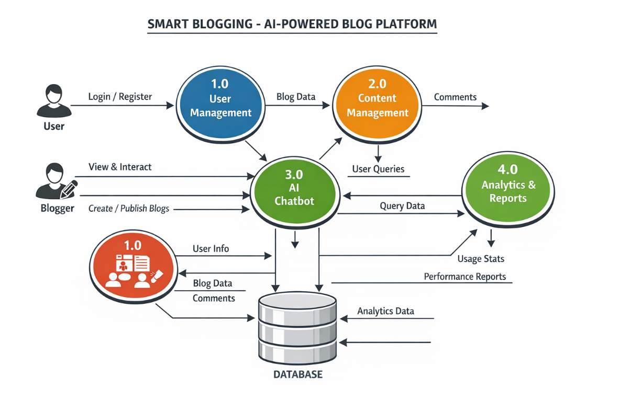
Fig 1.1 : System Design
5.6 Database Design
The database is designed to store and manage all system data efficiently.
Main Tables:
- User Table: Stores user details (name, email, password)
- Blog Table: Stores blog content and metadata
- Comment Table: Stores user comments
- Like Table: Stores like interactions
- Analytics Table: Stores performance data
Database Features:
- Structured data storage
- Fast data retrieval
- Secure data handling
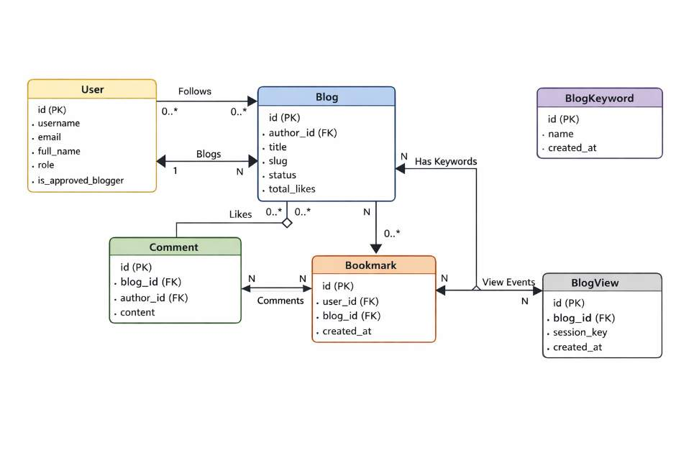
Fig 1.2 : ER Daigram

5.7 Process Flow
The process flow explains how different operations are executed within the system.
User Process Flow:
- Register → Login → Browse Blogs → Interact

Blogger Process Flow:
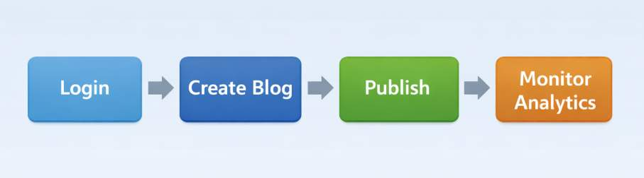
Fig 1.3 : Process Flow of Website

AI Process Flow:
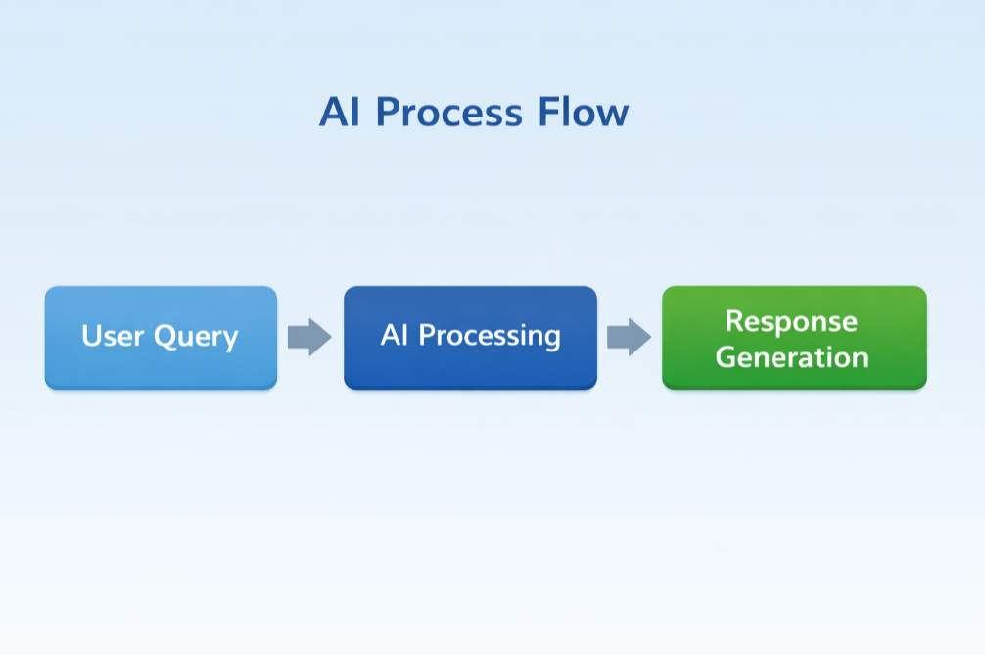
Fig 1.4 : Process Flow of AI Interaction

5.8 Security Mechanism
Security is an important part of the system design.
Security Features:
- Secure login authentication
- Password encryption
- User session management
- Protection against unauthorized access

File Structure:
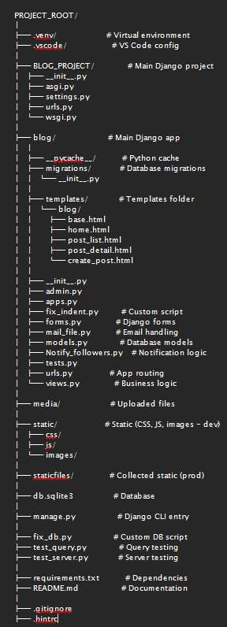
Fig 1.5 Project file structure

CODES

fix_db.py
import sqlite3
try:
conn = sqlite3.connect('db.sqlite3')
cur = conn.cursor()
# Add the column if it doesn't exist
cur.execute("ALTER TABLE blog_blog ADD COLUMN keywords varchar(255) NOT NULL DEFAULT ''")
conn.commit()
print("Successfully added keywords column to blog_blog")
except Exception as e:
print(f"Error modifying database: {e}")
finally:
if 'conn' in locals():
conn.close()

manage.py
#!/usr/bin/env python
"""Django's command-line utility for administrative tasks."""
import os
import sys
def main():
"""Run administrative tasks."""
os.environ.setdefault('DJANGO_SETTINGS_MODULE', 'BLOG_PROJECT.settings')
try:
from django.core.management import execute_from_command_line
except ImportError as exc:
raise ImportError(
"Couldn't import Django. Are you sure it's installed and "
"available on your PYTHONPATH environment variable? Did you "
"forget to activate a virtual environment?"
) from exc
execute_from_command_line(sys.argv)
if __name__ == '__main__':
main()

README.md
# AI Blog Platform with Chatbot
## 📌 Project Overview
An AI-powered blog platform integrated with an intelligent chatbot. The chatbot uses the blog content as its primary knowledge base to answer user queries. If the required information is not found within the blog, it fetches relevant data from online sources and provides reference links.
## 🎯 Objectives
- Provide instant answers from blog content using AI
- Improve user engagement through conversational interaction
- Enable source-aware and context-based responses
- Reduce manual content searching for users
## ⚙️ Key Features
- AI-powered chatbot integrated into the blog
- Blog content used as the main knowledge base
- Context-aware question answering
- Direct navigation to relevant blog sections
- External web search with source links when content is unavailable
- User-friendly and responsive interface
## 🧠 How It Works
1. User asks a question through the chatbot
2. Chatbot searches the blog database for relevant content
3. If found, it responds with an answer and redirects to the exact blog section
4. If not found, it fetches information from the web and displays the source link
## 🛠️ Technology Stack
- Frontend: HTML, CSS, JavaScript , NextJS
- Backend: Python / Django (or your chosen backend)
- Database: Firebase
- AI/NLP: NLP-based retrieval and response generation
## 📂 Project Modules
- User Interface Module
- Blog Management Module
- AI Chatbot Module
- Knowledge Retrieval Module
- External Search Module
## 🚀 Future Enhancements
- Voice-based chatbot interaction
- Multilingual support
- Personalized content recommendations
- Advanced analytics for user queries
## 👨‍🎓 Project Type
Final Year Diploma Project – Computer Engineering
## 👥 Team Members
- Maaz Siddiqui – Project Lead
- Sufiyan Shaikh –
- Awan Shaikh –
- Anas Shaikh –
## 📄 License
This project is developed for academic purposes.

test_query.py
import sqlite3
try:
conn = sqlite3.connect('db.sqlite3')
cur = conn.cursor()
cur.execute("SELECT keywords FROM blog_blog LIMIT 1")
rows = cur.fetchall()
print("Success: Can select keywords. Rows:", rows)
except Exception as e:
print(f"Error selecting from database: {e}")
finally:
if 'conn' in locals():
conn.close()

test_server.py
import urllib.request
try:
response = urllib.request.urlopen('http://127.0.0.1:8000/')
print(f"Success! Status Code: {response.status}")
except Exception as e:
print(f"Error accessing local server: {e}")

blog/admin.py
from django.contrib import admin
from django.contrib.auth.admin import UserAdmin as BaseUserAdmin
from django.contrib.auth import get_user_model
from .models import Blog, BlogKeyword
User = get_user_model()
# ===========================
# USER ADMIN
# ===========================
@admin.register(User)
class UserAdmin(BaseUserAdmin):
model = User
list_display = (
"email",
"username",
"role",
"is_approved_blogger",
"email_verified",
"is_staff",
"is_superuser",
"created_at",
)
list_filter = (
"role",
"is_approved_blogger",
"email_verified",
"is_staff",
"is_superuser",
"created_at",
)
search_fields = (
"email",
"username",
"full_name",
)
ordering = ("-created_at",)
readonly_fields = (
"id",
"created_at",
"updated_at",
"last_login",
"password_updated_at",
"total_posts",
"total_views",
"total_likes",
"followers",
)
fieldsets = (
("Authentication", {
"fields": (
"email",
"username",
"password",
)
}),
("Profile", {
"fields": (
"full_name",
"bio",
"profile_image",
)
}),
("Social Links", {
"fields": (
"website",
"instagram_link",
"x_link",
"git_link",
)
}),
("Blogging & Metrics", {
"fields": (
"role",
"is_approved_blogger",
"total_posts",
"total_views",
"total_likes",
"followers",
)
}),
("Permissions", {
"fields": (
"is_staff",
"is_superuser",
"groups",
"user_permissions",
)
}),
("System", {
"fields": (
"email_verified",
"timezone",
"language_preference",
"last_login",
"last_active_at",
"created_at",
"updated_at",
)
}),
)
add_fieldsets = (
(None, {
"classes": ("wide",),
"fields": (
"email",
"username",
"password1",
"password2",
"role",
"is_staff",
"is_superuser",
),
}),
)
filter_horizontal = ("groups", "user_permissions")
actions = (
"approve_blogger",
"verify_email",
)
def approve_blogger(self, request, queryset):
queryset.update(is_approved_blogger=True)
approve_blogger.short_description = "Approve selected bloggers"
def verify_email(self, request, queryset):
queryset.update(email_verified=True)
verify_email.short_description = "Mark email as verified"
# ===========================
# BLOG ADMIN
# ===========================
@admin.register(Blog)
class BlogAdmin(admin.ModelAdmin):
list_display = (
"title",
"author",
"status",
"category",
"total_views",
"total_likes",
"published_at",
"created_at",
)
list_filter = (
"status",
"category",
"nation",
"published_at",
"created_at",
)
search_fields = (
"title",
"slug",
"author__email",
"author__username",
)
prepopulated_fields = {"slug": ("title",)}
ordering = ("-created_at",)
readonly_fields = (
"id",
"total_views",
"total_likes",
"total_comments",
"total_bookmarks",
"created_at",
"updated_at",
)
fieldsets = (
("Author", {
"fields": ("author",)
}),
("Content", {
"fields": (
"title",
"slug",
"short_description",
"content",
"cover_image",
)
}),
("Classification", {
"fields": (
"category",
"nation",
"keywords",
)
}),
("Status & Visibility", {
"fields": (
"status",
"is_comments_enabled",
"published_at",
)
}),
("Metrics (Read-only)", {
"fields": (
"total_views",
"total_likes",
"total_comments",
"total_bookmarks",
)
}),
("System", {
"fields": (
"created_at",
"updated_at",
)
}),
)
filter_horizontal = ()
actions = (
"publish_blogs",
"unpublish_blogs",
)
def publish_blogs(self, request, queryset):
queryset.update(status="PUBLISHED")
publish_blogs.short_description = "Publish selected blogs"
def unpublish_blogs(self, request, queryset):
queryset.update(status="DRAFT")
unpublish_blogs.short_description = "Move selected blogs to Draft"
# ===========================
# BLOG KEYWORD ADMIN
# ===========================
@admin.register(BlogKeyword)
class BlogKeywordAdmin(admin.ModelAdmin):
list_display = ("name", "created_at")
search_fields = ("name",)
ordering = ("name",)

blog/apps.py
from django.apps import AppConfig
class BlogConfig(AppConfig):
name = 'blog'

blog/fix_indent.py
import os
path = r'c:\Users\siddi\Desktop\Vibe-Code-Test\FYP\blog\views.py'
with open(path, 'r', encoding='utf-8') as f:
lines = f.readlines()
new_lines = []
for i, line in enumerate(lines):
if 250 <= i <= 258:
stripped = line.strip()
if not stripped:
new_lines.append('\n')
elif stripped.startswith('#'):
new_lines.append(' ' + stripped + '\n')
elif stripped.startswith('category ='):
new_lines.append(' ' + stripped + '\n')
elif stripped.startswith('if '):
new_lines.append(' ' + stripped + '\n')
elif stripped.startswith('query ='):
new_lines.append(' ' + stripped + '\n')
elif stripped.startswith('blog_list ='):
new_lines.append(' ' + stripped + '\n')
else:
new_lines.append(line)
else:
new_lines.append(line)
with open(path, 'w', encoding='utf-8') as f:
f.writelines(new_lines)
print("Fixed indentation.")

blog/forms.py
from django import forms
from .models import User, Comment
class ProfileUpdateForm(forms.ModelForm):
"""
Form used to update user profile information,
including profile image.
hi i am maaz siddiqui
i am from india
i am a student
i am a web developer
"""
class Meta:
model = User
fields = [
"profile_image", # ✅ included ONCE
"full_name",
"bio",
"website",
"instagram_link",
"x_link",
"git_link",
]
widgets = {
'full_name': forms.TextInput(attrs={'class': 'form-control'}),
'bio': forms.Textarea(attrs={'class': 'form-control'}),
'profile_image': forms.FileInput(attrs={'class': 'form-control mt-2'}),
'website': forms.URLInput(attrs={'class': 'form-control'}),
'instagram_link': forms.URLInput(attrs={'class': 'form-control'}),
'x_link': forms.URLInput(attrs={'class': 'form-control'}),
'git_link': forms.URLInput(attrs={'class': 'form-control'}),
}
class CommentForm(forms.ModelForm):
class Meta:
model = Comment
fields = ['content']
widgets = {
'content': forms.Textarea(attrs={
'class': 'form-control',
'rows': 3,
'placeholder': 'Write your comment here...'
})
}

blog/mail_file.py
import smtplib
# Hello
class MAIL_SENDIND():
def __init__(self, revicers_email, indent, username=None, otp=None,**kwargs):
self.revicers_email = revicers_email
self.indent = indent
self.status = 'fail'
self.title = kwargs.get("title")
self.slug = kwargs.get("slug")
self.created_at = kwargs.get("doc")
sender_mail = "maaz.irshad.siddiqui@gmail.com"
password = "tvud sggg rdle ywll"
# -------- BUILD MESSAGE (USING YOUR TEXT) --------
if indent == "reset-password":
message = f"""Subject: OTP for Password Reset – Smart Blogger
Dear User,
Your OTP for password reset is:
OTP: {otp}
Do not share this OTP with anyone.
Smart Blogger Security Team
"""
elif indent == "recover-username":
message = f"""Subject: Username Recovery – Smart Blogger
Dear User,
You recently requested to recover the username associated with your Smart Blogger account.
Account Details:
------------------------------
Registered Email : {revicers_email}
Username : {username}
------------------------------
Best regards,
Smart Blogger Support Team
This is an automated system-generated email. Please do not reply.
"""
elif indent == "pass-update":
message = f"""Subject: Password Change Alert – Smart Blogger
Dear User,
This is a security notification to inform you that the password for your Smart Blogger account has been changed.
Account Email:
------------------------------
{revicers_email}
------------------------------
If this was not you, please reset your password immediately.
Best regards,
Smart Blogger Security Team
This is an automated system-generated email. Please do not reply.
"""
elif indent == "recover-username":
message = f"""Subject: Username Recovery – Smart Blogger
Dear User,
You recently requested to recover the username associated with your Smart Blogger account.
Account Details:
------------------------------
Registered Email : {revicers_email}
Username : {username}
------------------------------
Best regards,
Smart Blogger Support Team
This is an automated system-generated email. Please do not reply.
"""
elif indent == "post-notify":
message = f"""Subject: New Blog Post from an Author You Follow – Smart Blogger
Dear User,
An author you follow on Smart Blogger has published a new blog post. We wanted to keep you informed so you don’t miss the latest update.
Post Details:
------------------------------
Author : {username}
Title : {kwargs.get("title")}
Published On : {kwargs.get("doc")}
Read Article : /blog/{kwargs.get("slug")}
------------------------------
Visit Smart Blogger to read the full article and explore more content from authors you follow.
Best regards,
Smart Blogger Team
This is an automated system-generated email. Please do not reply.
"""
elif indent == "verify-email":
message = f"""Subject: Verify Your Email Address – Smart Blogger
Dear User,
Thank you for creating an account on Smart Blogger. To complete your registration and secure your account, please verify your email address using the One-Time Password (OTP) below.
Verification Details:
------------------------------
Email : {self.revicers_email}
OTP Code : {otp}
Valid For : 10 minutes
------------------------------
Please enter this OTP on the verification screen to activate your account.
If you did not request this verification, you can safely ignore this email.
Best regards,
Smart Blogger Team
This is an automated system-generated email. Please do not reply.
"""
else:
# Invalid indent → safe exit
return
# -------- SEND MAIL (ONCE, SAFELY) --------
try:
with smtplib.SMTP_SSL("smtp.gmail.com", 465) as connection:
connection.login(sender_mail, password)
connection.sendmail(
sender_mail,
revicers_email,
message.encode("utf-8")
)
self.status = 'success'
except Exception as e:
print("Mail sending failed:", e)
self.status = 'fail'

blog/models.py
# Create your models here.
from django.utils.text import slugify
from django.db import models
from django.conf import settings
from django.contrib.auth.models import AbstractBaseUser, PermissionsMixin
from django.contrib.auth.base_user import BaseUserManager
import uuid
class UserManager(BaseUserManager):
def create_user(self, email, username, password=None, **extra_fields):
if not email:
raise ValueError("Email is required")
if not username:
raise ValueError("Username is required")
email = self.normalize_email(email)
user = self.model(email=email, username=username, **extra_fields)
user.set_password(password)
user.save(using=self._db)
return user
def create_superuser(self, email, username, password=None, **extra_fields):
extra_fields.setdefault("is_staff", True)
extra_fields.setdefault("is_superuser", True)
extra_fields.setdefault("email_verified", True)
return self.create_user(email, username, password, **extra_fields)
class User(AbstractBaseUser, PermissionsMixin):
ROLE_CHOICES = (
("USER", "Normal User"),
("BLOGGER", "Blogger"),
)
followers = models.ManyToManyField('self',symmetrical=False,related_name="following",blank=True)
id = models.BigAutoField(primary_key=True)
# Authentication
objects = UserManager()
username = models.CharField(max_length=150, unique=True)#
email = models.EmailField(unique=True)#
password_updated_at = models.DateTimeField(null=True, blank=True)#
# Role & Status
role = models.CharField(max_length=10, choices=ROLE_CHOICES, default="USER")
is_staff = models.BooleanField(default=False)
email_verified = models.BooleanField(default=False)
# Profile
full_name = models.CharField(max_length=255, blank=True) #
bio = models.TextField(blank=True) ##
profile_image = models.ImageField(upload_to="profiles/", null=True, blank=True)
website = models.URLField(blank=True) ##
instagram_link = models.URLField( blank=True)##
x_link = models.URLField( blank=True)##
git_link = models.URLField( blank=True)##
# Blogging Metrics
total_posts = models.PositiveIntegerField(default=0)
total_views = models.PositiveBigIntegerField(default=0)
total_likes = models.PositiveBigIntegerField(default=0)
is_approved_blogger = models.BooleanField(default=False)
# System Tracking
created_at = models.DateTimeField(auto_now_add=True)
updated_at = models.DateTimeField(auto_now=True)
last_active_at = models.DateTimeField(null=True, blank=True)
timezone = models.CharField(max_length=50, default="UTC")
language_preference = models.CharField(max_length=10, default="en")
USERNAME_FIELD = "email"
REQUIRED_FIELDS = ["username"]
def __str__(self):
return self.username
# ---------------------------- BLOG DATA MODEL ------------------------------
author = models.ForeignKey(
"User",
on_delete=models.CASCADE,
related_name="blogs"
)
class Blog(models.Model):
STATUS_CHOICES = (
("DRAFT", "Draft"),
("PUBLISHED", "Published"),
)
COLOR_CHOICES = (
("BLACK", "Black"),
("WHITE", "White"),
("NONE", "None"),
)
id = models.BigAutoField(primary_key=True)
# Author
author = models.ForeignKey(
User,
on_delete=models.CASCADE,
related_name="blogs"
)
# Content
title = models.CharField(max_length=255)
title_bg_color = models.CharField(max_length=10,choices=COLOR_CHOICES,default="NONE")
slug = models.SlugField(max_length=300, unique=True)
short_description = models.TextField(blank=True)
content = models.TextField() # CKEditor HTML stored here
cover_image = models.ImageField(upload_to="blogs/covers/", null=True, blank=True)
# Classification & Search
keywords = models.CharField(max_length=255, blank=True)
category = models.CharField(max_length=100, blank=True)
likes = models.ManyToManyField(User, related_name='liked_blogs', blank=True)
nation = models.CharField(max_length=100, blank=True) # optional geo targeting
# Status & Visibility
status = models.CharField(
max_length=10,
choices=STATUS_CHOICES,
default="DRAFT"
)
is_comments_enabled = models.BooleanField(default=True)
# Metrics (denormalized for performance)
views = models.IntegerField(default=0)
total_views = models.PositiveBigIntegerField(default=0)
total_likes = models.PositiveBigIntegerField(default=0)
total_comments = models.PositiveBigIntegerField(default=0)
total_bookmarks = models.PositiveBigIntegerField(default=0)
# Timestamps
published_at = models.DateTimeField(null=True, blank=True)
created_at = models.DateTimeField(auto_now_add=True)
updated_at = models.DateTimeField(auto_now=True)
class Meta:
ordering = ["-published_at", "-created_at"]
indexes = [
models.Index(fields=["slug"]),
models.Index(fields=["status"]),
models.Index(fields=["published_at"]),
]
def save(self, *args, **kwargs):
if not self.slug:
self.slug = slugify(self.title)
original_slug = self.slug
queryset = Blog.objects.all()
if self.pk:
queryset = queryset.exclude(pk=self.pk)
# If the slug exists, append a unique suffix
while queryset.filter(slug=self.slug).exists():
self.slug = f'{original_slug}-{str(uuid.uuid4())[:4]}'
super().save(*args, **kwargs)
def __str__(self):
return f"{self.author}"
class BlogKeyword(models.Model):
id = models.BigAutoField(primary_key=True)
name = models.CharField(max_length=50, unique=True)
created_at = models.DateTimeField(auto_now_add=True)
def __str__(self):
return self.name
class Comment(models.Model):
id = models.BigAutoField(primary_key=True)
blog = models.ForeignKey(Blog, on_delete=models.CASCADE, related_name='comments')
author = models.ForeignKey(User, on_delete=models.CASCADE)
content = models.TextField()
created_at = models.DateTimeField(auto_now_add=True)
# updated_at = models.DateTimeField(auto_now=True)
class Meta:
ordering = ['-created_at']
def __str__(self):
return f"Comment by {self.author.username} on {self.blog.title}"
# ================================ Bookmark =======================================
class Bookmark(models.Model):
user = models.ForeignKey(
User,
on_delete=models.CASCADE,
related_name="bookmarks"
)
blog = models.ForeignKey(
Blog,
on_delete=models.CASCADE,
related_name="bookmarked_by"
)
created_at = models.DateTimeField(auto_now_add=True)
class Meta:
unique_together = ("user", "blog")
def __str__(self):
return f"{self.user.username} bookmarked {self.blog.title}"
class BlogView(models.Model):
"""
Tracks individual blog views strictly for traffic time and new/returning reader analytics.
"""
blog = models.ForeignKey(Blog, on_delete=models.CASCADE, related_name="view_events")
session_key = models.CharField(max_length=40, null=True, blank=True)
created_at = models.DateTimeField(auto_now_add=True)
class Meta:
indexes = [
models.Index(fields=['blog', 'session_key']),
models.Index(fields=['created_at']),
]
def __str__(self):
return f"View for {self.blog.title} at {self.created_at}"

blog/Notify_followers.py
from .mail_file import MAIL_SENDIND
class Notify_follower():
def __init__(self,author,blog):
self.author =author
self.blog =blog
self.notify()
def notify(self):
print(self.blog.title)
followers = self.author.followers.all()
print(followers)
for follower in followers:
# MAIL_SENDIND(indent='post-notify',revicers_email=follower.email,username=self.author.username)
MAIL_SENDIND(
indent='post-notify',
revicers_email=follower.email,
username=self.author.username,
title=self.blog.title,
slug=self.blog.slug,
doc=self.blog.created_at,
)
print(f"Mail sent to {follower.email}")
print(
f"Notify {follower.username}:"
f"Notify email: {follower.email}:"
f"New blog '{self.blog.title}' by {self.author.username}\n")

blog/tests.py
from django.test import TestCase
# Create your tests here.

blog/urls.py
from django.urls import path
from . import views
from django.conf import settings
from django.conf.urls.static import static
urlpatterns = [
path('', views.home, name='home'),
path('sign-in/', views.sign_in, name='sign_in'),
path('sign-up/', views.sign_up, name='sign_up'),
path('dashboard/', views.dashboard, name='dashboard'),
path('logout/', views.logout, name='logout'),
path('forget-id-pass/', views.fogretcred, name='forget-id-pass'),
path('guide/', views.guide, name='guide'),
path('user-profile/', views.user_profile, name='user_profile'),
path('create-blog/', views.create_blog_func, name='create_blog'),
path('delete-blog/<int:id>/', views.delete_blog_func, name='delete'),
path('change-visibility/<int:id>/<str:status>/', views.change_visibility, name='change_visibility'),
path('access-blog/<int:id>/', views.access_blog, name='access_blog'),
path('access-blog/<str:slug>/', views.access_blog_slug, name='access_blog_slug'),
path("edit-blog/<int:blog_id>/", views.edit_blog, name="edit_blog"),
path("follow-user/<str:username>/", views.follow_user, name="follow_user"),
path('author/<str:username>/', views.public_profile, name='public_profile'),
path('like/<int:id>/', views.like_blog, name='like_blog'),
path('search/', views.search_blogs, name='search_blogs'),
path('email-verify/', views.email_verify, name='email_verify'),
path('delete-acc/', views.delete_acc, name='delete_acc'),
path('terms-n-condtion/', views.terms_n_condtion, name='terms_n_condtion'),
path('privacy/', views.privacy, name='privacy'),
path('add_blog_bm/<int:id>/', views.add_blog_bm, name='add_blog_bm'),
path('api/analytics-data/', views.analytics_data_api, name='analytics_data_api'),
]
urlpatterns += static(settings.MEDIA_URL, document_root=settings.MEDIA_ROOT)

blog/views.py
import random
import threading
from django.shortcuts import render, get_object_or_404, redirect
from django.http import HttpResponse, HttpResponseRedirect, JsonResponse
from django.contrib import messages
from django.contrib.auth import authenticate, login, get_user_model, logout as auth_logout
from django.contrib.auth.decorators import login_required
from django.db.models import Q, Count, Sum, F
from django.db.models.functions import ExtractHour, TruncDate
from django.utils import timezone
from django.utils.html import strip_tags
from django.core.paginator import Paginator
# Local Application Imports
from .models import Blog, BlogKeyword, Comment, Bookmark, BlogView
from .forms import ProfileUpdateForm, CommentForm
from .mail_file import MAIL_SENDIND
from .Notify_followers import Notify_follower
# ========================================================
# AUTHENTICATION SYSTEM
# ========================================================
User = get_user_model()
@login_required
def logout(request):
auth_logout(request)
request.session['isSigin']=True
return redirect('home') # or 'home'
def generate_otp():
return str(random.randint(100000, 999999))
def fogretcred(request):
"""
Handles forgotten credentials, including password reset and username recovery.
This view manages multiple actions based on the 'unique-attr' POST parameter:
- 'send-otp': Sends a password reset OTP to the user's email.
- 'verify-otp': Verifies the OTP and updates the user's password.
- 'recover-username': Sends the username to the user's email.
"""
if request.method == 'POST':
unique_attr:str = request.POST.get('unique-attr')
# STEP 1: Send OTP for password reset
if unique_attr == "send-otp":
email = request.POST.get("email")
try:
user = User.objects.get(email=email)
except User.DoesNotExist:
messages.error(request, "No account found with this email")
return redirect("forget-id-pass")
otp = generate_otp()
# Store OTP and email in the session for verification
request.session["reset_email"] = email
request.session["reset_otp"] = otp
# Send OTP via email
MAIL_SENDIND(revicers_email=email, indent="reset-password", otp=otp)
x = MAIL_SENDIND(revicers_email=email,indent=unique_attr,username=user.username,otp=otp)
request.session["otp_sent"] = True
messages.success(request, "OTP sent to your email")
return redirect("forget-id-pass")
# STEP 2: Verify OTP and update the password
if unique_attr == "verify-otp":
entered_otp = request.POST.get("otp")
password = request.POST.get("password")
session_otp = request.session.get("reset_otp")
email = request.session.get("reset_email")
# Check if the entered OTP matches the one in the session
if not session_otp or entered_otp != session_otp:
messages.error(request, "Invalid OTP")
return redirect("forget-id-pass")
user = User.objects.get(email=email)
user.set_password(password)
user.save()
# Clean up session variables
request.session.flush()
messages.success(request, "Password updated successfully")
return redirect("sign_in")
# Handle username recovery
if unique_attr.lower() == 'recover-username':
email:str = request.POST.get("email")
user = User.objects.get(email=email)
# Send username to the user's email
x = MAIL_SENDIND(revicers_email=email,indent=unique_attr,username=user.username)
messages.success(request, "Mail sent")
# print(x.status)
return redirect('forget-id-pass')
# Handle direct password update (requires email and new password)
if unique_attr.lower() == 'pass-update':
email:str = request.POST.get("email")
password:str = request.POST.get("password")
re_password:str = request.POST.get("re-password")
# Check if passwords match
if password == re_password:
if not password or not re_password or not password.strip() or not re_password.strip():
messages.error(request,f"Enter your credentials to proceed.")
return redirect('forget-id-pass')
try:
user = User.objects.get(email=email)
except User.DoesNotExist:
messages.error(request,f"User Not Found")
return redirect('forget-id-pass')
# Set the new password
user.set_password(password)
x = MAIL_SENDIND(revicers_email=email,indent=unique_attr)
messages.success(request,f"Mail Sent")
# print(x.revicers_email)
user.save()
return redirect('forget-id-pass')
else:
messages.error(request,f"Password Mismatch")
return redirect('forget-id-pass')
return render(request, 'fogretcred.html')
def sign_in(request):
"""
Handles user authentication.
"""
if request.method == 'POST':
email:str = request.POST.get('email')
password:str = request.POST.get('password')
if not email or not password:
if not email.strip() or not password.strip():
messages.error(request,f"Enter your credentials to proceed.")
return redirect('sign_in')
try:
# Allow login with either email or username
user_obj = User.objects.get(Q(email=email) | Q(username=email))
except User.DoesNotExist:
messages.error(request,"Invalid username or password. Please try again.")
return redirect('sign_in')
if user_obj is not None:
if user_obj.check_password(password):
login(request,user_obj)
request.session['isSigin']=False
return redirect('dashboard')
messages.error(request, "Invalid username or password. Please try again, or create an account if you don’t have one.")
return redirect('sign_in')
# user = authenticate(request,username)
return render(request, 'login_signin.html')
def sign_up(request):
"""
Handles new user registration.
"""
if request.method == 'POST':
username:str = request.POST.get('username')
email:str = request.POST.get('email')
password:str = request.POST.get('password')
full_name:str = request.POST.get('full_name')
website:str = request.POST.get('website')
instagram_link:str = request.POST.get('instagram_link')
x_link:str = request.POST.get('x_link')
git_link:str = request.POST.get('git_link')
bio:str = request.POST.get('bio')
# Check for existing user with the same email or username
if (User.objects.filter(username=username).exists() or User.objects.filter(email=email).exists() ):
messages.error(request,"Email or Username already exists try some thing new")
return redirect('sign_up')
user = User(username=username,
email=email,
password=password,
full_name=full_name,
website=website,
instagram_link=instagram_link,
x_link=x_link,
git_link=git_link,
bio=bio)
user.set_password(password)
messages.success(request, "Account created successfully!")
user.save()
# print(username,email,password,full_name,website,instagram_link,x_link,git_link,bio)
# print("ADDED SUCCESSFULY")
return redirect('sign_up')
return render(request, 'register_signup.html')
# ========================================================
# CORE BLOG LOGIC
# ========================================================
from django.db.models import Count
def home(request):
blog_list = Blog.objects.filter(
status="PUBLISHED"
).order_by("-created_at")
# Trending blog (most liked)
latest_blogs = []
blog = (
Blog.objects
.filter(status="PUBLISHED")
.annotate(likes_count=Count("likes"))
.order_by("-likes_count")
.first()
)
if blog:
latest_blogs.append(blog)
return render(
request,
"home.html",
{
"blogs": blog_list,
"latest_blogs": latest_blogs,
}
)
from django.db.models import OuterRef, Subquery
@login_required
def dashboard(request):
blog_list = Blog.objects.filter(
status="PUBLISHED"
).order_by("-created_at")
# category filter
category = request.GET.get("category")
if category and category != "all":
blog_list = blog_list.filter(category=category)
# search
query = request.GET.get("q")
if query:
stop_words = {
"a","an","the",
"is","am","are","was","were","be","been","being",
"do","does","did","doing",
"have","has","had","having",
"will","would","shall","should","can","could","may","might","must",
"and","or","but","if","because","as","while","although",
"of","at","by","for","with","about","against","between","into","through",
"during","before","after","above","below","to","from","up","down",
"in","out","on","off","over","under","again","further","then","once",
"here","there","when","where","why","how",
"all","any","both","each","few","more","most","other","some","such",
"no","nor","not","only","own","same","so","than","too","very",
"s","t","just","don","should","now"
}
# clean query words
query_list = [
word.lower()
for word in query.split()
if word.lower() not in stop_words and len(word) > 2
]
combined_q = Q()
for word in query_list:
combined_q |= (
Q(title__icontains=word) |
Q(keywords__icontains=word) |
Q(category__icontains=word)
)
if query_list:
blog_list = blog_list.filter(combined_q).distinct()
print("query list", query_list)
print("blog_list", blog_list)
print("query ", query)
# trending blog (most likes)
trending_blog = (
Blog.objects
.filter(status="PUBLISHED")
.annotate(likes_count=Count("likes"))
.order_by("-likes_count")
.first()
)
# sorting
sort_param = request.GET.get("sort")
if sort_param == "likes_asc":
blog_list = blog_list.annotate(likes_count_sort=Count("likes")).order_by("likes_count_sort", "-created_at")
elif sort_param == "likes_desc":
blog_list = blog_list.annotate(likes_count_sort=Count("likes")).order_by("-likes_count_sort", "-created_at")
elif sort_param == "views_asc":
blog_list = blog_list.order_by("views", "-created_at")
elif sort_param == "views_desc":
blog_list = blog_list.order_by("-views", "-created_at")
blogs = blog_list
user = request.user
following_users = user.following.all()
latest_blogs = []
for author in following_users:
blog = (
Blog.objects
.filter(author=author, status="PUBLISHED")
.order_by("-created_at")
.first()
)
if blog:
latest_blogs.append(blog)
bookmarked_blogs = Blog.objects.filter(
bookmarked_by__user=request.user
).distinct()
return render(
request,
"dashboard.html",
{
"blogs": blogs,
"latest_blogs": latest_blogs,
"bookmarked_blogs": bookmarked_blogs,
"trending_blog": trending_blog,
"selected_category": category,
}
)
@login_required
def create_blog_func(request):
"""
Handles the creation of a new blog post.
- Processes the submitted form data to create a new blog instance.
- Associates keywords with the blog.
- Notifies the author's followers about the new post in a separate thread.
"""
if request.method == 'POST':
# Retrieve blog data from the POST request
title = request.POST.get('title')
title_bg = request.POST.get('color')
slug = request.POST.get('slug')
short_description = request.POST.get('short_description')
category = request.POST.get('category')
keywords_raw = request.POST.get('keywords') # comma separated
content = request.POST.get('content')
status = request.POST.get('visibility')
cover_image = request.FILES.get('cover_image')
# Create the blog instance first, as it's needed for ManyToMany relationships
blog = Blog.objects.create(
author=request.user,
title=title,
title_bg_color=title_bg,
slug=slug,
short_description=short_description,
content=content,
category=category,
status=status,
cover_image=cover_image,
keywords=keywords_raw if keywords_raw else ""
)
# Increment the author's total post count
request.user.total_posts +=1
request.user.save()
# Notify followers in a non-blocking background thread
threading.Thread(
target=Notify_follower,
args=(request.user, blog),
daemon=True).start()
# If the blog is published, set the publication timestamp
if status == "PUBLISHED":
blog.published_at = timezone.now()
blog.save(update_fields=["published_at"])
# Keywords already associated in Blog.objects.create
# Debugging output (optional)
print("STATUS:", status)
print("PLAIN CONTENT:", strip_tags(content))
if status == "PUBLISHED":
messages.success(request, "Blog published successfully.")
return render(request, "create_blog_file.html", {"blog": blog})
return render(request, "create_blog_file.html")
@login_required
def delete_blog_func(request, id):
"""
Deletes a blog post. Ensures that only the author of the blog can delete it.
"""
if request.method != 'POST':
return redirect('user_profile')
blog = get_object_or_404(
Blog,
id=id,
author=request.user
)
request.user.total_posts -=1
request.user.save()
blog.delete()
messages.success(request, "Blog deleted successfully.")
return redirect('user_profile')
@login_required
def change_visibility(request, id,status):
"""
Changes the visibility of a blog post (e.g., from 'DRAFT' to 'PUBLISHED').
"""
blog = get_object_or_404(
Blog,
id=id,
author=request.user
)
blog.status=status
blog.save()
print(blog)
print(blog.status)
print(id)
print(status)
messages.success(request, "Blog Visibility Changed Successfully.")
return redirect('user_profile')
from .models import BlogView
@login_required
def access_blog(request, id):
blog = get_object_or_404(Blog, id=id)
comments = blog.comments.all()
# ✅ ADD THIS BLOCK
is_bookmarked = Bookmark.objects.filter(
user=request.user,
blog=blog
).exists()
if request.method == 'POST':
Blog.objects.filter(id=blog.id)\
.update(total_comments=F("total_comments") + 1)
form = CommentForm(request.POST)
if form.is_valid():
comment = form.save(commit=False)
comment.blog = blog
comment.author = request.user
comment.save()
return redirect('access_blog', id=blog.id)
else:
session_key = f'viewed_blog_{blog.id}'
if not request.session.get(session_key, False):
Blog.objects.filter(id=blog.id).update(views=F("views") + 1)
request.session[session_key] = True
# Track analytics independently
if not request.session.session_key:
request.session.save()
user_session_key = request.session.session_key
BlogView.objects.create(blog=blog, session_key=user_session_key)
blog.refresh_from_db()
form = CommentForm()
context = {
'blog': blog,
'comments': comments,
'form': form,
'is_bookmarked': is_bookmarked, # ✅ PASS TO TEMPLATE
}
return render(request, 'access_blog.html', context)
@login_required
def access_blog_slug(request, slug):
blog = get_object_or_404(Blog, slug=slug)
return redirect('access_blog',id=blog.id)
def edit_blog(request, blog_id):
"""
Handles editing of an existing blog post.
"""
blog = get_object_or_404(Blog, id=blog_id, author=request.user)
if request.method == "POST":
blog.title = request.POST.get("title")
blog.title_bg_color = request.POST.get("title_bg_color", "NONE")
blog.slug = request.POST.get("slug")
blog.short_description = request.POST.get("short_description")
blog.category = request.POST.get("category")
blog.content = request.POST.get("content")
blog.status = request.POST.get("visibility")
if request.FILES.get("cover_image"):
blog.cover_image = request.FILES["cover_image"]
blog.save()
# Handle keywords
blog.keywords = request.POST.get("keywords", "")
blog.save()
messages.success(request, "Blog updated successfully.")
return redirect(request.META.get("HTTP_REFERER", "/user-profile/"))
def search_blogs(request):
"""
Searches for blogs based on a query string provided by the user.
"""
query = request.GET.get('q')
blogs = Blog.objects.filter(status="PUBLISHED").order_by("-created_at")
if query:
blogs = blogs.filter(
Q(title__icontains=query) |
Q(short_description__icontains=query) |
Q(content__icontains=query) |
Q(category__icontains=query)
).distinct()
context = {
'blogs': blogs,
'query': query,
}
return render(request, 'search_results.html', context)
# ========================================================
# SOCIAL & PROFILE LAYER
# ========================================================
from django.shortcuts import render, redirect
from django.contrib.auth.decorators import login_required
from django.contrib import messages
from .models import Blog
from .forms import ProfileUpdateForm
@login_required
def user_profile(request):
"""
Handles the user profile page.
- Displays profile details and user's blogs (GET).
- Updates profile details including image (POST).
"""
# Fetch blogs created by the logged-in user (latest first)
blogs = Blog.objects.filter(author=request.user).order_by('-created_at')
# Users that the current user follows
following_users = request.user.following.all()
followers = request.user.followers.all()
if request.method == 'POST':
form = ProfileUpdateForm(
request.POST,
request.FILES,
instance=request.user
)
if form.is_valid():
form.save()
messages.success(request, "Profile updated successfully.")
return redirect('user_profile')
else:
messages.error(request, "Please correct the errors below.")
else:
form = ProfileUpdateForm(instance=request.user)
# Analytics data
user_blogs = Blog.objects.filter(author=request.user)
total_blogs = user_blogs.count()
total_views = user_blogs.aggregate(t=Sum('views')).get('t') or 0
total_likes = user_blogs.aggregate(t=Sum('total_likes')).get('t') or 0
total_comments = user_blogs.aggregate(t=Sum('total_comments')).get('t') or 0
blogs_with_scores = user_blogs.annotate(
trending_score=F('views') + (F('total_likes') * 2) + (F('total_comments') * 3)
).order_by('-trending_score')
trending_blogs = blogs_with_scores[:5]
top_by_views = user_blogs.filter(views__gte=0).order_by('-views', '-published_at').first()
top_by_likes = user_blogs.filter(total_likes__gte=0).order_by('-total_likes', '-views', '-published_at').first()
top_by_comments = user_blogs.filter(total_comments__gte=0).order_by('-total_comments', '-published_at').first()
# --- Peak Traffic Time & New/Returning Analytics ---
user_blog_views = BlogView.objects.filter(blog__author=request.user)
# 1. Peak Traffic Time
hourly_counts = user_blog_views.annotate(hour=ExtractHour('created_at')).values('hour').annotate(count=Count('id')).order_by('hour')
traffic_by_hour = [0] * 24
for entry in hourly_counts:
if entry['hour'] is not None:
traffic_by_hour[entry['hour']] = entry['count']
if user_blog_views.exists():
peak_hour = traffic_by_hour.index(max(traffic_by_hour))
start_ampm = "AM" if peak_hour < 12 else "PM"
end_ampm = "AM" if (peak_hour + 1) % 24 < 12 else "PM"
start_12 = peak_hour if peak_hour <= 12 else peak_hour - 12
start_12 = 12 if start_12 == 0 else start_12
end_12 = (peak_hour + 1) if (peak_hour + 1) <= 12 else (peak_hour + 1) - 12
end_12 = 12 if end_12 == 0 else end_12
peak_traffic_time = f"{start_12} {start_ampm} - {end_12} {end_ampm}"
else:
peak_traffic_time = "Not enough data"
# 2. Returning vs New Readers
reader_sessions = user_blog_views.values('session_key').annotate(visits=Count('id'))
returning_readers_count = reader_sessions.filter(visits__gt=1).count()
new_readers_count = reader_sessions.filter(visits=1).count()
total_readers = returning_readers_count + new_readers_count
if total_readers > 0:
returning_readers_pct = round((returning_readers_count / total_readers) * 100)
new_readers_pct = 100 - returning_readers_pct
else:
returning_readers_pct = 0
new_readers_pct = 0
engagement_rate = 0
if total_views > 0:
engagement_rate = round(float((total_likes + total_comments) / total_views) * 100.0, 1)
recent_blogs_for_chart = user_blogs.filter(status="PUBLISHED").order_by("published_at")[:10]
chart_labels = [b.published_at.strftime("%b %d") if b.published_at else "Unknown" for b in recent_blogs_for_chart]
chart_views_data = [b.views for b in recent_blogs_for_chart]
sort_by = request.GET.get('sort_by', 'recent')
if sort_by == 'views_asc':
all_blogs_stats = user_blogs.order_by('views')
elif sort_by == 'views_desc':
all_blogs_stats = user_blogs.order_by('-views')
elif sort_by == 'likes_asc':
all_blogs_stats = user_blogs.order_by('total_likes')
elif sort_by == 'likes_desc':
all_blogs_stats = user_blogs.order_by('-total_likes')
elif sort_by == 'comments_asc':
all_blogs_stats = user_blogs.order_by('total_comments')
elif sort_by == 'comments_desc':
all_blogs_stats = user_blogs.order_by('-total_comments')
else:
all_blogs_stats = user_blogs.order_by('-published_at')
context = {
'blogs': blogs,
'form': form,
'following_users': following_users,
'followers': followers,
'total_blogs': total_blogs,
'total_views': total_views,
'total_likes': total_likes,
'total_comments': total_comments,
'trending_blogs': trending_blogs,
'top_by_views': top_by_views,
'top_by_likes': top_by_likes,
'top_by_comments': top_by_comments,
'peak_traffic_time': peak_traffic_time,
'traffic_by_hour': traffic_by_hour,
'returning_readers_pct': returning_readers_pct,
'new_readers_pct': new_readers_pct,
'engagement_rate': engagement_rate,
'chart_labels': chart_labels,
'chart_views_data': chart_views_data,
'all_blogs': all_blogs_stats,
}
return render(request, 'profile.html', context)
@login_required
def analytics_data_api(request):
"""
Returns JSON analytics data for the logged-in user's blogs.
Aggregates BlogView events per day to feed the profile analytics chart.
"""
user_blog_views = BlogView.objects.filter(blog__author=request.user)
# Aggregate views per day
daily_views = (
user_blog_views
.annotate(day=TruncDate("created_at"))
.values("day")
.annotate(count=Count("id"))
.order_by("day")
)
labels = []
views = []
for entry in daily_views:
day = entry["day"]
if day is not None:
labels.append(day.strftime("%b %d"))
views.append(entry["count"])
return JsonResponse(
{
"labels": labels,
"views": views,
}
)
@login_required
def public_profile(request, username):
"""
Displays the public profile of a user, showing their published blogs.
"""
author = get_object_or_404(User, username=username)
author_likes = (
Blog.objects
.filter(author=author)
.aggregate(total=Sum("total_likes"))
.get("total") or 0
)
total_comments = (
Blog.objects
.filter(author=author)
.aggregate(total=Sum("total_comments"))
.get("total") or 0
)
blogs = Blog.objects.filter(
author=author,
status="PUBLISHED"
).order_by("-published_at")
context = {
'author': author,
'blogs': blogs,
'author_likes':author_likes,
'total_comments':total_comments,
}
return render(request,'public_profile.html', context)
@login_required
def follow_user(request, username):
"""
Toggles the follow status of a user.
"""
target_user = get_object_or_404(User, username=username)
# Prevent users from following themselves
if request.user == target_user:
return redirect("public_profile",username=username)
# If already following, unfollow. Otherwise, follow.
if request.user in target_user.followers.all():
target_user.followers.remove(request.user)
else:
target_user.followers.add(request.user)
return HttpResponseRedirect(request.META.get('HTTP_REFERER', '/'))
from django.db.models import F
from django.db.models import Sum
@login_required
def like_blog(request, id):
blog = get_object_or_404(Blog, id=id)
if blog.likes.filter(id=request.user.id).exists():
blog.likes.remove(request.user)
Blog.objects.filter(id=blog.id, total_likes__gt=0)\
.update(total_likes=F("total_likes") - 1)
else:
blog.likes.add(request.user)
Blog.objects.filter(id=blog.id)\
.update(total_likes=F("total_likes") + 1)
return redirect("access_blog", id=blog.id)
from django.contrib.auth.decorators import login_required
from django.shortcuts import get_object_or_404, redirect
from django.db.models import F
from .models import Blog
@login_required
def add_blog_bm(request, id):
blog = get_object_or_404(Blog, id=id)
bookmark = Bookmark.objects.filter(
user=request.user,
blog=blog
).first()
if bookmark:
bookmark.delete()
else:
Bookmark.objects.create(
user=request.user,
blog=blog
)
return redirect(request.META.get('HTTP_REFERER', 'access_blog'), id=blog.id)
# ========================================================
# SOCIAL & PROFILE LAYER
# ========================================================
@login_required
def email_verify(request):
# 🔹 GET → Send OTP
if request.method == "GET":
print('Enter GET')
otp = generate_otp()
request.session["verify_email_otp"] = otp
request.session["verify_email_id"] = request.user.email
MAIL_SENDIND(revicers_email=request.user.email, indent="verify-email", otp=otp)
# x = MAIL_SENDIND(revicers_email=email,indent=unique_attr,username=user.username,otp=otp)
request.session["email_otp_sent"] = True
messages.success(request, "OTP sent to your email")
print('Exit GET')
return redirect("user_profile")
# 🔹 POST → Verify OTP
if request.method == "POST":
print('Enter POST')
user_otp = request.POST.get("otp")
session_otp = request.session.get("verify_email_otp")
session_email = request.session.get("verify_email_id")
check_mail_sent = request.session.get("email_otp_sent")
if not user_otp or not session_otp:
messages.error(request, "OTP not found. Please try again.")
return redirect("user_profile")
if user_otp == session_otp and request.user.email == session_email:
if check_mail_sent==True:
request.user.email_verified = True
request.user.save(update_fields=["email_verified"])
# cleanup
del request.session["verify_email_otp"]
del request.session["verify_email_id"]
messages.success(request, "Email verified successfully.")
else:
messages.error(request, "Invalid OTP.")
print('Exit POST')
return redirect("user_profile")
def guide(request):
return render(request,'guide.html')
@login_required
def delete_acc(request):
if request.method == "POST":
user = request.user
commented_blogs = Blog.objects.filter(comments__author=user).distinct()
for blog in commented_blogs:
count = Comment.objects.filter(blog=blog, author=user).count()
blog.total_comments = max(0, blog.total_comments - count)
blog.save(update_fields=["total_comments"])
# 🔹 Remove likes by this user
liked_blogs = Blog.objects.filter(likes=user)
for blog in liked_blogs:
blog.total_likes = max(0, blog.total_likes - 1)
blog.save(update_fields=["total_likes"])
blog.likes.remove(user)
# 🔹 Delete user's blogs (CASCADE already deletes comments)
Blog.objects.filter(author=user).delete()
auth_logout(request)
user.delete()
return redirect("home")
return redirect("user_profile")
# ------------------------------------------------------------------------------------
def terms_n_condtion(request):
return render(request,'terms.html')
def privacy(request):
return render(request,'privacy.html')
def custom_404_view(request, exception=None):
return HttpResponse("""
<!DOCTYPE html>
<html lang="en">
<head>
<meta charset="UTF-8">
<title>Page Not Available | Smart Blogger</title>
<meta name="viewport" content="width=device-width, initial-scale=1">
<!-- Bootstrap CSS -->
<link
href="https://cdn.jsdelivr.net/npm/bootstrap@5.3.2/dist/css/bootstrap.min.css"
rel="stylesheet"
>
<style>
body {
background: #f8f9fc;
font-family: "Segoe UI", system-ui, -apple-system, BlinkMacSystemFont;
color: #1f2937;
}
.error-wrapper {
min-height: 100vh;
display: flex;
align-items: center;
justify-content: center;
}
.error-card {
background: #ffffff;
border-radius: 16px;
padding: 3rem 2.5rem;
max-width: 520px;
width: 100%;
box-shadow: 0 20px 40px rgba(0, 0, 0, 0.08);
text-align: center;
}
.error-code {
font-size: 4.5rem;
font-weight: 800;
color: #0d6efd;
letter-spacing: 2px;
}
.error-title {
font-size: 1.4rem;
font-weight: 600;
margin-top: 0.5rem;
}
.error-desc {
font-size: 0.95rem;
color: #6b7280;
margin-top: 1rem;
line-height: 1.6;
}
.info-box {
background: #f1f5ff;
border-left: 4px solid #0d6efd;
padding: 1rem;
border-radius: 8px;
margin-top: 1.5rem;
text-align: left;
font-size: 0.9rem;
}
.btn-home {
margin-top: 2rem;
padding: 0.6rem 1.6rem;
border-radius: 30px;
font-weight: 500;
}
.footer-note {
margin-top: 1.5rem;
font-size: 0.8rem;
color: #9ca3af;
}
</style>
</head>
<body>
<div class="error-wrapper">
<div class="error-card">
<div class="error-code">404</div>
<div class="error-title">
Page Not Found
</div>
<p class="error-desc">
The page you are trying to access does not exist, has been removed,
or is temporarily unavailable. This can happen if the link is outdated
or the content has been moved.
</p>
<div class="info-box">
<strong>What you can do:</strong>
<ul class="mb-0 mt-2">
<li>Check the URL for typing errors</li>
<li>Return to the homepage and continue browsing</li>
<li>Access content from your dashboard</li>
</ul>
</div>
<a href="/" class="btn btn-primary btn-home">
Go Back to Home
</a>
<div class="footer-note">
Smart Blogger · Intelligent Blogging Platform
</div>
</div>
</div>
</body>
</html>
""", status=404)
from django.db.models import Sum, F

blog/templates/about_analytics.html
{% extends "about_base.html" %}
{% block extra_style %}
<script src="https://cdn.jsdelivr.net/npm/chart.js"></script>
<style>
.stat-card {
background: #f9fafb;
border: 1px solid #e5e7eb;
border-radius: 12px;
padding: 1.5rem;
text-align: center;
}
.stat-card h3 {
font-size: 2rem;
font-weight: 800;
color: #1f2937;
margin: 0;
}
.stat-card p {
font-size: 0.85rem;
color: #6b7280;
font-weight: 600;
text-transform: uppercase;
margin-top: 0.5rem;
}
.chart-container {
background: #fff;
border: 1px solid #e5e7eb;
border-radius: 12px;
padding: 1.5rem;
margin-bottom: 2rem;
}
.blog-list-item {
display: flex;
justify-content: space-between;
padding: 10px 0;
border-bottom: 1px solid #f3f4f6;
align-items: center;
}
.blog-list-item:last-child {
border-bottom: none;
}
.trending-score {
background: #fee2e2;
color: #dc2626;
padding: 4px 10px;
border-radius: 20px;
font-size: 0.8rem;
font-weight: bold;
}
</style>
{% endblock %}
{% block about_content %}
<div class="d-flex justify-content-between align-items-center mb-4">
<h3 class="fw-bold">Analytics Dashboard</h3>
<span class="badge bg-primary text-white rounded-pill px-3 py-2">
Engagement Rate: {{ engagement_rate }}%
</span>
</div>
<!-- Overview Statistics (Cards) -->
<div class="row g-3 mb-4">
<div class="col-md-3">
<div class="stat-card">
<h3>{{ total_blogs }}</h3>
<p>Total Blogs</p>
</div>
</div>
<div class="col-md-3">
<div class="stat-card">
<h3>{{ total_views }}</h3>
<p>Total Views</p>
</div>
</div>
<div class="col-md-3">
<div class="stat-card">
<h3>{{ total_likes }}</h3>
<p>Total Likes</p>
</div>
</div>
<div class="col-md-3">
<div class="stat-card">
<h3>{{ total_comments }}</h3>
<p>Total Comments</p>
</div>
</div>
</div>
<!-- Advanced Analytics (Cards) -->
<div class="row g-3 mb-4">
<div class="col-md-6">
<div class="stat-card">
<h3 class="text-primary">{{ peak_traffic_time|default:"N/A" }}</h3>
<p>Most Active Reading Time</p>
</div>
</div>
<div class="col-md-6">
<div class="stat-card d-flex justify-content-center gap-4 align-items-center">
<div>
<h3 class="text-success">{{ returning_readers_pct }}%</h3>
<p class="mb-0">Returning Readers</p>
</div>
<div class="vr"></div>
<div>
<h3 class="text-info">{{ new_readers_pct }}%</h3>
<p class="mb-0">New Readers</p>
</div>
</div>
</div>
</div>
<!-- Charts -->
<div class="row g-4 mb-4">
<div class="col-lg-4">
<div class="chart-container h-100">
<h6 class="fw-bold mb-3">Views Growth</h6>
<canvas id="viewsChart"></canvas>
</div>
</div>
<div class="col-lg-4">
<div class="chart-container h-100">
<h6 class="fw-bold mb-3">Engagement Comparison</h6>
<canvas id="engagementChart"></canvas>
</div>
</div>
<div class="col-lg-4">
<div class="chart-container h-100">
<h6 class="fw-bold mb-3">Traffic by Hour</h6>
<canvas id="trafficHourChart"></canvas>
</div>
</div>
</div>
<!-- Lists -->
<div class="row g-4">
<div class="col-lg-6">
<div class="chart-container h-100 mb-0">
<h6 class="fw-bold mb-3">🔥 Trending Blogs</h6>
<div>
{% for blog in trending_blogs %}
<div class="blog-list-item d-flex gap-2">
<a href="/access-blog/{{ blog.id }}" class="text-dark text-decoration-none text-truncate fw-medium"
style="max-width: 200px;" title="{{ blog.title }}">{{ blog.title }}</a>
<span class="trending-score">Views: {{ blog.views }}</span>
</div>
{% empty %}
<p class="text-muted small">No trending blogs yet.</p>
{% endfor %}
</div>
</div>
</div>
<div class="col-lg-6">
<div class="chart-container h-100 mb-0">
<h6 class="fw-bold mb-3">🏆 Top Performing Blogs</h6>
<div>
{% if top_by_views %}
<div class="blog-list-item d-flex gap-3">
<span class="text-muted small fw-bold" style="min-width: 100px;">Most Viewed</span>
<a href="/access-blog/{{ top_by_views.id }}"
class="fw-bold text-dark text-decoration-none text-truncate" title="{{ top_by_views.title }}">{{
top_by_views.title }}</a>
</div>
{% endif %}
{% if top_by_likes %}
<div class="blog-list-item d-flex gap-3">
<span class="text-muted small fw-bold" style="min-width: 100px;">Most Liked</span>
<a href="/access-blog/{{ top_by_likes.id }}"
class="fw-bold text-dark text-decoration-none text-truncate" title="{{ top_by_likes.title }}">{{
top_by_likes.title }}</a>
</div>
{% endif %}
{% if top_by_comments %}
<div class="blog-list-item d-flex gap-3">
<span class="text-muted small fw-bold" style="min-width: 100px;">Most Discussed</span>
<a href="/access-blog/{{ top_by_comments.id }}"
class="fw-bold text-dark text-decoration-none text-truncate"
title="{{ top_by_comments.title }}">{{ top_by_comments.title }}</a>
</div>
{% endif %}
{% if not top_by_views and not top_by_likes and not top_by_comments %}
<p class="text-muted small">No data available.</p>
{% endif %}
</div>
</div>
</div>
</div>
<!-- All Blogs Performance Table -->
<div class="row mt-4 mb-4">
<div class="col-12">
<div class="chart-container mb-0" style="overflow-x: auto;">
<h6 class="fw-bold mb-3">📊 Total Performance Breakdown</h6>
<table class="table table-hover align-middle mb-0">
<thead class="table-light">
<tr>
<th scope="col">
<a href="?sort_by=recent" class="text-dark text-decoration-none d-flex align-items-center">
Blog Title
{% if request.GET.sort_by == 'recent' or not request.GET.sort_by %}<i
class="bi bi-caret-down-fill ms-1 small"></i>{% endif %}
</a>
</th>
<th scope="col" class="text-center">
<a href="?sort_by=views"
class="text-dark text-decoration-none d-flex align-items-center justify-content-center">
Views <i class="bi bi-eye ms-1"></i>
{% if request.GET.sort_by == 'views' %}<i
class="bi bi-caret-down-fill ms-1 small"></i>{% endif %}
</a>
</th>
<th scope="col" class="text-center">
<a href="?sort_by=likes"
class="text-dark text-decoration-none d-flex align-items-center justify-content-center">
Likes <i class="bi bi-heart ms-1"></i>
{% if request.GET.sort_by == 'likes' %}<i
class="bi bi-caret-down-fill ms-1 small"></i>{% endif %}
</a>
</th>
<th scope="col" class="text-center">
<a href="?sort_by=comments"
class="text-dark text-decoration-none d-flex align-items-center justify-content-center">
Comments <i class="bi bi-chat ms-1"></i>
{% if request.GET.sort_by == 'comments' %}<i
class="bi bi-caret-down-fill ms-1 small"></i>{% endif %}
</a>
</th>
</tr>
</thead>
<tbody>
{% for blog in all_blogs %}
<tr>
<td>
<a href="/access-blog/{{ blog.id }}"
class="text-dark fw-bold text-decoration-none d-block text-truncate"
style="max-width: 250px;" title="{{ blog.title }}">{{ blog.title }}</a>
<div class="small text-muted">{{ blog.published_at|date:"M d, Y"|default:"Draft" }}</div>
</td>
<td class="text-center fw-medium text-primary">{{ blog.views }}</td>
<td class="text-center fw-medium text-danger">{{ blog.total_likes }}</td>
<td class="text-center fw-medium text-warning">{{ blog.total_comments }}</td>
</tr>
{% empty %}
<tr>
<td colspan="4" class="text-center text-muted py-3">No blogs published yet.</td>
</tr>
{% endfor %}
</tbody>
</table>
</div>
</div>
</div>
<script>
document.addEventListener("DOMContentLoaded", function () {
const viewsCtx = document.getElementById('viewsChart').getContext('2d');
new Chart(viewsCtx, {
type: 'line',
data: {
labels: {{ chart_labels| safe }},
datasets: [{
label: 'Views Growth',
data: {{ chart_views_data| safe }},
borderColor: '#4f46e5',
backgroundColor: 'rgba(79, 70, 229, 0.1)',
borderWidth: 2,
fill: true,
tension: 0.3
}]
},
options: {
responsive: true,
plugins: {
legend: { display: false }
},
scales: {
y: { beginAtZero: true }
}
}
});
const engCtx = document.getElementById('engagementChart').getContext('2d');
new Chart(engCtx, {
type: 'bar',
data: {
labels: ['Views', 'Likes', 'Comments'],
datasets: [{
label: 'Metrics',
data: [{{ total_views }}, {{ total_likes }}, {{ total_comments }}],
backgroundColor: ['#3b82f6', '#ec4899', '#f59e0b'],
borderRadius: 6
}]
},
options: {
responsive: true,
plugins: {
legend: { display: false }
},
scales: {
y: { beginAtZero: true }
}
}
});
const trafficHourCtx = document.getElementById('trafficHourChart').getContext('2d');
new Chart(trafficHourCtx, {
type: 'bar',
data: {
labels: ['12AM', '1AM', '2AM', '3AM', '4AM', '5AM', '6AM', '7AM', '8AM', '9AM', '10AM', '11AM', '12PM', '1PM', '2PM', '3PM', '4PM', '5PM', '6PM', '7PM', '8PM', '9PM', '10PM', '11PM'],
datasets: [{
label: 'Views',
data: {{ traffic_by_hour| safe }
},
backgroundColor: '#10b981',
borderRadius: 4
}]
},
options: {
responsive: true,
plugins: { legend: { display: false } },
scales: { y: { beginAtZero: true } }
}
});
});
</script>
{% endblock %}

blog/templates/access_blog.html
{% extends "base.html" %}
{% load static %}
{% block body %}
<style>
/* ================= GLOBAL FIX ================= */
html,
body {
width: 100%;
overflow-x: hidden;
}
/* ================= HERO ================= */
.fullscreen-img {
width: 100%;
min-height: 100vh;
background-size: cover;
background-position: center;
background-repeat: no-repeat;
display: flex;
flex-direction: column;
align-items: center;
justify-content: center;
padding: 2rem;
text-align: center;
position: relative;
}
.fullscreen-img::before {
content: "";
position: absolute;
inset: 0;
background: linear-gradient(to bottom,
rgba(0, 0, 0, 0.35),
rgba(0, 0, 0, 0.55));
}
.hero-content {
position: relative;
z-index: 2;
backdrop-filter: blur(12px);
background: rgba(255, 255, 255, 0.08);
padding: 2rem 3rem;
border-radius: 18px;
box-shadow: 0 20px 50px rgba(0, 0, 0, 0.35);
}
.hero-content h1 {
color: #fff;
font-size: clamp(1.8rem, 4vw, 2.8rem);
font-weight: 800;
margin-bottom: .6rem;
}
.hero-content h3 {
color: #e5e7eb;
font-size: clamp(1rem, 2.5vw, 1.2rem);
opacity: 0.9;
}
/* ================= BOOKMARK ================= */
.bookmark-on-image {
position: absolute;
bottom: 25px;
right: 25px;
background: rgba(255, 255, 255, 0.85);
backdrop-filter: blur(6px);
border-radius: 50%;
padding: 10px 12px;
box-shadow: 0 8px 25px rgba(0, 0, 0, .3);
z-index: 5;
transition: 0.2s ease;
}
.bookmark-on-image:hover {
transform: scale(1.1);
}
/* ================= BLOG CONTENT ================= */
.blog-content {
max-width: 1050px;
margin: 2.5rem auto;
padding: 3rem;
background: #ffffff;
border-radius: 20px;
box-shadow: 0 20px 60px rgba(0, 0, 0, 0.08);
line-height: 1.8;
font-size: 1.05rem;
}
/* ================= LIKE ================= */
.like-panel {
position: fixed;
left: 16px;
bottom: 40px;
background: #ffffff;
border-radius: 999px;
padding: 10px 16px;
display: flex;
align-items: center;
gap: 10px;
box-shadow: 0 12px 35px rgba(0, 0, 0, .18);
z-index: 2100;
transition: 0.2s ease;
}
.like-panel:hover {
transform: translateY(-3px);
}
.like-panel span {
font-size: 1rem;
font-weight: 700;
}
/* ================= COMMENTS ================= */
.comment-form textarea {
border-radius: 10px;
padding: 10px;
}
.card {
border-radius: 16px;
border: none;
box-shadow: 0 8px 30px rgba(0, 0, 0, 0.06);
}
.card-title {
font-weight: 600;
}
.card-text {
font-size: 0.95rem;
}
/* ================= CHATBOT ================= */
.chatbot-panel {
position: fixed;
right: 24px;
bottom: 140px;
width: 380px;
max-height: 70vh;
background: #ffffff;
border-radius: 18px;
box-shadow: 0 20px 60px rgba(0, 0, 0, 0.25);
display: flex;
flex-direction: column;
opacity: 0;
transform: translateY(20px);
pointer-events: none;
transition: all 0.3s ease;
z-index: 2000;
}
.chatbot-panel.active {
opacity: 1;
transform: translateY(0);
pointer-events: auto;
}
.chatbot-toggle {
position: fixed;
right: 20px;
bottom: 40px;
width: 50px;
height: 50px;
border-radius: 50%;
background: #111;
color: #fff;
border: none;
font-size: 20px;
z-index: 2100;
}
/* ================= MOBILE ================= */
@media (max-width: 768px) {
.blog-content {
margin: 1rem;
padding: 1.5rem;
}
.hero-content {
padding: 1.5rem;
}
.chatbot-panel {
right: 10px;
left: 10px;
width: auto;
bottom: 180px;
max-height: 60vh;
}
.like-panel {
bottom: 100px;
}
.chatbot-toggle {
bottom: 100px;
}
}
</style>
<!-- ================= HERO ================= -->
<!-- ================= HERO ================= -->
<div class="fullscreen-img" style="background:url('{{ blog.cover_image.url }}') center/cover no-repeat;">
<div class="hero-content" style="
{% if blog.title_bg_color == 'BLACK' %}
background: rgba(0,0,0,0.45);
{% elif blog.title_bg_color == 'WHITE' %}
background: rgba(255,255,255,0.35);
{% else %}
background: rgba(0,0,0,0.35);
{% endif %}
">
<h1 style="
{% if blog.title_bg_color == 'BLACK' %}
color: #ffffff;
{% elif blog.title_bg_color == 'WHITE' %}
color: #000000;
{% else %}
color: #ffffff;
{% endif %}
">
{{ blog.title }}
{{ blog.title_bg_color }}
</h1>
<h3 style="
{% if blog.title_bg_color == 'BLACK' %}
color: #e5e7eb;
{% elif blog.title_bg_color == 'WHITE' %}
color: #111111;
{% else %}
color: #e5e7eb;
{% endif %}
">
{{ blog.slug }}
</h3>
</div>
<a href="{% url 'add_blog_bm' blog.id %}" class="bookmark-on-image" title="Bookmark">
{% if is_bookmarked %}
<i class="bi bi-bookmark-fill fs-5"></i>
{% else %}
<i class="bi bi-bookmark fs-5"></i>
{% endif %}
</a>
</div>
<!-- ================= LIKE ================= -->
<div class="like-panel">
{% if user.is_authenticated %}
<a href="{% url 'like_blog' blog.id %}" style="text-decoration:none;">
{% if request.user in blog.likes.all %} ❤️ {% else %} 🤍 {% endif %}
</a>
{% else %}
<a href="{% url 'sign_in' %}" style="text-decoration:none;">🤍</a>
{% endif %}
<span class="me-2">{{ blog.total_likes|default:0 }}</span>
<span style="border-left: 2px solid #e5e7eb; height: 18px; margin: 0 4px;"></span>
<span class="ms-2 text-muted" title="Views">👁 {{ blog.views|default:0 }}</span>
</div>
<hr class="my-5 mx-auto" style="width:50%;">
<!-- ================= BLOG ================= -->
<article class="blog-content">
<div class="mb-3">
<strong style="font-size:1.3rem;">
Author:
<a href="{% url 'public_profile' blog.author.username %}">
@{{ blog.author.username }}
</a>
</strong>
</div>
<hr style="width:12%; margin-left:0;">
<div class="mt-4">
{{ blog.content|safe }}
</div>
</article>
<hr class="my-5 mx-auto" style="width:50%;">
<!-- ================= COMMENTS ================= -->
<div class="row">
<div class="col-md-8 mx-auto">
<h5 class="mb-4">Leave a Comment</h5>
{% if user.is_authenticated %}
<form method="POST" class="comment-form">
{% csrf_token %}
{{ form.content }}
<br>
<button class="btn btn-dark btn-sm mt-2">
Post Comment
</button>
</form>
{% else %}
<div class="alert alert-info mt-2">
Login required to comment.
</div>
{% endif %}
<h6 class="mt-5">Comments ({{ comments.count }})</h6>
{% for comment in comments %}
<div class="card mb-3 p-3">
<div class="d-flex justify-content-between mb-2">
<span class="card-title">
{{ comment.author.full_name|default:comment.author.username }}
</span>
<small class="text-muted">
{{ comment.created_at|date:"M d, Y" }}
</small>
</div>
<p class="card-text mb-0">{{ comment.content }}</p>
</div>
{% empty %}
<p class="text-muted">
No comments yet. Be the first to share your thoughts!
</p>
{% endfor %}
</div>
</div>
<!-- ================= CHATBOT ================= -->
<div class="chatbot-panel" id="chatbotPanel">
<div class="chatbot-header">
<span>AI Assistant</span>
<button onclick="toggleChat()">✕</button>
</div>
<div class="chatbot-body">
<p>
<strong>Bot:</strong>
Ask me to improve your blog, rewrite content, or generate ideas.
</p>
</div>
<div class="chatbot-footer">
<textarea rows="2" placeholder="Write your prompt..."></textarea>
<button>Send</button>
</div>
</div>
<button class="chatbot-toggle" onclick="toggleChat()">☰</button>
<script>
function toggleChat() {
document.getElementById("chatbotPanel").classList.toggle("active");
}
</script>
{% endblock body %}

blog/templates/base.html
<!doctype html>
<html lang="en">
<head>
<meta charset="UTF-8" />
<meta name="viewport" content="width=device-width, initial-scale=1.0" />
<title>{% block title %}Smart Blogging{% endblock %}</title>
<!-- Fonts -->
<link rel="preconnect" href="https://fonts.googleapis.com">
<link rel="preconnect" href="https://fonts.gstatic.com" crossorigin>
<link
href="https://fonts.googleapis.com/css2?family=Inter:wght@300;400;500;600;700&family=Merriweather:ital,wght@0,300;0,400;0,700;1,400&display=swap"
rel="stylesheet">
<!-- Icons -->
<link href="https://cdn.jsdelivr.net/npm/bootstrap-icons/font/bootstrap-icons.css" rel="stylesheet" />
<!-- Bootstrap 5 (Grid Only preference, but full build for utility convenience) -->
<link href="https://cdn.jsdelivr.net/npm/bootstrap@5.3.3/dist/css/bootstrap.min.css" rel="stylesheet" />
<!-- Custom Design System -->
<link rel="stylesheet" href="/static/base.css">
{% block style %}{% endblock %}
{% block extra_head %}{% endblock %}
{% block head %}{% endblock %}
</head>
<body class="d-flex flex-column min-vh-100">
<!-- ================= HEADER ================= -->
<header id="mainNav" class="navbar-glass">
<div class="container-custom h-100">
<div class="d-flex align-items-center justify-content-between py-3">
<!-- Logo -->
<a href="/" class="d-flex align-items-center gap-2">
<span class="fs-4 fw-bold text-gradient">Smart Blogger.</span>
</a>
<!-- Desktop Nav -->
<nav class="d-none d-md-flex align-items-center gap-4">
<a href="/dashboard/" class="nav-link {% if request.path == '/dashboard/' %}active{% endif %}">
<i class="bi bi-house me-1"></i> Home
</a>
<a href="/guide/" class="nav-link {% if request.path == '/guide/' %}active{% endif %}">
<i class="bi bi-journal-text me-1"></i> Guide
</a>
<div class="vr mx-2"></div>
{% if not request.user.is_authenticated %}
<a href="{% url 'sign_in' %}" class="btn btn-ghost">Sign In</a>
<a href="{% url 'sign_up' %}" class="btn btn-primary">Get Started</a>
{% else %}
<div class="dropdown">
<a href="#" class="d-flex align-items-center gap-2 text-decoration-none dropdown-toggle"
data-bs-toggle="dropdown">
{% if request.user.profile_image %}
<img src="{{ request.user.profile_image.url }}" class="rounded-circle border" width="32" height="32"
alt="Avatar">
{% else %}
<div class="rounded-circle bg-secondary text-white d-flex align-items-center justify-content-center"
style="width: 32px; height: 32px; font-size: 0.8rem;">
{{ request.user.username|make_list|first|upper }}
</div>
{% endif %}
<span class="fw-medium small d-none d-lg-block">{{ request.user.username }}</span>
</a>
<ul class="dropdown-menu dropdown-menu-end shadow-lg border-0 mt-2 rounded-3">
<li><a class="dropdown-item py-2" href="/user-profile/"><i class="bi bi-person me-2"></i> Profile</a></li>
<li><a class="dropdown-item py-2" href="/create-blog/"><i class="bi bi-pencil-square me-2"></i> Write a
Story</a></li>
<li>
<hr class="dropdown-divider">
</li>
<li><a class="dropdown-item py-2 text-danger" href="/logout"><i class="bi bi-box-arrow-right me-2"></i>
Log Out</a></li>
</ul>
</div>
{% endif %}
</nav>
<!-- Mobile Toggle (Simple) -->
<button class="btn btn-ghost d-md-none" type="button" data-bs-toggle="collapse" data-bs-target="#mobileMenu">
<i class="bi bi-list fs-4"></i>
</button>
</div>
</div>
<!-- Mobile Menu Collapse -->
<div class="collapse d-md-none bg-white border-bottom" id="mobileMenu">
<div class="container-custom py-3 d-flex flex-column gap-3">
<a href="/dashboard/" class="nav-link"><i class="bi bi-house me-2"></i> Home</a>
<a href="/guide/" class="nav-link"><i class="bi bi-journal-text me-2"></i> Guide</a>
{% if request.user.is_authenticated %}
<a href="/create-blog/" class="nav-link"><i class="bi bi-pencil-square me-2"></i> Write</a>
<a href="/user-profile/" class="nav-link"><i class="bi bi-person me-2"></i> Profile</a>
<a href="/logout" class="nav-link text-danger"><i class="bi bi-box-arrow-right me-2"></i> Logout</a>
{% else %}
<a href="{% url 'sign_in' %}" class="btn btn-secondary w-100">Sign In</a>
<a href="{% url 'sign_up' %}" class="btn btn-primary w-100">Get Started</a>
{% endif %}
</div>
</div>
</header>
<!-- ================= MAIN ================= -->
<main class="flex-grow-1" style="padding-top: 80px;">
{% block body %}{% endblock %}
</main>
<!-- ================= FOOTER ================= -->
<footer class="footer-modern mt-2">
<div class="container-custom text-center">
<div>
<span class="fs-5 fw-bold text-white">Smart Blogger</span>
<p class="small opacity-50 mt-2">
<a href="">Help</a> |
<a href="">Status</a> |
<a href="/guide">Developers</a> |
<a href="/privacy">Privacy</a> |
<a href="/terms-n-condtion">Terms & Conditions</a>
</p>
<p class="small opacity-50 mt-2">Share your stories with the world.</p>
</div>
<div class="d-flex justify-content-center gap-4 mb-2">
<a href="https://x.com/siddiquimaazzz" target="_blank" class="fs-5"><i class="bi bi-twitter-x"></i></a>
<a href="https://github.com/maazsiddiqui79/" target="_blank" class="fs-5"><i class="bi bi-github"></i></a>
<a href="https://www.instagram.com/siddiqui.maazzz/" target="_blank" class="fs-5"><i
class="bi bi-instagram"></i></a>
</div>
<div class="small opacity-50">
&copy; {{ year|default:"2026" }} Smart Blogger. All rights reserved.
</div>
</div>
</footer>
{% block extra_js %}{% endblock %}
<script src="https://cdn.jsdelivr.net/npm/bootstrap@5.3.3/dist/js/bootstrap.bundle.min.js"></script>
<script>
// Header scroll effect
const header = document.querySelector('.navbar-glass');
window.addEventListener('scroll', () => {
if (window.scrollY > 10) {
header.style.boxShadow = 'var(--shadow-sm)';
header.classList.add('py-1');
} else {
header.style.boxShadow = 'none';
header.classList.remove('py-1');
}
});
</script>
</body>
</html>

blog/templates/create_blog_file.html
{% extends "base.html" %}
{% load static %}
{% block head %}
<link rel="stylesheet" href="/static/css/create_new_blog.css" />
{% endblock head %}
{% block body %}
<!-- Hero -->
<div class="fullscreen-img">
<h1>New Post</h1>
<h3>You’re going to make a great blog post</h3>
</div>
<!-- Form -->
<div class="blog-form-container">
<h2>Create Blog Post</h2>
{% if messages %}
<div class="messages-container">
{% for message in messages %}
<div
class="alert
{% if message.tags == 'error' %}
alert-danger
{% else %}
alert-{{ message.tags }}
{% endif %}
alert-dismissible fade show"
role="alert"
>
{{ message }}
<button type="button" class="btn-close" data-bs-dismiss="alert"></button>
</div>
{% endfor %}
</div>
{% endif %}
<form method="POST" enctype="multipart/form-data" action="/create-blog/">
<!-- BLOG PUBLISHED MESSAGE -->
{% if blog %}
<div class="publish-success-box">
<div class="success-icon">✓</div>
<div class="success-content">
<h4>Blog Published Successfully</h4>
<p>
Your post is now live and accessible at
<span
type="text"
value="{{ request.scheme }}://{{ request.get_host }}{% url 'access_blog_slug' blog.slug %}"
readonly
id="publishedLink"
>{{ request.scheme }}://{{ request.get_host }}{% url
'access_blog_slug' blog.slug %}</span
>
</p>
<button
type="button"
class="btn btn-dark btn-outline-light"
onclick="copyBlogLink()"
>
Copy
</button>
<a
href="{% url 'access_blog_slug' blog.slug %}"
class="btn btn-light btn-outline-dark"
target="_blank"
>
Open
</a>
<p
id="copyMessage"
class="copy-message container bg-body-secondary px-3 py-2 mt-2 rounded"
></p>
</div>
</div>
{% endif %} {% csrf_token %}
<div class="form-group">
<label>Blog Title</label>
<input type="text" name="title" class="form-control" required />
</div>
<div class="form-group">
<label class="d-block mb-2">Title BackGround Color</label>
<div class="form-check form-check-inline">
<input
class="form-check-input"
type="radio"
name="color"
id="colorBlack"
value="BLACK"
required
/>
<label class="form-check-label" for="colorBlack">Black</label>
</div>
<div class="form-check form-check-inline">
<input
class="form-check-input"
type="radio"
name="color"
id="colorWhite"
value="WHITE"
/>
<label class="form-check-label" for="colorWhite">White</label>
</div>
<div class="form-check form-check-inline">
<input
class="form-check-input"
type="radio"
name="color"
id="colorNone"
value="NONE"
checked
/>
<label class="form-check-label" for="colorNone">None</label>
</div>
<small class="text-muted d-block mt-2">
<strong>Black:</strong> Choose this for a bold, premium look with high
contrast. Avoid if your content uses dark images or needs a light,
minimal appearance.
</small>
<small class="text-muted d-block mt-1">
<strong>White:</strong> Best for clean, readable layouts and long-form
content. Avoid if you want a dramatic or dark-themed presentation.
</small>
<small class="text-muted d-block mt-1">
<strong>None:</strong> Uses the default theme styling. Choose this if
you don’t want to override the system or page design.
</small>
</div>
<div class="form-group">
<label>Slug</label>
<input type="text" name="slug" class="form-control" required />
</div>
<div class="form-group">
<label>Short Description</label>
<textarea
name="short_description"
rows="3"
class="form-control"
></textarea>
</div>
<div class="form-group">
<label>Category</label>
<input type="text" name="category" class="form-control" />
</div>
<div class="form-group">
<label>Keywords (comma separated)</label>
<input
type="text"
name="keywords"
class="form-control"
placeholder="django, ai, blogging"
/>
</div>
<div class="form-group">
<label>Cover Image</label>
<input type="file" name="cover_image" class="form-control" />
</div>
<div class="form-group">
<label>Blog Content</label>
<textarea name="content" id="editor"></textarea>
</div>
<div class="form-group">
<label class="fw-bold">Visibility</label>
<div>
<input type="radio" name="visibility" value="DRAFT" checked /> Draft
</div>
<div>
<input type="radio" name="visibility" value="PUBLISHED" /> Published
</div>
</div>
<button type="submit" class="submit-btn">Publish</button>
</form>
<!---------------------- Chatbot UI ---------------------->
<div class="chatbot-wrapper">
<!-- Notice the toggle logic has been updated directly here. -->
<button class="chatbot-toggle" onclick="toggleChatUi()">
<span class="hamburger-icon"><svg xmlns="http://www.w3.org/2000/svg" width="35" height="35" fill="currentColor" class="bi bi-robot" viewBox="0 0 16 16"><path d="M6 12.5a.5.5 0 0 1 .5-.5h3a.5.5 0 0 1 0 1h-3a.5.5 0 0 1-.5-.5M3 8.062C3 6.76 4.235 5.765 5.53 5.886a26.6 26.6 0 0 0 4.94 0C11.765 5.765 13 6.76 13 8.062v1.157a.93.93 0 0 1-.765.935c-.845.147-2.34.346-4.235.346s-3.39-.2-4.235-.346A.93.93 0 0 1 3 9.219zm4.542-.827a.25.25 0 0 0-.217.068l-.92.9a25 25 0 0 1-1.871-.183.25.25 0 0 0-.068.495c.55.076 1.232.149 2.02.193a.25.25 0 0 0 .189-.071l.754-.736.847 1.71a.25.25 0 0 0 .404.062l.932-.97a25 25 0 0 0 1.922-.188.25.25 0 0 0-.068-.495c-.538.074-1.207.145-1.98.189a.25.25 0 0 0-.166.076l-.754.785-.842-1.7a.25.25 0 0 0-.182-.135"/><path d="M8.5 1.866a1 1 0 1 0-1 0V3h-2A4.5 4.5 0 0 0 1 7.5V8a1 1 0 0 0-1 1v2a1 1 0 0 0 1 1v1a2 2 0 0 0 2 2h10a2 2 0 0 0 2-2v-1a1 1 0 0 0 1-1V9a1 1 0 0 0-1-1v-.5A4.5 4.5 0 0 0 10.5 3h-2zM14 7.5V13a1 1 0 0 1-1 1H3a1 1 0 0 1-1-1V7.5A3.5 3.5 0 0 1 5.5 4h5A3.5 3.5 0 0 1 14 7.5"/></svg>
</span>
<span class="close-icon" style="display: none">✕</span>
</button>
</div>
<div class="chatbot-panel" id="chatbotPanel">
<div class="chatbot-header">AI Assistant</div>
<!-- Message body dynamically updated by JS -->
<div class="chatbot-body">
<div class="chat-message chat-bot">
<strong>Bot:</strong> Remember to keep your content engaging,
informative, and inspiring!
</div>
</div>
<div class="chatbot-footer">
<textarea rows="2" placeholder="Write your prompt..."></textarea>
<button>Send</button>
</div>
</div>
</div>
<script src="https://cdn.ckeditor.com/4.14.0/standard/ckeditor.js"></script>
<script src="/static/js/CREATE_BLOG_FILEJS.js"></script>
{% endblock %}

blog/templates/dashboard.html
{% extends "base.html" %}
{% load static %}
{% block title %}Dashboard | Smart Blogger{% endblock %}
{% block style %}
<style>
:root {
--bg-color: #f8fafc;
--highlight: radial-gradient(circle at 18% 0%, rgba(59, 130, 246, 0.16) 0%, rgba(248, 250, 252, 0) 55%),
radial-gradient(circle at 82% 100%, rgba(56, 189, 248, 0.12) 0%, rgba(248, 250, 252, 0) 55%);
--pattern: url("data:image/svg+xml,%3Csvg width='56' height='56' viewBox='0 0 56 56' xmlns='http://www.w3.org/2000/svg'%3E%3Crect width='56' height='56' fill='%23f8fafc'/%3E%3Cpath d='M0 28h56M28 0v56' stroke='%23e2e8f0' stroke-width='0.5' stroke-opacity='0.6' shape-rendering='crispEdges'/%3E%3Ccircle cx='28' cy='28' r='1' fill='%23d1d5db' fill-opacity='0.55'/%3E%3C/svg%3E");
}
body {
background-color: var(--bg-color);
background-image: var(--highlight), var(--pattern);
background-attachment: fixed;
}
.dashboard-container {
padding-top: 2rem;
padding-bottom: 4rem;
}
/* glass sidebar */
.dashboard-sidebar {
position: sticky;
top: 90px;
padding: 1.5rem;
border-radius: 18px;
background: rgba(255, 255, 255, 0.55);
backdrop-filter: blur(20px);
border: 1px solid rgba(255, 255, 255, 0.35);
box-shadow:
0 10px 25px rgba(0, 0, 0, 0.08),
inset 0 1px 0 rgba(255, 255, 255, 0.6);
margin-bottom: 1.5rem;
}
.sidebar-link {
display: flex;
align-items: center;
padding: .7rem 1rem;
border-radius: 10px;
transition: .25s;
text-decoration: none;
color: #1e293b;
font-weight: 500;
margin-bottom: .4rem;
}
.sidebar-link i {
margin-right: .6rem;
}
.sidebar-link:hover {
background: rgba(255, 255, 255, 0.7);
color: #2563eb;
transform: translateX(4px);
}
/* mobile quick menu */
.mobile-menu {
display: flex;
justify-content: space-between;
background: white;
border-radius: 14px;
padding: .8rem;
margin-bottom: 1rem;
border: 1px solid #e2e8f0;
}
.mobile-menu a {
flex: 1;
text-align: center;
text-decoration: none;
color: #334155;
font-size: .8rem;
}
.mobile-menu i {
display: block;
font-size: 18px;
margin-bottom: 3px;
}
/* trending */
.dashboard-sidebar1 {
padding: 1.5rem;
border-radius: 18px;
background: rgba(255, 255, 255, 0.55);
backdrop-filter: blur(20px);
border: 1px solid rgba(255, 255, 255, 0.35);
box-shadow:
0 10px 25px rgba(0, 0, 0, 0.08),
inset 0 1px 0 rgba(255, 255, 255, 0.6);
margin-bottom: 1.5rem;
}
.trending-card {
display: flex;
gap: 1rem;
background: rgba(255, 255, 255, 0);
border-radius: 16px;
padding: 1rem;
border: 1px solid #e2e8f0;
}
.trending-img {
width: 60px;
height: 70px;
object-fit: cover;
border-radius: 12px;
}
/* header */
.dashboard-header {
position: relative;
overflow: hidden;
border-radius: 24px;
padding: 2.5rem;
margin-bottom: 2rem;
background: rgba(255, 255, 255, 0.35);
backdrop-filter: blur(30px);
border: 1px solid rgba(255, 255, 255, 0.6);
box-shadow:
0 15px 35px rgba(0, 0, 0, 0.1);
}
.dashboard-stats {
display: flex;
gap: 1rem;
margin-top: 1rem;
flex-wrap: wrap;
}
.stat-card {
flex: 1;
min-width: 110px;
padding: .8rem;
border-radius: 10px;
background: rgba(255, 255, 255, 0.5);
text-align: center;
}
/* search */
.search-bar {
margin-bottom: 1.5rem;
}
/* categories */
.category-chips {
display: flex;
gap: .6rem;
flex-wrap: wrap;
margin-bottom: 1.6rem;
}
.chip {
padding: .4rem .9rem;
border-radius: 20px;
background: white;
border: 1px solid #e2e8f0;
font-size: .8rem;
text-decoration: none;
color: #334155;
}
.chip:hover {
background: #2563eb;
color: white;
}
/* blog grid */
.blog-grid {
display: grid;
grid-template-columns: repeat(3, 1fr);
gap: 1.4rem;
}
.blog-card {
background: white;
border-radius: 16px;
overflow: hidden;
border: 1px solid #e2e8f0;
display: flex;
flex-direction: column;
transition: .3s;
}
.blog-card:hover {
transform: translateY(-6px);
box-shadow: 0 15px 35px rgba(0, 0, 0, .08);
}
.blog-image {
width: 100%;
height: 170px;
object-fit: cover;
}
.blog-body {
padding: 1rem;
display: flex;
flex-direction: column;
flex: 1;
}
.blog-title {
font-size: .95rem;
font-weight: 600;
margin-bottom: .4rem;
}
.blog-desc {
font-size: .82rem;
color: #64748b;
margin-bottom: .6rem;
flex-grow: 1;
}
.blog-footer {
display: flex;
justify-content: space-between;
align-items: center;
border-top: 1px solid #f1f5f9;
padding-top: .5rem;
font-size: .8rem;
}
.author-box {
display: flex;
align-items: center;
gap: 6px;
}
.author-avatar {
width: 28px;
height: 28px;
border-radius: 50%;
object-fit: cover;
}
.blog-stats {
display: flex;
gap: 10px;
color: #64748b;
}
@media(max-width:992px) {
.blog-grid {
grid-template-columns: repeat(2, 1fr);
}
}
@media(max-width:576px) {
.blog-grid {
grid-template-columns: 1fr;
}
}
</style>
{% endblock %}
{% block body %}
<div class="container dashboard-container">
<div class="row g-4">
<!-- Sidebar Desktop -->
<div class="col-lg-3 d-none d-lg-block">
<aside class="dashboard-sidebar">
<a href="{% url 'home' %}" class="sidebar-link">
<i class="bi bi-house-door"></i> Home
</a>
<a href="{% url 'user_profile' %}" class="sidebar-link">
<i class="bi bi-person"></i> Profile
</a>
<a href="#" class="sidebar-link" data-bs-toggle="modal" data-bs-target="#bookmarkModal">
<i class="bi bi-bookmark"></i> Bookmarks
</a>
<a href="{% url 'create_blog' %}" class="sidebar-link">
<i class="bi bi-pencil-square"></i> Write Blog
</a>
</aside>
{% if trending_blog %}
<div class="dashboard-sidebar1">
<h5 class="fw-bold mb-3">🔥 Trending Blog</h5>
<a href="{% url 'access_blog' trending_blog.id %}" class="text-decoration-none text-dark">
<div class="trending-card">
{% if trending_blog.cover_image %}
<img src="{{ trending_blog.cover_image.url }}" class="trending-img">
{% endif %}
<div>
<h6>{{ trending_blog.title }}</h6>
<small class="text-muted">🔥 {{ trending_blog.likes.count }} likes &nbsp;•&nbsp; <i
class="bi bi-eye"></i> {{ trending_blog.views|default:0 }} views</small>
</div>
</div>
</a>
</div>
{% endif %}
</div>
<!-- Main Content -->
<div class="col-lg-9">
<div class="dashboard-header">
<h2>Hello, {{ request.user.full_name }} 👋</h2>
<p>Welcome back to Smart Blogger</p>
<div class="dashboard-stats">
<div class="stat-card">
<strong>{{ request.user.blogs.count }}</strong>
<br>Blogs
</div>
<div class="stat-card">
<strong>{{ bookmarked_blogs|length }}</strong>
<br>Bookmarks
</div>
<div class="stat-card">
<strong>{{ request.user.followers.count }}</strong>
<br>Followers
</div>
</div>
</div>
<!-- Mobile Menu -->
<div class="mobile-menu d-lg-none">
<a href="{% url 'home' %}">
<i class="bi bi-house-door"></i>
Home
</a>
<a href="{% url 'user_profile' %}">
<i class="bi bi-person"></i>
Profile
</a>
<a href="#" data-bs-toggle="modal" data-bs-target="#bookmarkModal">
<i class="bi bi-bookmark"></i>
Bookmarks
</a>
<a href="{% url 'create_blog' %}">
<i class="bi bi-pencil-square"></i>
Write
</a>
</div>
<!-- Trending Blog Mobile -->
{% if trending_blog %}
<div class="dashboard-sidebar1 d-lg-none">
<h5 class="fw-bold mb-3">🔥 Trending Blog</h5>
<a href="{% url 'access_blog' trending_blog.id %}" class="text-decoration-none text-dark">
<div class="trending-card">
{% if trending_blog.cover_image %}
<img src="{{ trending_blog.cover_image.url }}" class="trending-img">
{% endif %}
<div>
<h6>{{ trending_blog.title }}</h6>
<small class="text-muted">🔥 {{ trending_blog.likes.count }} likes &nbsp;•&nbsp; <i
class="bi bi-eye"></i> {{ trending_blog.views|default:0 }} views</small>
</div>
</div>
</a>
</div>
{% endif %}
<!-- Search -->
<div class="search-bar">
<form method="GET">
<div class="input-group">
<input type="search" name="q" class="form-control" placeholder="Search blogs..."
value="{{ request.GET.q|default:'' }}">
<button class="btn btn-primary">Search</button>
</div>
</form>
</div>
<!-- categories -->
<div class="category-chips">
<a href="?category=all" class="chip">All</a>
<a href="?category=DevOps" class="chip">DevOps</a>
<a href="?category=Programming" class="chip">Programming</a>
<a href="?category=Cybersecurity" class="chip">Cybersecurity</a>
<a href="?category=Artificial Intelligence" class="chip">Artificial Intelligence</a>
</div>
<div class="d-flex justify-content-between align-items-center mb-4">
<h4 class="fw-bold mb-0">Latest Blogs</h4>
<div class="dropdown">
<button class="btn btn-outline-secondary btn-sm rounded-pill px-3 dropdown-toggle" type="button"
data-bs-toggle="dropdown" aria-expanded="false">
<i class="bi bi-filter"></i> Sort By
</button>
<ul class="dropdown-menu dropdown-menu-end shadow-sm border-0">
<li>
<h6 class="dropdown-header">Views</h6>
</li>
<li>
<a class="dropdown-item {% if request.GET.sort == 'views_desc' %}active{% endif %}"
href="?sort=views_desc{% if request.GET.category %}&category={{ request.GET.category }}{% endif %}{% if request.GET.q %}&q={{ request.GET.q }}{% endif %}">
<i class="bi bi-sort-numeric-down"></i> Highest First
</a>
</li>
<li>
<a class="dropdown-item {% if request.GET.sort == 'views_asc' %}active{% endif %}"
href="?sort=views_asc{% if request.GET.category %}&category={{ request.GET.category }}{% endif %}{% if request.GET.q %}&q={{ request.GET.q }}{% endif %}">
<i class="bi bi-sort-numeric-up"></i> Lowest First
</a>
</li>
<li>
<hr class="dropdown-divider">
</li>
<li>
<h6 class="dropdown-header">Likes</h6>
</li>
<li>
<a class="dropdown-item {% if request.GET.sort == 'likes_desc' %}active{% endif %}"
href="?sort=likes_desc{% if request.GET.category %}&category={{ request.GET.category }}{% endif %}{% if request.GET.q %}&q={{ request.GET.q }}{% endif %}">
<i class="bi bi-sort-down"></i> Most Liked
</a>
</li>
<li>
<a class="dropdown-item {% if request.GET.sort == 'likes_asc' %}active{% endif %}"
href="?sort=likes_asc{% if request.GET.category %}&category={{ request.GET.category }}{% endif %}{% if request.GET.q %}&q={{ request.GET.q }}{% endif %}">
<i class="bi bi-sort-up"></i> Least Liked
</a>
</li>
</ul>
</div>
</div>
<div class="blog-grid">
{% for blog in blogs %}
<div class="blog-card">
<a href="{% url 'access_blog' blog.id %}">
{% if blog.cover_image %}
<img src="{{ blog.cover_image.url }}" class="blog-image">
{% else %}
<img src="{% static 'assets/default-blog.jpg' %}" class="blog-image">
{% endif %}
</a>
<div class="blog-body">
<div class="blog-title">{{ blog.title }}</div>
<div class="blog-desc">
{{ blog.short_description|truncatewords:18 }}
</div>
<div class="blog-footer">
<a href="{% url 'public_profile' blog.author.username %}"
class="author-box text-decoration-none text-dark">
{% if blog.author.profile_image %}
<img src="{{ blog.author.profile_image.url }}" class="author-avatar">
{% endif %}
<span>{{ blog.author.username }}</span>
</a>
<div class="blog-stats">
<span><i class="bi bi-eye"></i> {{ blog.views|default:0 }}</span>
<span>❤️ {{ blog.likes.count }}</span>
<a href="{% url 'add_blog_bm' blog.id %}">
{% if blog in bookmarked_blogs %}
<i class="bi bi-bookmark-fill text-primary"></i>
{% else %}
<i class="bi bi-bookmark"></i>
{% endif %}
</a>
</div>
</div>
</div>
</div>
{% endfor %}
</div>
</div>
</div>
</div>
<!-- BookMark Modal -->
<!-- Bookmark Modal -->
<div class="modal fade" id="bookmarkModal" tabindex="-1" aria-hidden="true">
<div class="modal-dialog modal-lg modal-dialog-scrollable">
<div class="modal-content">
<div class="modal-header">
<h5 class="modal-title">📑 Your Bookmarks</h5>
<button type="button" class="btn-close" data-bs-dismiss="modal"></button>
</div>
<div class="modal-body">
{% if bookmarked_blogs %}
<div class="row g-3">
{% for blog in bookmarked_blogs %}
<div class="col-md-6">
<div class="card h-100">
<a href="{% url 'access_blog' blog.id %}">
{% if blog.cover_image %}
<img src="{{ blog.cover_image.url }}" class="card-img-top"
style="height:150px;object-fit:cover;">
{% else %}
<img src="{% static 'assets/default-blog.jpg' %}" class="card-img-top"
style="height:150px;object-fit:cover;">
{% endif %}
</a>
<div class="card-body">
<h6 class="card-title">{{ blog.title }}</h6>
<p class="card-text text-muted small">
{{ blog.short_description|truncatewords:12 }}
</p>
</div>
<div class="card-footer d-flex justify-content-between align-items-center">
<small class="text-muted">
<i class="bi bi-eye"></i> {{ blog.views|default:0 }} &nbsp;
❤️ {{ blog.likes.count }} likes
</small>
<a href="{% url 'add_blog_bm' blog.id %}">
<i class="bi bi-bookmark-fill text-primary"></i>
</a>
</div>
</div>
</div>
{% endfor %}
</div>
{% else %}
<div class="text-center py-4">
<i class="bi bi-bookmark fs-2 text-muted"></i>
<p class="text-muted mt-2">
You haven't bookmarked any blogs yet.
</p>
</div>
{% endif %}
</div>
</div>
</div>
</div>
{% endblock %}

blog/templates/error404.html
<!doctype html>
<html lang="en">
<head>
<meta charset="UTF-8" />
<title>{{ error_code }} | Error</title>
<meta name="viewport" content="width=device-width, initial-scale=1.0" />
<!-- Bootstrap -->
<link
href="https://cdn.jsdelivr.net/npm/bootstrap@5.3.3/dist/css/bootstrap.min.css"
rel="stylesheet"
/>
<style>
body {
min-height: 100vh;
display: flex;
align-items: center;
justify-content: center;
background-color: #f4f6f8;
font-family: system-ui, -apple-system, BlinkMacSystemFont,
"Segoe UI", Roboto, Oxygen, Ubuntu, Cantarell, sans-serif;
}
.error-box {
text-align: center;
background: #ffffff;
padding: 3rem 2.5rem;
border-radius: 12px;
max-width: 520px;
width: 100%;
box-shadow: 0 10px 30px rgba(0, 0, 0, 0.08);
}
.error-code {
font-size: 4rem;
font-weight: 700;
color: #212529;
letter-spacing: 2px;
}
.error-message {
font-size: 1.05rem;
color: #6c757d;
margin: 1rem 0 2rem;
line-height: 1.6;
}
.btn-home {
padding: 0.6rem 1.6rem;
font-weight: 500;
border-radius: 6px;
}
footer {
margin-top: 2rem;
font-size: 0.85rem;
color: #adb5bd;
}
</style>
</head>
<body>
<div class="error-box">
<div class="error-code">{{ error_code }}</div>
<div class="error-message">
{{ error_message }}
</div>
<a href="{% url 'home' %}" class="btn btn-dark btn-home">
Return to Home
</a>
<footer>
© {{ now|default:"" }} Your Application
</footer>
</div>
</body>
</html>

blog/templates/fogretcred.html
{% extends "base.html" %}
{% load static %}
{% block title %}Account Recovery | Smart Blogger{% endblock %}
{% block style %}
<style>
.recovery-wrapper {
min-height: calc(100vh - 70px);
background: #f8fafc;
display: flex;
justify-content: center;
padding-top: 5rem;
}
.recovery-card {
max-width: 500px;
width: 100%;
background: white;
border-radius: var(--radius-xl);
box-shadow: var(--shadow-lg);
padding: 2.5rem;
}
.nav-pills .nav-link {
color: var(--text-muted);
font-weight: 500;
border-radius: var(--radius-md);
}
.nav-pills .nav-link.active {
background-color: var(--primary);
color: white;
}
</style>
{% endblock %}
{% block body %}
<div class="recovery-wrapper">
<div class="recovery-card h-auto align-self-start">
<div class="text-center mb-4">
<h2 class="fw-bold">Account Recovery</h2>
<p class="text-muted">Recover access to your account.</p>
</div>
<!-- Navigation Tabs -->
<ul class="nav nav-pills nav-fill mb-4 gap-2 p-1 bg-light rounded-3" id="recoveryTab" role="tablist">
<li class="nav-item">
<button class="nav-link active small py-2" id="password-tab" data-bs-toggle="tab" data-bs-target="#tab-password"
type="button">Forgot Password</button>
</li>
<li class="nav-item">
<button class="nav-link small py-2" id="username-tab" data-bs-toggle="tab" data-bs-target="#tab-username"
type="button">Forgot Username</button>
</li>
<li class="nav-item">
<button class="nav-link small py-2" id="change-tab" data-bs-toggle="tab" data-bs-target="#tab-change"
type="button">Change Password</button>
</li>
</ul>
<div class="tab-content">
<!-- Forgot Password -->
<div class="tab-pane fade show active" id="tab-password">
<form method="post" action="{% url 'forget-id-pass' %}">
{% csrf_token %}
<input type="hidden" name="unique-attr"
value="{% if request.session.otp_sent %}verify-otp{% else %}send-otp{% endif %}" />
{% if not request.session.otp_sent %}
<div class="mb-3">
<label class="form-label">Email Address</label>
<input type="email" name="email" class="form-control" placeholder="Enter your registered email" required>
</div>
<button type="submit" class="btn btn-primary w-100">Send Recovery OTP</button>
{% else %}
<div class="alert alert-success small">
<i class="bi bi-check-circle me-1"></i> OTP sent to your email.
</div>
<div class="mb-3">
<label class="form-label">Enter OTP</label>
<input type="text" name="otp" class="form-control text-center letter-spacing-2" placeholder="XXXXXX"
required>
</div>
<div class="mb-3">
<label class="form-label">New Password</label>
<input type="password" name="password" class="form-control" placeholder="New secure password" required>
</div>
<button type="submit" class="btn btn-primary w-100">Verify & Reset Password</button>
{% endif %}
</form>
</div>
<!-- Forgot Username -->
<div class="tab-pane fade" id="tab-username">
<form method="post" action="{% url 'forget-id-pass' %}">
{% csrf_token %}
<input type="hidden" name="unique-attr" value="recover-username" />
<div class="mb-3">
<label class="form-label">Email Address</label>
<input type="email" name="email" class="form-control" placeholder="Enter your registered email" required>
<div class="form-text">We'll send your username to this email.</div>
</div>
<button type="submit" class="btn btn-primary w-100">Recover Username</button>
</form>
</div>
<!-- Change Password -->
<div class="tab-pane fade" id="tab-change">
<form method="post" action="{% url 'forget-id-pass' %}">
{% csrf_token %}
<input type="hidden" name="unique-attr" value="pass-update" />
<div class="mb-3">
<label class="form-label">Email Address</label>
<input type="email" name="email" class="form-control" required>
</div>
<div class="mb-3">
<label class="form-label">New Password</label>
<input type="password" name="password" class="form-control" required>
</div>
<div class="mb-3">
<label class="form-label">Confirm New Password</label>
<input type="password" name="re-password" class="form-control" required>
</div>
<button type="submit" class="btn btn-primary w-100">Update Password</button>
</form>
</div>
</div>
<div class="mt-4 text-center">
<a href="{% url 'sign_in' %}" class="small text-muted text-decoration-none">Back to Sign In</a>
</div>
</div>
</div>
{% endblock %}

blog/templates/guide.html
{% extends "base.html" %}
{% load static %}
{% block title %}About{% endblock %}
{% block style %}
<link rel="stylesheet" href="{% static 'css/about.css' %}">
{% endblock %}
{% block body %}
<style>
.hero-overlay h1,
.hero-overlay h5 {
color: #fff;
text-align: center;
text-shadow: 10px 18px 15px rgba(255, 255, 255, 0.395);
}
</style>
<!-- ===== HERO SECTION ===== -->
<section class="about-hero">
<div class="hero-overlay">
<h1 class="text-white">Smart Blogger</h1>
<h5 class="text-white">Platform Overview · Documentation · Usage Guide</h5>
</div>
</section>
<div class="about-wrapper container m-0 p-0">
<!-- Mobile Header -->
<div class="d-md-none about-mobile-header mt-5">
<span>Documentation</span>
<button class="btn btn-outline-light btn-sm" data-bs-toggle="offcanvas" data-bs-target="#aboutSidebar">
☰
</button>
</div>
<div class="row g-0">
<!-- ===== DESKTOP SIDEBAR ===== -->
<aside class="col-md-3 about-sidebar d-none d-md-block">
<ul class="about-menu">
<br>
<li class="active" data-tab="overView">Overview of Smart Blogging</li>
<li data-tab="Guide">User Guide and Workflow</li>
<li data-tab="Developer">Project Background and Team Information</li>
</ul>
</aside>
<!-- ===== MOBILE OFFCANVAS ===== -->
<div class="offcanvas offcanvas-start d-md-none" tabindex="-1" id="aboutSidebar">
<div class="offcanvas-header">
<h6>Documentation</h6>
<button type="button" class="btn-close" data-bs-dismiss="offcanvas" aria-label="Close">
</button>
</div>
<div class="offcanvas-body">
<ul class="about-menu">
<li class="active" data-tab="overView">Overview of Smart Blogging</li>
<li data-tab="Guide">User Guide and Workflow</li>
<li data-tab="Developer">Project Background and Team Information</li>
</ul>
</div>
</div>
<!-- ===== MAIN CONTENT ===== -->
<main class="col-12 col-md-9 about-content">
{% include "docs/overView.html" %}
{% include "docs/Guide.html" %}
{% include "docs/Developer.html" %}
</main>
</div>
</div>
<!-- Bootstrap JS (Required) -->
<script src="https://cdn.jsdelivr.net/npm/bootstrap@5.3.2/dist/js/bootstrap.bundle.min.js"></script>
<!-- ===== TAB LOGIC ===== -->
<script>
document.addEventListener("DOMContentLoaded", () => {
const tabs = document.querySelectorAll(".about-menu li");
const contents = document.querySelectorAll(".tab-content");
const saved = localStorage.getItem("aboutTab");
if (saved) {
tabs.forEach(t => t.classList.remove("active"));
contents.forEach(c => c.classList.remove("active"));
document.querySelectorAll(`[data-tab="${saved}"]`)
.forEach(el => el.classList.add("active"));
document.getElementById(saved)?.classList.add("active");
}
tabs.forEach(tab => {
tab.addEventListener("click", () => {
tabs.forEach(t => t.classList.remove("active"));
contents.forEach(c => c.classList.remove("active"));
document.querySelectorAll(`[data-tab="${tab.dataset.tab}"]`)
.forEach(el => el.classList.add("active"));
document.getElementById(tab.dataset.tab).classList.add("active");
localStorage.setItem("aboutTab", tab.dataset.tab);
if (window.innerWidth < 768) {
const offcanvas = bootstrap.Offcanvas.getInstance(
document.getElementById("aboutSidebar")
);
offcanvas?.hide();
}
});
});
});
</script>
{% endblock %}

blog/templates/home.html
{% extends "base.html" %}
{% load static %}
{% block title %}Home | Smart Blogger{% endblock %}
{% block style %}
<style>
.hero-section {
background: linear-gradient(135deg, #f8fafc 0%, #e2e8f0 100%);
padding: 8rem 0;
padding-top: 2rem;
border-bottom: 1px solid var(--border-color);
position: relative;
overflow: hidden;
}
/* Idea Network */
.idea-network {
position: absolute;
right: -60px;
top: 40px;
width: 720px;
height: 420px;
opacity: .35;
pointer-events: none;
}
/* Glass Editor */
.editor-preview {
backdrop-filter: blur(18px);
background: rgba(255, 255, 255, 0.6);
border: 1px solid rgba(255, 255, 255, .6);
border-radius: 18px;
box-shadow: 0 20px 40px rgba(0, 0, 0, .08);
padding: 1.2rem;
max-width: 320px;
position: absolute;
right: 190px;
top: 70px;
/*animation:floatCard 6s ease-in-out infinite;*/
z-index: 3;
}
.editor-header {
display: flex;
gap: 6px;
margin-bottom: 10px;
}
.editor-dot {
width: 10px;
height: 10px;
border-radius: 50%;
}
.editor-dot:nth-child(1) {
background: #ff5f56
}
.editor-dot:nth-child(2) {
background: #ffbd2e
}
.editor-dot:nth-child(3) {
background: #27c93f
}
.editor-title {
font-size: 14px;
font-weight: 600;
margin-bottom: 8px;
}
.editor-text {
font-size: 12px;
color: #475569;
line-height: 1.5;
}
.editor-actions {
margin-top: 10px;
display: flex;
gap: 8px;
}
.editor-actions span {
font-size: 11px;
padding: 3px 8px;
border-radius: 6px;
background: #f1f5f9;
}
/* Floating topic cards */
.mini-card {
position: absolute;
padding: 8px 14px;
background: white;
border-radius: 12px;
box-shadow: 0 10px 20px rgba(0, 0, 0, .08);
font-size: 12px;
font-weight: 500;
animation: floatSmall 7s ease-in-out infinite;
}
.card1 {
top: 120px;
right: 460px;
}
.card2 {
top: 210px;
right: 380px;
}
.card3 {
top: 60px;
right: 280px;
}
.card4 {
top: 260px;
right: 180px;
}
@keyframes floatCard {
0% {
transform: translateY(0)
}
50% {
transform: translateY(-12px)
}
100% {
transform: translateY(0)
}
}
@keyframes floatSmall {
0% {
transform: translateY(0)
}
50% {
transform: translateY(-8px)
}
100% {
transform: translateY(0)
}
}
/* Typing animation */
.typing-wrapper {
font-size: 1.25rem;
font-weight: 500;
margin-bottom: 1.5rem;
color: #334155;
height: 30px;
}
.typing-cursor {
border-right: 2px solid #6366f1;
margin-left: 2px;
animation: blink 1s infinite;
}
@keyframes blink {
0%,
100% {
opacity: 1
}
50% {
opacity: 0
}
}
/* CTA */
.hero-cta {
display: flex;
gap: 1rem;
}
.hero-cta .btn {
padding: .8rem 1.6rem;
font-weight: 600;
border-radius: 12px;
}
/* Cards */
.card-img-top {
height: 220px;
object-fit: cover;
transition: transform .3s ease;
}
.card-premium:hover .card-img-top {
transform: scale(1.05);
}
.card-image-wrapper {
overflow: hidden;
border-top-left-radius: var(--radius-xl);
border-top-right-radius: var(--radius-xl);
}
.author-avatar {
width: 24px;
height: 24px;
object-fit: cover;
border-radius: 50%;
}
/* Sidebar sticky */
.sidebar-wrapper {
position: sticky;
top: 120px;
}
/* Mobile */
@media (max-width:992px) {
.sidebar-col {
order: -1;
margin-bottom: 2rem;
}
.sidebar-wrapper {
position: relative;
top: unset;
}
.idea-network {
display: none;
}
.editor-preview {
display: none;
}
.mini-card {
display: none;
}
}
</style>
{% endblock %}
{% block body %}
<section class="hero-section">
<!-- Idea network visualization -->
<svg class="idea-network" viewBox="0 0 720 420">
<line x1="15" y1="320" x2="220" y2="120" stroke="#94a3b8" />
<line x1="220" y1="120" x2="360" y2="200" stroke="#94a3b8" />
<line x1="360" y1="200" x2="520" y2="110" stroke="#94a3b8" />
<line x1="360" y1="200" x2="480" y2="300" stroke="#94a3b8" />
<line x1="220" y1="120" x2="260" y2="400" stroke="#94a3b8" />
<line x1="520" y1="110" x2="640" y2="210" stroke="#94a3b8" />
<circle cx="15" cy="320" r="7" fill="#6366f1" />
<circle cx="220" cy="120" r="9" fill="#6366f1" />
<circle cx="360" cy="200" r="7" fill="#6366f1" />
<circle cx="520" cy="110" r="7" fill="#6366f1" />
<circle cx="480" cy="300" r="7" fill="#6366f1" />
<circle cx="260" cy="400" r="7" fill="#6366f1" />
<circle cx="640" cy="210" r="7" fill="#6366f1" />
</svg>
<div class="container-custom">
<div class="row align-items-center">
<div class="col-lg-7">
<span class="badge bg-primary bg-opacity-10 text-primary mb-3 px-3 py-2 rounded-pill fw-bold">
New Era of Blogging
</span>
<h1 class="display-3 fw-bold mb-4">
Where Good Ideas <br>
<span class="text-gradient">Find You.</span>
</h1>
<div class="typing-wrapper">
Write about <span id="typing-text"></span><span class="typing-cursor"></span>
</div>
<p class="lead text-muted mb-4" style="max-width:500px;">
Read and share new perspectives on about any topic.
</p>
<div class="hero-cta">
<a href="{% url 'create_blog' %}" class="btn btn-primary">
Start Writing
</a>
<a href="#latest" class="btn btn-outline-dark">
Explore Blogs
</a>
</div>
</div>
<div class="col-lg-5 position-relative">
<!-- Editor preview -->
<div class="editor-preview">
<div class="editor-header">
<div class="editor-dot"></div>
<div class="editor-dot"></div>
<div class="editor-dot"></div>
</div>
<div class="editor-title">New Blog Draft</div>
<div class="editor-text">
The future of storytelling spans geopolitics, culture, technology and personal experiences
shared across the internet.
</div>
<div class="editor-actions">
<span>Publish</span>
<span>Preview</span>
</div>
</div>
</div>
</div>
</div>
</section>
<div class="container-custom py-5">
<div class="row g-5">
<!-- Blog Feed -->
<div class="col-lg-8">
<h3 id="latest" class="fw-bold mb-4">Latest Stories</h3>
<div class="row g-4">
{% for blog in blogs %}
<div class="col-md-6">
<article class="card-premium h-100 d-flex flex-column">
<a href="/access-blog/{{ blog.id }}" class="text-decoration-none text-dark flex-grow-1">
<div class="card-image-wrapper">
{% if blog.cover_image %}
<img src="{{ blog.cover_image.url }}" class="card-img-top">
{% else %}
<div class="card-img-top bg-light d-flex align-items-center justify-content-center">
<i class="bi bi-image fs-1 opacity-25"></i>
</div>
{% endif %}
</div>
<div class="card-body p-4 d-flex flex-column h-100">
<h5 class="fw-bold">{{ blog.title|truncatechars:50 }}</h5>
<p class="text-muted small flex-grow-1">
{{ blog.short_description|truncatewords:20 }}
</p>
</div>
</a>
<div class="card-footer bg-transparent border-top p-3">
<div class="d-flex align-items-center justify-content-between">
<a href="{% url 'public_profile' blog.author.username %}"
class="d-flex align-items-center text-decoration-none">
{% if blog.author.profile_image %}
<img src="{{ blog.author.profile_image.url }}" class="author-avatar me-2">
{% else %}
<div class="author-avatar bg-secondary text-white d-flex align-items-center justify-content-center me-2"
style="font-size:10px;">
{{ blog.author.username|first|upper }}
</div>
{% endif %}
<span class="small fw-medium text-dark">{{ blog.author.username }}</span>
{% if blog.author.email_verified %}
<i class="bi bi-patch-check-fill ms-1" style="font-size:12px;"></i>
{% endif %}
</a>
<div class="d-flex gap-3 text-muted small">
<span>
<i class="bi bi-eye me-1"></i>
{{ blog.views|default:0 }}
</span>
<span>
<i class="bi bi-heart me-1"></i>
{{ blog.total_likes|default:0 }}
</span>
<span>
<i class="bi bi-chat me-1"></i>
{{ blog.total_comments|default:0 }}
</span>
</div>
</div>
</div>
</article>
</div>
{% endfor %}
</div>
</div>
<!-- Sidebar -->
<div class="col-lg-4 sidebar-col">
<div class="sidebar-wrapper">
<div class="bg-white rounded-4 p-4 shadow-sm border mb-4">
<h5 class="fw-bold mb-3">⚡ Trending Now</h5>
{% for blog in latest_blogs %}
<a href="/access-blog/{{ blog.id }}" class="text-decoration-none d-block mb-3">
<h6 class="mb-1 text-dark fw-medium">
{{ blog.title|truncatechars:40 }}
</h6>
<span class="small text-muted">
{{ blog.author.username }}
</span>
</a>
{% empty %}
<p class="text-muted small">No trending posts yet.</p>
{% endfor %}
</div>
<div class="bg-white rounded-4 p-4 shadow-sm border">
<h5 class="fw-bold mb-3">Recommended Topics</h5>
<div class="d-flex flex-wrap gap-2">
<span class="badge bg-light text-dark border p-2 fw-normal">Technology</span>
<span class="badge bg-light text-dark border p-2 fw-normal">Lifestyle</span>
<span class="badge bg-light text-dark border p-2 fw-normal">AI</span>
</div>
</div>
</div>
</div>
</div>
</div>
<script>
const words = [
"AI",
"Programming",
"Geopolitics",
"Content Creation",
"Lifestyle",
"Cybersecurity"
];
let i = 0;
let j = 0;
let current = "";
let isDeleting = false;
function type() {
current = words[i];
if (!isDeleting) {
document.getElementById("typing-text").textContent = current.substring(0, j++);
if (j > current.length) {
isDeleting = true;
setTimeout(type, 1200);
return;
}
}
else {
document.getElementById("typing-text").textContent = current.substring(0, j--);
if (j === 0) {
isDeleting = false;
i = (i + 1) % words.length;
}
}
setTimeout(type, isDeleting ? 40 : 80);
}
type();
</script>
{% endblock %}

blog/templates/login_signin.html
{% extends "base.html" %}
{% load static %}
{% block title %}Sign In | Smart Blogger{% endblock %}
{% block style %}
<style>
input {
background-color: #ffffff00;
color: white;
padding: 15px;
width: 100%;
border: 1.5px white solid;
}
input::placeholder {
color: rgba(255, 255, 255, 0.7);
}
input:focus {
background-color: rgba(0, 0, 0, 0.43);
color: white;
outline: none;
}
/* MOBILE LAYOUT */
.auth-wrapper {
min-height: calc(100vh - 70px);
display: flex;
align-items: center;
justify-content: center;
background:url("{% static 'assets/Login.avif' %}") center/cover no-repeat;
position: relative;
padding: 2rem;
}
.auth-wrapper::before {
content: "";
position: absolute;
inset: 0;
background: linear-gradient(rgba(0, 0, 0, 0.55), rgba(0, 0, 0, 0.55));
z-index: 0;
}
.auth-form-side {
width: 100%;
display: flex;
align-items: center;
justify-content: center;
z-index: 2;
}
.login-container {
width: 100%;
max-width: 420px;
padding: 2.5rem;
background: rgba(243, 243, 243, 0.05);
color: white;
backdrop-filter: blur(9px);
border-radius: 16px;
box-shadow: 0 20px 40px rgba(0, 0, 0, 0.25);
}
.auth-image-side {
display: none;
}
/* DESKTOP LAYOUT */
@media (min-width:900px) {
.auth-wrapper {
background: none;
padding: 0;
align-items: stretch;
}
.auth-wrapper::before {
display: none;
}
.auth-form-side {
flex: 1;
padding: 3rem;
background: #ffffff;
}
.login-container {
background: #ffffff;
color: #111;
backdrop-filter: none;
box-shadow: none;
border-radius: 0;
padding: 0;
}
/* FIX TEXT COLOR ON DESKTOP */
.login-container h1,
.login-container label,
.login-container p {
color: #111 !important;
}
.login-container a {
color: #0d6efd !important;
}
input {
color: #111;
border: 1.5px #ccc solid;
}
input::placeholder {
color: #777;
}
input:focus {
background: #f3f3f3;
color: #111;
}
.auth-image-side {
flex: 1;
display: block;
background:url("{% static 'assets/Login.avif' %}") center/cover no-repeat;
position: relative;
}
.auth-image-side::after {
content: "";
position: absolute;
inset: 0;
background: rgba(0, 0, 0, 0.3);
}
}
</style>
{% endblock %}
{% block body %}
<div class="auth-wrapper">
<div class="auth-form-side">
<div class="login-container animate-fade-in">
{% if messages %}
<div class="container-custom mt-3">
{% for message in messages %}
<div class="alert alert-{{ message.tags }} alert-dismissible fade show shadow-sm border-0 rounded-3"
role="alert">
{{ message }}
<button type="button" class="btn-close" data-bs-dismiss="alert"></button>
</div>
{% endfor %}
</div>
{% endif %}
<div class="mb-5 text-center text-md-start">
<h1 class="h2 fw-bold mb-2">Welcome back</h1>
<p>Please enter your details to sign in.</p>
</div>
<form method="post" action="{% url 'sign_in' %}">
{% csrf_token %}
<div class="mb-4">
<label class="form-label fw-medium">Email or Username</label>
<input type="text" name="email" placeholder="Enter your email" required autocapitalize="off">
</div>
<div class="mb-4">
<div class="d-flex justify-content-between align-items-center mb-2">
<label class="form-label fw-medium mb-0">Password</label>
<a href="{% url 'forget-id-pass' %}" class="small fw-bold text-decoration-none">
Forgot password?
</a>
</div>
<input type="password" name="password" placeholder="••••••••" required>
</div>
<button type="submit" class="btn btn-primary btn-lg w-100 mb-4">
Sign in
</button>
<p class="text-center small">
Don't have an account?
<a href="/sign-up/" class="fw-bolder text-decoration-none">
Sign up
</a>
</p>
</form>
</div>
</div>
<div class="auth-image-side">
<div class="position-absolute top-0 start-0 p-5 z-2 text-white">
<h2 class="display-6 fw-bold mb-3 text-white">
Share your story with the world.
</h2>
<p class="lead opacity-75 text-white text-center">
Join our community of writers and readers
</p>
</div>
</div>
</div>
{% endblock %}

blog/templates/privacy.html
{% extends "base.html" %}
{% block title %}Privacy Policy | Smart Blogger{% endblock %}
{% block style %}
<style>
.legal-hero {
background: linear-gradient(135deg, #f8fafc, #e2e8f0);
padding: 4rem 0;
border-bottom: 1px solid var(--border-color);
}
.legal-card {
background: #fff;
border-radius: 24px;
padding: 3rem;
box-shadow: var(--shadow-lg);
border: 1px solid var(--border-color);
}
.legal-card h2 {
font-weight: 700;
margin-top: 2.5rem;
margin-bottom: 1rem;
}
.legal-card p {
color: var(--text-muted);
line-height: 1.9;
margin-bottom: 1rem;
}
.legal-card ul {
padding-left: 1.3rem;
margin-bottom: 1.5rem;
}
.legal-card li {
margin-bottom: 0.7rem;
color: var(--text-muted);
}
@media (max-width: 768px) {
.legal-card {
padding: 2rem 1.5rem;
border-radius: 16px;
}
}
</style>
{% endblock %}
{% block body %}
<section class="legal-hero text-center">
<div class="container">
<h1 class="fw-bold display-5">Privacy Policy</h1>
<p class="text-muted mt-3">Effective Date: 01 Jan 2026</p>
</div>
</section>
<div class="container py-5">
<div class="legal-card">
<p>
This Privacy Policy explains how Smart Blogging collects, uses, stores, and protects user information.
By using this platform, you agree to the practices described in this policy.
</p>
<p>
Smart Blogging is an academic final year project developed for educational purposes.
While reasonable security measures are implemented, the platform is not a commercial service.
</p>
<h2>1. Information We Collect</h2>
<p>When you create an account or use the platform, we may collect:</p>
<ul>
<li>Full name and username</li>
<li>Email address</li>
<li>Profile image and biography</li>
<li>Published blog posts and comments</li>
<li>Follower and like activity</li>
<li>Login session information</li>
<li>Basic device or IP address information for security purposes</li>
</ul>
<h2>2. How We Use Your Information</h2>
<p>Your information is used to:</p>
<ul>
<li>Create and manage user accounts</li>
<li>Display public profiles and blog content</li>
<li>Improve user experience</li>
<li>Maintain platform security</li>
<li>Analyze usage for academic evaluation</li>
</ul>
<h2>3. Publicly Visible Information</h2>
<p>
Certain information is visible to other users and the public, including:
</p>
<ul>
<li>Username</li>
<li>Profile image</li>
<li>Bio</li>
<li>Published blogs</li>
<li>Follower and engagement counts</li>
</ul>
<p>
Users are advised not to publish sensitive personal data.
</p>
<h2>4. Data Security</h2>
<p>
Smart Blogging uses standard security practices to protect user data.
</p>
<ul>
<li>Passwords are securely hashed using Django’s authentication system.</li>
<li>Administrative access is restricted.</li>
<li>Reasonable safeguards are applied to prevent unauthorized access.</li>
</ul>
<p>
However, no internet-based system can guarantee absolute security.
</p>
<h2>5. Cookies and Session Data</h2>
<p>
The platform uses cookies and session technologies to:
</p>
<ul>
<li>Maintain login sessions</li>
<li>Remember user preferences</li>
<li>Improve overall functionality</li>
</ul>
<p>
Users may control cookie usage through browser settings.
</p>
<h2>6. Data Sharing</h2>
<p>
Smart Blogging does not sell, rent, or trade user data.
</p>
<p>
Information may only be disclosed:
</p>
<ul>
<li>If required by law</li>
<li>For academic review or project evaluation purposes</li>
</ul>
<h2>7. Third-Party Services</h2>
<p>
The platform may include links to third-party websites.
Smart Blogging is not responsible for the privacy practices or content of external services.
</p>
<h2>8. User Rights</h2>
<p>Users have the right to:</p>
<ul>
<li>Update profile information</li>
<li>Edit or delete blog posts</li>
<li>Request account deletion</li>
<li>Request removal of personal data</li>
</ul>
<h2>9. Data Retention</h2>
<p>
User data is retained for as long as the account remains active
or as required for academic evaluation purposes.
Upon account deletion, reasonable steps will be taken to remove associated data.
</p>
<h2>10. Updates to This Policy</h2>
<p>
This Privacy Policy may be updated periodically.
Continued use of Smart Blogging after updates indicates acceptance of the revised policy.
</p>
</div>
</div>
{% endblock %}

blog/templates/profile.html
{% extends "base.html" %}
{% load static %}
{% block title %}Account Settings | Smart Blogger{% endblock %}
{% block style %}
<script src="https://cdn.jsdelivr.net/npm/chart.js"></script>
<style>
.profile-wrapper {
padding-top: 2rem;
padding-bottom: 4rem;
}
/* ================= SIDEBAR ================= */
.profile-sidebar {
position: sticky;
top: 90px;
}
.profile-sidebar h5 {
font-weight: 700;
margin-bottom: 1.5rem;
}
.profile-tab {
padding: 0.9rem 1.2rem;
border-radius: 10px;
cursor: pointer;
font-weight: 500;
margin-bottom: 0.5rem;
transition: 0.2s ease;
white-space: nowrap;
}
.profile-tab:hover {
background: #f3f4f6;
}
.profile-tab.active {
background: #e7e2d6;
font-weight: 600;
}
/* ================= CONTENT ================= */
.profile-content {
background: #fff;
border-radius: 16px;
border: 1px solid #e5e7eb;
padding: 2.5rem;
min-height: 650px;
}
.tab-pane {
display: none;
}
.tab-pane.active {
display: block;
animation: fadeIn 0.25s ease-in-out;
}
@keyframes fadeIn {
from {
opacity: 0;
transform: translateY(6px);
}
to {
opacity: 1;
transform: translateY(0);
}
}
/* ================= MOBILE FIX ================= */
@media (max-width: 991px) {
/* Make whole layout full width */
.container.profile-wrapper {
max-width: 100%;
padding-left: 0;
padding-right: 0;
}
.row.g-5 {
margin: 0;
}
.col-lg-9 {
padding-left: 0;
padding-right: 0;
}
/* Sidebar horizontal */
.profile-sidebar {
position: relative;
top: unset;
margin-bottom: 1rem;
display: flex;
overflow-x: auto;
gap: 0.5rem;
padding: 0 1rem 0.5rem 1rem;
scrollbar-width: none;
}
.profile-sidebar::-webkit-scrollbar {
display: none;
}
.profile-sidebar h5 {
display: none;
}
.profile-tab {
margin-bottom: 0;
flex: 0 0 auto;
}
/* Content should take full width but keep slight spacing */
.profile-content {
border-radius: 0;
border-left: none;
border-right: none;
padding: 0.9rem;
/* margin: 0 10px; */
/* slight side spacing */
}
}
</style>
{% endblock %}
{% block body %}
<div class="container profile-wrapper">
<div class="row g-5">
<!-- SIDEBAR -->
<div class="col-lg-3 profile-sidebar">
<h5>Account Settings</h5>
<div class="profile-tab active" data-tab="profile">Edit Profile</div>
<div class="profile-tab" data-tab="about">About</div>
<div class="profile-tab" data-tab="followers">Following</div>
<div class="profile-tab" data-tab="blogs">Your Blogs</div>
<div class="profile-tab" data-tab="analytics">Analytics</div>
<div class="profile-tab" data-tab="security">Security</div>
</div>
<!-- CONTENT -->
<div class="col-lg-9">
<div class="profile-content">
<div class="tab-pane active" id="profile">
{% include "includes/profile.html" %}
</div>
<div class="tab-pane" id="about">
{% include "includes/about.html" %}
</div>
<div class="tab-pane" id="followers">
{% include "includes/followers.html" %}
</div>
<div class="tab-pane" id="blogs">
{% include "includes/blog.html" %}
</div>
<div class="tab-pane" id="security">
{% include "includes/security.html" %}
</div>
<div class="tab-pane" id="analytics">
{% include "includes/analytics.html" %}
</div>
</div>
</div>
</div>
</div>
<script>
document.addEventListener("DOMContentLoaded", function () {
const tabs = document.querySelectorAll(".profile-tab");
const panes = document.querySelectorAll(".tab-pane");
function switchTab(tabId) {
tabs.forEach(tab => {
tab.classList.toggle("active", tab.dataset.tab === tabId);
});
panes.forEach(pane => {
pane.classList.toggle("active", pane.id === tabId);
});
localStorage.setItem("activeProfileTab", tabId);
}
const saved = localStorage.getItem("activeProfileTab");
if (saved) switchTab(saved);
tabs.forEach(tab => {
tab.addEventListener("click", () => switchTab(tab.dataset.tab));
});
});
</script>
{% endblock %}

blog/templates/public_profile.html
{% extends "base.html" %}
{% load static %}
{% block title %}{{ author.username }} | Profile{% endblock %}
{% block style %}
<style>
.profile-header {
background: linear-gradient(to bottom, var(--bg-light) 60%, transparent 60%);
padding-top: 3rem;
padding-bottom: 2rem;
}
.profile-card {
background: #fff;
border-radius: 20px;
padding: 2.5rem 2rem;
box-shadow: var(--shadow-lg);
border: 1px solid var(--border-color);
max-width: 900px;
margin: 0 auto;
}
.profile-avatar-xl {
width: 160px;
height: 160px;
border-radius: 50%;
border: 4px solid #fff;
box-shadow: var(--shadow-lg);
object-fit: cover;
}
.social-link-btn {
width: 40px;
height: 40px;
display: flex;
align-items: center;
justify-content: center;
border-radius: 50%;
background: white;
color: var(--text-dark);
border: 1px solid var(--border-color);
transition: var(--transition);
}
.social-link-btn:hover {
transform: translateY(-3px);
background: var(--primary);
color: white;
border-color: var(--primary);
}
.stat-box {
background: #f9fafb;
border-radius: 14px;
padding: 1rem 1.2rem;
text-align: center;
min-width: 110px;
}
.blog-grid {
display: grid;
grid-template-columns: repeat(auto-fill, minmax(320px, 1fr));
gap: 1.5rem;
}
/* ================= RESPONSIVE ================= */
@media (max-width: 768px) {
.profile-card {
padding: 2rem 1.2rem;
border-radius: 0;
box-shadow: none;
border-left: none;
border-right: none;
}
.profile-avatar-xl {
width: 120px;
height: 120px;
}
.stat-box {
min-width: auto;
flex: 1;
}
}
</style>
{% endblock %}
{% block body %}
<!-- HEADER AREA -->
<div class="profile-header">
<div class="container">
<div class="profile-card text-center">
<div class="position-relative d-inline-block mb-3">
{% if author.profile_image %}
<img src="{{ author.profile_image.url }}" class="profile-avatar-xl">
{% else %}
<img src="{% static 'assets/default-avatar.png' %}" class="profile-avatar-xl">
{% endif %}
{% if author.email_verified %}
<div
class="position-absolute bottom-0 end-0 bg-primary text-white p-2 rounded-circle border border-2 border-white d-flex align-items-center justify-content-center"
style="width: 32px; height: 32px;" title="Verified Author">
<i class="bi bi-check-lg small"></i>
</div>
{% else %}
<div
class="position-absolute bottom-0 end-0 bg-warning text-dark rounded-circle border border-2 border-white d-flex align-items-center justify-content-center"
style="width: 30px; height: 30px;"
title="Account Not Verified">
<i class="bi bi-exclamation-lg"></i>
</div>
{% endif %}
</div>
<h1 class="fw-bold mb-1 d-flex align-items-center justify-content-center gap-2">
{{ author.full_name }}
{% if author.is_staff %}
<i class="bi bi-person-badge-fill text-primary" title="Staff"></i>
{% endif %}
</h1>
<p class="text-muted fw-medium fs-5 mb-3">@{{ author.username }}</p>
{% if author.bio %}
<div class="row justify-content-center mb-4">
<div class="col-lg-8">
<p class="text-muted">{{ author.bio }}</p>
</div>
</div>
{% endif %}
<div class="d-flex justify-content-center gap-3 flex-wrap mb-4">
<div class="stat-box">
<h4 class="fw-bold mb-0">{{ blogs.count }}</h4>
<small class="text-muted text-uppercase fw-bold" style="font-size: 0.7rem;">Posts</small>
</div>
<div class="stat-box">
<h4 class="fw-bold mb-0">{{ author.followers.count }}</h4>
<small class="text-muted text-uppercase fw-bold" style="font-size: 0.7rem;">Followers</small>
</div>
<div class="stat-box">
<h4 class="fw-bold mb-0">{{ author_likes }}</h4>
<small class="text-muted text-uppercase fw-bold" style="font-size: 0.7rem;">Likes</small>
</div>
</div>
<div class="d-flex justify-content-center gap-2 mb-4 flex-wrap">
{% if request.user.is_authenticated and request.user != author %}
<a href="{% url 'follow_user' author.username %}"
class="btn {% if request.user in author.followers.all %}btn-outline-primary{% else %}btn-primary{% endif %} px-4 rounded-pill fw-bold">
{% if request.user in author.followers.all %}
<i class="bi bi-person-check-fill me-1"></i> Following
{% else %}
<i class="bi bi-person-plus-fill me-1"></i> Follow
{% endif %}
</a>
{% endif %}
<button class="btn btn-light border px-4 rounded-pill fw-bold" onclick="shareProfile()">
<i class="bi bi-share-fill me-1"></i> Share
</button>
</div>
<div class="d-flex justify-content-center gap-2 flex-wrap">
{% if author.website %}
<a href="{{ author.website }}" class="social-link-btn" target="_blank"><i class="bi bi-globe"></i></a>
{% endif %}
{% if author.instagram_link %}
<a href="{{ author.instagram_link }}" class="social-link-btn" target="_blank"><i class="bi bi-instagram"></i></a>
{% endif %}
{% if author.x_link %}
<a href="{{ author.x_link }}" class="social-link-btn" target="_blank"><i class="bi bi-twitter-x"></i></a>
{% endif %}
{% if author.git_link %}
<a href="{{ author.git_link }}" class="social-link-btn" target="_blank"><i class="bi bi-github"></i></a>
{% endif %}
</div>
</div>
</div>
</div>
<div class="container pb-5">
<hr class="my-5 opacity-10">
<div class="d-flex align-items-center justify-content-between mb-4">
<h3 class="fw-bold">Stories by {{ author.username }}</h3>
</div>
<div class="blog-grid">
{% for blog in blogs %}
<article class="card-premium h-100 d-flex flex-column animate-scale-in">
<a href="/access-blog/{{ blog.id }}" class="text-decoration-none text-dark flex-grow-1">
<div class="card-image-wrapper">
{% if blog.cover_image %}
<img src="{{ blog.cover_image.url }}" class="card-img-top" alt="{{ blog.title }}">
{% else %}
<div class="bg-light d-flex align-items-center justify-content-center h-100 text-muted">
<i class="bi bi-image fs-1 opacity-25"></i>
</div>
{% endif %}
</div>
<div class="card-body p-4">
<div class="text-primary fw-bold small text-uppercase mb-2">{{ blog.category }}</div>
<h5 class="fw-bold mb-3">{{ blog.title }}</h5>
<p class="text-muted small">{{ blog.short_description|truncatewords:20 }}</p>
</div>
</a>
<div class="card-footer bg-transparent border-top p-3 text-muted small">
{{ blog.created_at|date:"M d, Y" }}
</div>
</article>
{% empty %}
<div class="col-12 py-5 text-center" style="grid-column: 1 / -1;">
<div class="mb-3 text-muted opacity-25">
<i class="bi bi-journal-x" style="font-size: 4rem;"></i>
</div>
<h4 class="text-muted fw-bold">No stories published yet.</h4>
<p class="text-muted">This author hasn't written any stories.</p>
</div>
{% endfor %}
</div>
</div>
<script>
function shareProfile() {
if (navigator.share) {
navigator.share({
title: '{{ author.full_name }} on Smart Blogger',
url: window.location.href
});
} else {
navigator.clipboard.writeText(window.location.href);
alert('Profile link copied to clipboard!');
}
}
</script>
{% endblock %}

blog/templates/register_signup.html
{% extends "base.html" %}
{% load static %}
{% block title %}Create Account | Smart Blogger{% endblock %}
{% block style %}
<style>
input{
background-color:transparent;
color:white;
padding:12px;
width:100%;
border:1.5px white solid;
}
input::placeholder{
color:rgba(255,255,255,0.7);
}
textarea{
background:transparent;
color:white;
border:1.5px white solid;
}
textarea::placeholder{
color:rgba(255,255,255,0.7);
}
input:focus,
textarea:focus{
background:rgba(0,0,0,0.35);
color:white;
outline:none;
}
/* MOBILE LAYOUT */
.signup-wrapper{
min-height:calc(100vh - 70px);
display:flex;
align-items:center;
justify-content:center;
padding:3rem 1rem;
background:url("{% static 'assets/register-bg.jpg' %}") center/cover no-repeat;
position:relative;
}
.signup-wrapper::before{
content:'';
position:absolute;
inset:0;
background:linear-gradient(rgba(0,0,0,0.6),rgba(0,0,0,0.6));
z-index:0;
}
.signup-card{
background:rgba(255,255,255,0.06);
backdrop-filter:blur(12px);
border-radius:20px;
box-shadow:0 25px 50px rgba(0,0,0,0.35);
max-width:950px;
width:100%;
overflow:hidden;
position:relative;
z-index:2;
color:white;
}
.signup-info{
display:none;
}
.signup-btn{
border-radius:12px;
padding:0.7rem;
font-weight:600;
}
/* DESKTOP LAYOUT */
@media (min-width:900px){
.signup-wrapper{
background:#f8fafc;
padding:4rem 1rem;
}
.signup-wrapper::before{
display:none;
}
.signup-card{
background:#ffffff;
backdrop-filter:none;
color:#111;
}
.signup-info{
display:flex;
align-items:center;
background:url("{% static 'assets/register-bg.jpg' %}") center/cover no-repeat;
position:relative;
color:white;
}
.signup-info::before{
content:'';
position:absolute;
inset:0;
background:rgba(0,0,0,0.55);
}
.signup-info-content{
position:relative;
z-index:2;
}
/* FIX TEXT COLORS */
.signup-card h2,
.signup-card label,
.signup-card p{
color:#111 !important;
}
.signup-card a{
color:#0d6efd !important;
}
/* INPUTS */
.signup-card input,
.signup-card textarea{
background:#f8fafc;
border:1px solid #e2e8f0;
color:#111;
}
.signup-card input::placeholder,
.signup-card textarea::placeholder{
color:#777;
}
.signup-card input:focus,
.signup-card textarea:focus{
background:#f3f3f3;
color:#111;
}
}
</style>
{% endblock %}
{% block body %}
<div class="signup-wrapper">
<div class="signup-card animate-fade-in">
<div class="row g-0">
<!-- LEFT IMAGE PANEL -->
<div class="col-md-5 signup-info d-none d-md-flex">
<div class="p-5 signup-info-content">
<h2 class="fw-bold mb-4 text-white">
Start your journey today.
</h2>
<ul class="list-unstyled d-flex flex-column gap-3 opacity-75">
<li>
<i class="bi bi-check-circle-fill me-2 text-success"></i>
Publish unlimited stories
</li>
<li>
<i class="bi bi-check-circle-fill me-2 text-success"></i>
Build your audience
</li>
<li>
<i class="bi bi-check-circle-fill me-2 text-success"></i>
Engage with community
</li>
</ul>
</div>
</div>
<!-- FORM SIDE -->
<div class="col-md-7 p-4 p-md-5">
<div class="text-center mb-4 mb-md-5">
<h2 class="fw-bold">Create Account</h2>
<p>Enter your details to register.</p>
</div>
<form method="post" action="{% url 'sign_up' %}">
{% csrf_token %}
<div class="row g-3">
<div class="col-12">
<label class="form-label small fw-bold text-uppercase">
Core Details
</label>
</div>
<div class="col-md-6">
<input type="text"
name="username"
placeholder="Username"
required>
</div>
<div class="col-md-6">
<input type="email"
name="email"
placeholder="Email Address"
required>
</div>
<div class="col-12">
<input type="password"
name="password"
placeholder="Create Password"
required>
</div>
<div class="col-12 mt-4">
<label class="form-label small fw-bold text-uppercase">
Profile (Optional)
</label>
</div>
<div class="col-12">
<input type="text"
name="full_name"
placeholder="Full Name">
</div>
<div class="col-12">
<textarea
name="bio"
rows="2"
placeholder="Tell us about yourself..."></textarea>
</div>
<div class="col-md-6">
<input type="url"
name="website"
placeholder="Website URL">
</div>
<div class="col-md-6">
<input type="url"
name="instagram_link"
placeholder="Instagram URL">
</div>
<div class="col-md-6">
<input type="url"
name="x_link"
placeholder="X (Twitter) URL">
</div>
<div class="col-md-6">
<input type="url"
name="git_link"
placeholder="GitHub URL">
</div>
</div>
<div class="mt-4 mt-md-5">
<button type="submit" class="btn btn-primary w-100 signup-btn">
Create Account
</button>
</div>
<p class="text-center mt-4 small">
Already have an account?
<a href="{% url 'sign_in' %}" class="fw-semibold text-decoration-none">
Sign in
</a>
</p>
</form>
</div>
</div>
</div>
</div>
{% endblock %}

blog/templates/search_results.html
{% extends "base.html" %}
{% load static %}
{% block body %}
<div class="container" style="margin-top: 100px; min-height: 60vh;">
<div class="row mb-4">
<div class="col-12">
<h2 class="fw-bold">
Search Results for: <span class="text-primary">"{{ query }}"</span>
</h2>
<p class="text-muted">Found {{ blogs|length }} matching post(s)</p>
</div>
</div>
<div class="row">
<div class="col-lg-8 mx-auto">
{% for blog in blogs %}
<div class="mb-4">
{% include 'includes/blog_card.html' %}
</div>
{% empty %}
<div class="text-center py-5">
<div class="mb-3 opacity-25">
<i class="bi bi-search" style="font-size: 4rem; color: var(--text-muted);"></i>
</div>
<h4 class="text-muted fw-bold">No results found for "{{ query }}"</h4>
<p class="text-muted">Try searching for different keywords or checking for typos.</p>
<a href="{% url 'home' %}" class="btn btn-primary rounded-pill px-4 mt-3">Back to Home</a>
</div>
{% endfor %}
</div>
</div>
</div>
{% endblock %}

blog/templates/terms.html
{% extends "base.html" %}
{% block title %}Terms & Conditions | Smart Blogger{% endblock %}
{% block style %}
<style>
.legal-hero {
background: linear-gradient(135deg, #f8fafc, #e2e8f0);
padding: 4rem 0;
border-bottom: 1px solid var(--border-color);
}
.legal-card {
background: #fff;
border-radius: 24px;
padding: 3rem;
box-shadow: var(--shadow-lg);
border: 1px solid var(--border-color);
}
.legal-card h2 {
font-weight: 700;
margin-top: 2.5rem;
margin-bottom: 1rem;
}
.legal-card p {
color: var(--text-muted);
line-height: 1.9;
margin-bottom: 1rem;
}
.legal-card ul {
padding-left: 1.3rem;
margin-bottom: 1.5rem;
}
.legal-card li {
margin-bottom: 0.7rem;
color: var(--text-muted);
}
@media (max-width: 768px) {
.legal-card {
padding: 2rem 1.5rem;
border-radius: 16px;
}
}
</style>
{% endblock %}
{% block body %}
<section class="legal-hero text-center">
<div class="container">
<h1 class="fw-bold display-5">Terms & Conditions</h1>
<p class="text-muted mt-3">Effective Date: 01 Jan 2026</p>
</div>
</section>
<div class="container py-5">
<div class="legal-card">
<p>
Welcome to Smart Blogging. These Terms and Conditions govern your access to and use of this platform.
By creating an account, accessing, or using Smart Blogging, you agree to be bound by these Terms.
If you do not agree with any part of these Terms, you must discontinue use of the platform immediately.
</p>
<p>
Smart Blogging is an academic final year project developed for educational and demonstration purposes.
The platform allows users to publish blog posts, interact with other users, follow profiles,
and engage with content through likes and comments.
</p>
<h2>1. Eligibility and Account Registration</h2>
<p>
To use certain features of Smart Blogging, users must create an account.
By registering, you confirm that the information provided is accurate and complete.
</p>
<ul>
<li>You are responsible for maintaining the confidentiality of your login credentials.</li>
<li>You agree not to share your account with others.</li>
<li>You are fully responsible for all activities conducted under your account.</li>
<li>You must notify the platform immediately if unauthorized use of your account occurs.</li>
</ul>
<h2>2. User Responsibilities</h2>
<p>
Users are expected to behave responsibly and ethically while using the platform.
You agree not to misuse the platform or engage in activities that harm other users.
</p>
<ul>
<li>Do not publish unlawful, abusive, or harmful content.</li>
<li>Do not engage in harassment, hate speech, or discrimination.</li>
<li>Do not impersonate other individuals or entities.</li>
<li>Do not attempt to gain unauthorized access to platform systems.</li>
<li>Do not distribute spam or misleading information.</li>
</ul>
<h2>3. User-Generated Content</h2>
<p>
Users retain ownership of the content they create and publish, including blog posts,
profile information, comments, and uploaded media.
</p>
<p>
By publishing content on Smart Blogging, you grant the platform a non-exclusive,
royalty-free license to display, reproduce, and distribute your content within the platform
for operational and academic purposes.
</p>
<p>
You are solely responsible for ensuring that your content does not violate intellectual property rights
or applicable laws.
</p>
<h2>4. Intellectual Property Rights</h2>
<p>
All platform elements including design, branding, layout, logos, and source code are the property of Smart Blogging,
unless otherwise stated. These materials are protected under applicable intellectual property laws.
</p>
<p>
Users may not copy, modify, reproduce, distribute, or exploit platform materials
without prior written permission.
</p>
<h2>5. Content Moderation and Enforcement</h2>
<p>
Smart Blogging reserves the right to review, remove, or restrict access to content
that violates these Terms or community standards.
</p>
<p>
Repeated violations may result in temporary suspension or permanent termination of accounts.
</p>
<h2>6. Third-Party Links</h2>
<p>
The platform may contain links to third-party websites or services.
Smart Blogging does not control or endorse external sites and is not responsible
for their content, privacy policies, or practices.
</p>
<h2>7. Limitation of Liability</h2>
<p>
Smart Blogging is provided on an “as is” basis.
The platform does not guarantee uninterrupted or error-free operation.
</p>
<ul>
<li>The platform is not responsible for user-generated content.</li>
<li>The platform is not liable for data loss due to technical issues.</li>
<li>The platform is not responsible for damages arising from misuse.</li>
</ul>
<h2>8. Termination of Services</h2>
<p>
Users may delete their accounts at any time.
Smart Blogging reserves the right to suspend or terminate access
if these Terms are violated or if misuse is detected.
</p>
<h2>9. Amendments to Terms</h2>
<p>
These Terms and Conditions may be updated periodically.
Continued use of the platform following updates constitutes acceptance of the revised Terms.
</p>
<h2>10. Governing Nature of Project</h2>
<p>
Smart Blogging is developed as an academic project.
While reasonable efforts are made to ensure reliability and security,
it is not a commercial service and is intended primarily for educational evaluation.
</p>
</div>
</div>
{% endblock %}

blog/templates/docs/Developer.html
<div id="Developer" class="tab-content">
<div class="container-fluid px-0">
<!-- Section Header -->
<div class="mb-4">
<h2 class="fw-bold">Project Background and Team Information</h2>
<p class="text-muted">
This section outlines the academic background, project vision, and
development team behind the Smart Blogger platform.
</p>
</div>
<!-- Introduction -->
<div class="mb-5">
<h4 class="fw-semibold">Introduction</h4>
<p>
Smart Blogger is a comprehensive final-year diploma project developed
with the objective of redefining how blogging platforms operate in the
modern digital era. Unlike traditional blogging systems that rely purely
on manual content creation and static interaction, Smart Blogger
integrates artificial intelligence to enhance usability, engagement, and
overall user experience.
</p>
<p>
This project represents the culmination of three years of academic
learning in Computer Engineering, where concepts such as web
development, databases, authentication, and basic AI integration are
applied in a real-world, production-style application.
</p>
</div>
<!-- Academic Background -->
<div class="mb-5">
<h4 class="fw-semibold">Academic Background and Motivation</h4>
<p>
The project is developed during the final year (third year) of the
<strong>Diploma in Computer Engineering</strong> at
<strong>M. H. Saboo Siddik Polytechnic</strong>. The objective was not
only to fulfill academic requirements but also to gain hands-on
experience in designing and developing a complete, functional software
system.
</p>
<p>
Smart Blogger bridges the gap between classroom theory and industry
expectations by focusing on real-world implementation, clean
architecture, and structured problem-solving.
</p>
<p>
The project is carried out under the guidance of
<strong>Mr. Iqra Khan</strong>, whose mentorship supported the team in
maintaining technical clarity and academic discipline throughout the
development process.
</p>
</div>
<!-- Project Vision -->
<div class="mb-5">
<h4 class="fw-semibold">Project Vision</h4>
<p>
The vision behind Smart Blogger is to build a blogging platform that is
not only functional, but intelligent. The platform is designed to assist
users at every stage—from onboarding to content creation—while
maintaining a clean, minimal, and professional interface.
</p>
<p>
By combining modern UI principles with backend logic and AI assistance,
the project demonstrates how traditional web applications can evolve
into smarter and more user-centric systems.
</p>
</div>
<!-- Development Team -->
<div class="mb-5">
<h4 class="fw-semibold">Development Team</h4>
<p>
Smart Blogger is a collaborative effort developed by a team of four
diploma students, with responsibilities distributed across technical
development, testing, and documentation.
</p>
<ul class="list-group list-group-flush">
<li class="list-group-item">
<strong>Maaz Siddiqui</strong> – Team Lead, Backend Development, AI
Integration
<br />
Responsible for system architecture, backend logic, database
integration, authentication, and AI-assisted features.
<strong><a href="https://www.themaaz.online" target="_blank" rel="noopener noreferrer">Portfolio</a><br></strong>
</li>
<li class="list-group-item">
<strong>Sufiyan Shaikh</strong> – Frontend Development
<br />
Responsible for user interface design, responsive layouts, and
frontend implementation.
<strong><a href="https://edtech-project-finale.onrender.com/" target="_blank" rel="noopener noreferrer">Portfolio</a><br></strong>
</li>
<li class="list-group-item">
<strong>Anas Qureshi</strong> – Software Testing and Academic Paperwork
</li>
<li class="list-group-item">
<strong>Awan Shaikh</strong> – Software Testing and Documentation
</li>
</ul>
</div>
<!-- Learning Outcomes -->
<div class="mb-5">
<h4 class="fw-semibold">Learning Outcomes</h4>
<p>
Through this project, the team gained practical exposure to full-stack
development, project planning, teamwork, debugging, and the integration
of emerging technologies such as artificial intelligence into
conventional systems.
</p>
</div>
<!-- Future Scope -->
<div>
<h4 class="fw-semibold">Future Scope</h4>
<p>
Smart Blogger can be further extended with features such as personalized
AI recommendations, advanced analytics, content moderation, and scalable
API-based architecture. These enhancements can transform the project
into a production-ready platform suitable for wider adoption.
</p>
</div>
</div>
</div>

blog/templates/docs/Guide.html
<div id="Guide" class="tab-content">
<div class="container-fluid px-0">
<!-- Section Header -->
<div class="mb-4">
<h2 class="fw-bold">User Guide and Workflow</h2>
<p class="text-muted">
This section explains the complete user workflow on the Smart Blogger
platform, from account creation to blog publishing and user interaction.
</p>
</div>
<!-- Bookmark Navigation -->
<div class="mb-5">
<h5 class="fw-semibold">Quick Navigation</h5>
<ul class="list-group list-group-flush">
<li class="list-group-item">
<a href="#recommendations-best-practices" class="text-decoration-none">
<strong> Recommendations & Best Practices </strong>
</a>
</li>
<li class="list-group-item">
<a href="#account-creation" class="text-decoration-none">
<strong> Creating an Account </strong>
</a>
</li>
<li class="list-group-item">
<a href="#blog-publishing" class="text-decoration-none">
<strong> Writing and Publishing a Blog </strong>
</a>
</li>
<li class="list-group-item">
<a href="#ckeditor-publishing" class="text-decoration-none">
<strong> Publishing with CKEditor </strong>
</a>
</li>
<li class="list-group-item">
<a href="#blog-visibility" class="text-decoration-none">
<strong> Controlling Blog Visibility </strong>
</a>
</li>
<li class="list-group-item">
<a href="#follow-connect" class="text-decoration-none">
<strong> Following and Connecting with Bloggers </strong>
</a>
</li>
</ul>
</div>
<!-- Recommendations & Best Practices -->
<div id="recommendations-best-practices" class="mb-5">
<h2>Project &amp; Blog Improvement Guidelines</h2>
<p>
To enhance the overall quality, visibility, and credibility of your project and blog,
it is important to follow certain technical and content-related recommendations.
These guidelines help improve presentation, optimize discoverability, and ensure
a professional user experience across the platform.
</p>
<ul>
<li>
Use a <strong>darker or high-contrast cover image</strong> whenever possible to improve
readability and visual appeal, especially on mobile devices.
</li>
<li>
Add the <strong>maximum relevant keywords</strong> to your blog to improve search
engine visibility without compromising content quality.
</li>
<li>
<strong>Verify your email address</strong> to increase account authenticity, enable
important notifications, and enhance platform security.
</li>
<li>
Write clear, descriptive, and meaningful <strong>titles and short descriptions</strong>
that accurately represent the blog content.
</li>
<li>
Organize content using appropriate <strong>categories and tags</strong> for better
navigation and user discovery.
</li>
<li>
Keep content well-structured with short paragraphs to improve readability.
</li>
<li>
Ensure all images are optimized for faster loading and better performance.
</li>
<li>
Proofread blogs to avoid grammatical and spelling errors before publishing.
</li>
<li>
Update older blogs periodically to keep information accurate and relevant.
</li>
<li>
Maintain consistency in publishing to build reader engagement and credibility.
</li>
<li>
Include <strong>internal links</strong> to related blogs or project sections to
improve user engagement and content discoverability.
</li>
<li>
Use meaningful <strong>file names and alt text</strong> for images to improve accessibility
and SEO.
</li>
</ul>
</div>
<!-- Creating an Account -->
<div id="account-creation" class="mb-5">
<h4 class="fw-semibold">Creating an Account</h4>
<p>
To access blogging and interaction features, users must create an
account on the platform. The registration process is designed to be
simple, secure, and user-friendly.
</p>
<ul class="list-group list-group-flush">
<li class="list-group-item">Navigate to the registration page</li>
<li class="list-group-item">Enter required user details</li>
<li class="list-group-item">Create secure login credentials</li>
<li class="list-group-item">Authenticate and access the dashboard</li>
</ul>
<!-- Image Placeholder -->
<div class="my-4 text-center">
<img
src="/static/images/sign-up.png"
class="img-fluid rounded shadow-sm"
alt="CKEditor rich text editor interface for writing blog posts">
<p class="text-muted small mt-2">
CKEditor interface used for writing and formatting blog content
</p>
</div>
</div>
<!-- Forgot Password / Username -->
<div id="forgot-password" class="mb-5">
<h4 class="fw-semibold">Forgot Username or Password</h4>
<p>
Smart Blogger provides a secure and user-friendly account recovery
mechanism for users who forget their login credentials. This ensures
uninterrupted access to the platform while maintaining account security.
</p>
<p>
The recovery process is designed to verify user identity before allowing
access changes, preventing unauthorized account usage.
</p>
<!-- Image Placeholder -->
<div class="my-4 text-center">
<img
src="/static/images/Forget password.png"
class="img-fluid rounded shadow-sm"
alt="Forgot password page showing email input for account recovery">
<p class="text-muted small mt-2">
Forgot password interface used to initiate account recovery
</p>
</div>
<!-- When to Use -->
<h5 class="fw-semibold mt-4">When to Use Account Recovery</h5>
<ul class="list-group list-group-flush">
<li class="list-group-item">
When the user forgets their account password
</li>
<li class="list-group-item">
When login credentials are not accepted
</li>
<li class="list-group-item">
When access to the account is temporarily lost
</li>
</ul>
<!-- Recovery Steps -->
<h5 class="fw-semibold mt-4">Steps to Recover Account</h5>
<ul class="list-group list-group-flush">
<li class="list-group-item">
Navigate to the login page
</li>
<li class="list-group-item">
Click on the <strong>Forgot Password</strong> option
</li>
<li class="list-group-item">
Enter the registered email address or username
</li>
<li class="list-group-item">
Submit the recovery request
</li>
<li class="list-group-item">
Receive a password reset link or verification code
</li>
</ul>
</div>
<!-- Create New Password -->
<div id="reset-password" class="mb-5">
<h4 class="fw-semibold">Creating a New Password</h4>
<p>
After successful verification, Smart Blogger allows users to securely
create a new password. This step ensures that only the authorized user
regains access to the account.
</p>
<p>
Password creation follows basic security standards to protect user data
and prevent unauthorized access.
</p>
<!-- Image Placeholder -->
<div class="my-4 text-center">
<img
src="/static/images/Create New Password.png"
class="img-fluid rounded shadow-sm"
alt="Create new password form with password and confirm password fields">
<p class="text-muted small mt-2">
New password creation interface after verification
</p>
</div>
<!-- Password Guidelines -->
<h5 class="fw-semibold mt-4">Password Guidelines</h5>
<ul class="list-group list-group-flush">
<li class="list-group-item">
Use a strong and unique password
</li>
<li class="list-group-item">
Avoid using easily guessable information
</li>
<li class="list-group-item">
Confirm the new password before submission
</li>
<li class="list-group-item">
Ensure password meets platform security rules
</li>
</ul>
<!-- Final Steps -->
<h5 class="fw-semibold mt-4">Final Steps</h5>
<ul class="list-group list-group-flush">
<li class="list-group-item">
Submit the new password
</li>
<li class="list-group-item">
Receive confirmation of successful password reset
</li>
<li class="list-group-item">
Log in using the new credentials
</li>
</ul>
<p class="mt-3">
This recovery mechanism ensures account safety while minimizing user
friction, making Smart Blogger reliable and user-centric compared to
traditional blogging platforms.
</p>
</div>
<!-- Writing and Publishing -->
<div id="blog-publishing" class="mb-5">
<h4 class="fw-semibold">Writing and Publishing a Blog</h4>
<p>
Smart Blogger provides a structured content creation workflow that
allows users to write, edit, and publish blogs efficiently.
</p>
<ul class="list-group list-group-flush">
<li class="list-group-item">
Access the blog creation option from the user dashboard
</li>
<li class="list-group-item">
Enter the blog title and main content
</li>
<li class="list-group-item">
Format content using the built-in editor tools
</li>
<li class="list-group-item">
Preview the blog before publishing
</li>
<li class="list-group-item">
Publish the blog to make it visible to readers
</li>
</ul>
</div>
<!-- CKEditor Detailed Section -->
<div id="ckeditor-publishing" class="mb-5">
<h4 class="fw-semibold">Publishing Blogs Using CKEditor</h4>
<p>
Smart Blogger integrates <strong>CKEditor</strong> to provide a
professional and feature-rich content writing experience. CKEditor
enables users to create structured, visually appealing blog posts
without requiring knowledge of HTML or web development.
</p>
<p>
All formatting actions performed by the user are automatically
converted into clean and semantic HTML, ensuring consistency and
compatibility across devices and browsers.
</p>
<!-- Image Placeholder -->
<div class="my-4 text-center">
<img
src="/static/images/new blog.png"
class="img-fluid rounded shadow-sm"
alt="CKEditor rich text editor interface for writing blog posts">
<p class="text-muted small mt-2">
CKEditor interface used for writing and formatting blog content
</p>
</div>
<!-- Capabilities -->
<h5 class="fw-semibold mt-4">What You Can Do Using CKEditor</h5>
<ul class="list-group list-group-flush">
<li class="list-group-item">Write and edit rich text content</li>
<li class="list-group-item">Apply bold, italic, underline, and strike formatting</li>
<li class="list-group-item">Insert headings and subheadings</li>
<li class="list-group-item">Create ordered and unordered lists</li>
<li class="list-group-item">Add hyperlinks to internal or external pages</li>
<li class="list-group-item">Embed images and visual elements</li>
<li class="list-group-item">Align text and media content</li>
<li class="list-group-item">Preview content before final publishing</li>
</ul>
<!-- HTML Tags -->
<h5 class="fw-semibold mt-4">HTML Elements Generated by CKEditor</h5>
<p>
CKEditor internally generates standard HTML elements to represent
formatted content.
</p>
<ul class="list-group list-group-flush">
<li class="list-group-item"><code>&lt;h1&gt; – &lt;h6&gt;</code> for headings</li>
<li class="list-group-item"><code>&lt;p&gt;</code> for paragraphs</li>
<li class="list-group-item"><code>&lt;strong&gt;</code> and <code>&lt;em&gt;</code> for emphasis</li>
<li class="list-group-item"><code>&lt;ul&gt;</code>, <code>&lt;ol&gt;</code>, <code>&lt;li&gt;</code> for lists</li>
<li class="list-group-item"><code>&lt;a&gt;</code> for hyperlinks</li>
<li class="list-group-item"><code>&lt;img&gt;</code> for images</li>
<li class="list-group-item"><code>&lt;blockquote&gt;</code> for quotations</li>
<li class="list-group-item"><code>&lt;table&gt;</code> for Tables and Partion</li>
</ul>
<!-- How It Works -->
<h5 class="fw-semibold mt-4">How CKEditor Works in Smart Blogger</h5>
<p>
When a user creates or edits a blog post, CKEditor captures formatting
actions and converts them into HTML markup. This markup is securely
stored in the database as part of the blog content.
</p>
<p>
When the blog is viewed by readers, the stored HTML is rendered exactly
as authored, preserving layout, formatting, and embedded media.
</p>
<!-- Image Placeholder -->
<div class="my-4 text-center">
<img
src="/static/images/Ck editor.png"
class="img-fluid rounded shadow-sm"
alt="Preview of a published blog created using CKEditor">
<p class="text-muted small mt-2">
Preview of a blog post published using CKEditor
</p>
</div>
<!-- Why CKEditor -->
<h5 class="fw-semibold mt-4">Why CKEditor Is Used</h5>
<ul class="list-group list-group-flush">
<li class="list-group-item">Eliminates manual HTML coding</li>
<li class="list-group-item">Produces clean and standardized HTML</li>
<li class="list-group-item">Improves content readability</li>
<li class="list-group-item">Supports professional publishing workflows</li>
<li class="list-group-item">Suitable for beginners and advanced users</li>
</ul>
</div>
<!-- Blog Visibility -->
<div id="blog-visibility" class="mb-5">
<h4 class="fw-semibold">Controlling Blog Visibility</h4>
<p>
Smart Blogger allows users to manage the visibility and lifecycle of
their blog posts.
</p>
<ul class="list-group list-group-flush">
<li class="list-group-item">Save blogs as drafts</li>
<li class="list-group-item">Publish blogs when ready</li>
<li class="list-group-item">Edit published blogs</li>
<li class="list-group-item">Maintain content updates over time</li>
</ul>
</div>
<div class="my-4 text-center">
<img
src="/static/images/visibility-mode.png"
class="img-fluid rounded shadow-sm"
alt="CKEditor rich text editor interface for writing blog posts">
<p class="text-muted small mt-2">
CKEditor interface used for writing and formatting blog content
</p>
</div>
<!-- Follow and Connect -->
<div id="follow-connect">
<h4 class="fw-semibold">Following and Connecting with Bloggers</h4>
<p>
The platform enables interaction by allowing users to follow and
connect with other bloggers.
</p>
<div class="my-4 text-center">
<img
src="/static/images/follow-btn.png"
class="img-fluid rounded shadow-sm"
alt="CKEditor rich text editor interface for writing blog posts">
<p class="text-muted small mt-2">
CKEditor interface used for writing and formatting blog content
</p>
</div>
<ul class="list-group list-group-flush">
<li class="list-group-item">Follow bloggers to receive updates</li>
<li class="list-group-item">Discover content through user connections</li>
<li class="list-group-item">Share blogs with other users</li>
<li class="list-group-item">Build an engaged blogging community</li>
</ul>
</div>
</div>
</div>

blog/templates/docs/overView.html
<div id="overView" class="tab-content active">
<div class="container-fluid px-0">
<!-- Section Title -->
<div class="mb-4">
<h2 class="fw-bold">Overview</h2>
<p class="text-muted">
This section provides a structured understanding of blogging,
challenges in traditional platforms, and how Smart Blogger introduces
a smarter approach to content publishing.
</p>
</div>
<!-- What Is Blogging -->
<div class="mb-5">
<h4 class="fw-semibold">What Is Blogging</h4>
<p>
Blogging is a digital publishing practice where individuals or
organizations create and share written content on the internet in the
form of blog posts. These posts are typically organized
chronologically and may include text, images, links, and embedded
media.
</p>
<p>
Blogging is widely used for knowledge sharing, personal expression,
professional communication, education, and brand building. Over time,
it has evolved from simple online journals into a structured content
ecosystem that supports interaction, discoverability, and long-term
content management.
</p>
</div>
<!-- How Blogging Is Done -->
<div class="mb-5">
<h4 class="fw-semibold">How Blogging Is Done</h4>
<p>
The blogging process follows a defined workflow that transforms ideas
into published content. This workflow ensures consistency,
readability, and accessibility for readers.
</p>
<ul class="list-group list-group-flush">
<li class="list-group-item">Identifying a topic or purpose for the blog post</li>
<li class="list-group-item">Writing content using a text or rich-text editor</li>
<li class="list-group-item">Formatting content with headings, images, and links</li>
<li class="list-group-item">Publishing the post on the platform</li>
<li class="list-group-item">Managing edits, updates, and audience interaction</li>
</ul>
<p class="mt-3">
Modern platforms also support draft management, content previews
before publishing, and tools to maintain long-term content quality.
</p>
</div>
<!-- Blogging Users -->
<div class="mb-5">
<h4 class="fw-semibold">Blogging Users and Platform Scale</h4>
<p>
Blogging is used globally by hundreds of millions of users, including
students, professionals, educators, businesses, and content creators.
From personal blogs to enterprise-level platforms, blogging plays a
critical role in digital communication and information sharing.
</p>
<p>
As the user base continues to grow, blogging platforms must handle
large volumes of content, concurrent users, and diverse publishing
requirements.
</p>
</div>
<!-- Problems -->
<div class="mb-5">
<h4 class="fw-semibold">Problems Faced in Traditional Blogging Platforms</h4>
<p>
Despite widespread adoption, many blogging platforms still rely on
manual and traditional workflows that introduce usability challenges.
</p>
<ul class="list-group list-group-flush">
<li class="list-group-item">Lack of guidance and onboarding for beginners</li>
<li class="list-group-item">Outdated or limited writing interfaces</li>
<li class="list-group-item">Repetitive and manual publishing workflows</li>
<li class="list-group-item">Poor navigation and feature discoverability</li>
<li class="list-group-item">Limited interaction beyond basic comments</li>
</ul>
</div>
<!-- Smart Blogging -->
<div class="mb-5">
<h4 class="fw-semibold">What Is Smart Blogging</h4>
<p>
Smart blogging introduces intelligence and assistance into the
traditional blogging workflow. Instead of relying entirely on manual
effort, smart blogging platforms provide guided interactions,
automation, and usability-focused enhancements.
</p>
<p>
Smart Blogger applies this concept by combining a structured blogging
system with AI-assisted interaction. The platform focuses on helping
users write, publish, navigate, and engage more efficiently—without
compromising creative freedom.
</p>
</div>
<!-- Core Features -->
<div class="mb-5">
<h4 class="fw-semibold">Core Features of Smart Blogger</h4>
<ul class="list-group list-group-flush">
<li class="list-group-item">Secure user authentication and profile management</li>
<li class="list-group-item">Blog creation, editing, and publishing system</li>
<li class="list-group-item">Structured content storage and retrieval</li>
<li class="list-group-item">Responsive design for desktop and mobile devices</li>
<li class="list-group-item">Clean and organized content presentation</li>
</ul>
</div>
<!-- Key Features -->
<div class="mb-5">
<h4 class="fw-semibold">Key Features and Platform Differentiation</h4>
<p>
Smart Blogger is designed to move beyond classic blogging platforms by
enhancing both content creation and user interaction.
</p>
<ul class="list-group list-group-flush">
<li class="list-group-item">
Advanced blog publishing using <strong>CKEditor</strong>, offering a
professional writing environment with rich formatting, media
embedding, and structured content control
</li>
<li class="list-group-item">
AI-assisted chatbot to guide users through platform features and usage
</li>
<li class="list-group-item">
Ability to follow other users, enabling content discovery and engagement
</li>
<li class="list-group-item">
Blog sharing functionality for wider content reach
</li>
<li class="list-group-item">
Modern interface focused on clarity, usability, and performance
</li>
</ul>
</div>
<!-- Purpose -->
<div>
<h4 class="fw-semibold">Purpose of Smart Blogger</h4>
<p>
Smart Blogger is built to address the limitations of traditional
blogging platforms by combining modern web technologies with
intelligent support systems. The platform aims to simplify blogging
workflows, improve accessibility, and create a smarter content
publishing environment.
</p>
<p>
This approach makes Smart Blogger not just another blogging website,
but a modern, interactive, and intelligent platform aligned with
today’s digital content ecosystem.
</p>
</div>
</div>
</div>

blog/templates/includes/about.html
{% load static %}
<!-- ================= PROFILE HEADER ================= -->
<div class="border rounded-4 p-4 mb-5">
<div class="row align-items-center g-4">
<!-- Avatar -->
<div class="col-md-2 text-center">
{% if request.user.profile_image %}
<img src="{{ request.user.profile_image.url }}"
class="rounded-circle shadow-sm"
style="width:120px;height:120px;object-fit:cover;">
{% else %}
<img src="{% static 'assets/default-avatar.png' %}"
class="rounded-circle shadow-sm"
style="width:120px;height:120px;object-fit:cover;">
{% endif %}
</div>
<!-- Identity -->
<div class="col-md-10">
<div class="d-flex align-items-center gap-2 mb-1">
<h4 class="fw-bold mb-0">@{{ request.user.username }}</h4>
<i class="bi bi-patch-check-fill text-primary"></i>
</div>
<div class="text-muted mb-3">
{{ request.user.full_name }}
</div>
<!-- Stats -->
<div class="d-flex gap-5 mb-3">
<div>
<h6 class="fw-bold mb-0">{{ blogs|length }}</h6>
<small class="text-muted">Blogs</small>
</div>
<div>
<h6 class="fw-bold mb-0">{{ request.user.followers.count }}</h6>
<small class="text-muted">Followers</small>
</div>
<div>
<h6 class="fw-bold mb-0">{{ request.user.following.count }}</h6>
<small class="text-muted">Following</small>
</div>
</div>
<!-- Social Links -->
<div class="d-flex flex-wrap gap-2">
{% if request.user.website %}
<a href="{{ request.user.website }}"
target="_blank"
class="btn btn-light btn-sm rounded-pill border">
<i class="bi bi-globe me-1"></i> Website
</a>
{% endif %}
{% if request.user.x_link %}
<a href="{{ request.user.x_link }}"
target="_blank"
class="btn btn-light btn-sm rounded-pill border">
<i class="bi bi-twitter-x me-1"></i> X
</a>
{% endif %}
{% if request.user.git_link %}
<a href="{{ request.user.git_link }}"
target="_blank"
class="btn btn-light btn-sm rounded-pill border">
<i class="bi bi-github me-1"></i> GitHub
</a>
{% endif %}
</div>
</div>
</div>
</div>
<!-- ================= ABOUT SECTION ================= -->
<div class="mb-5">
<h6 class="fw-bold text-uppercase text-muted mb-3">About</h6>
<div class="border rounded-4 p-4 bg-light">
{{ request.user.bio|default:"This user hasn’t added a bio yet." }}
</div>
</div>
<!-- ================= BLOG GRID ================= -->
<h5 class="fw-bold mb-4">Published Blogs</h5>
<div class="row g-4">
{% for blog in blogs %}
<div class="col-md-6 col-lg-4">
<div class="card border-0 shadow-sm h-100">
{% if blog.cover_image %}
<img src="{{ blog.cover_image.url }}"
class="card-img-top"
style="height:180px;object-fit:cover;">
{% endif %}
<div class="card-body d-flex flex-column">
<h6 class="fw-bold">
<a href="/access-blog/{{ blog.id }}"
class="text-decoration-none text-dark">
{{ blog.title|truncatechars:60 }}
</a>
</h6>
<p class="small text-muted flex-grow-1">
{{ blog.short_description|truncatewords:18 }}
</p>
<div class="d-flex justify-content-between small text-muted mt-3">
<span>❤️ {{ blog.likes.count }}</span>
<span>💬 {{ blog.comments.count }}</span>
<span>{{ blog.created_at|date:"M d" }}</span>
</div>
</div>
</div>
</div>
{% empty %}
<div class="col-12 text-center py-5">
<p class="text-muted">No blogs published yet.</p>
</div>
{% endfor %}
</div>

blog/templates/includes/analytics.html
<script src="https://cdn.jsdelivr.net/npm/chart.js"></script>
<style>
.stat-card {
background: #f9fafb;
border: 1px solid #e5e7eb;
border-radius: 12px;
padding: 1.5rem;
text-align: center;
}
.stat-card h3 {
font-size: 2rem;
font-weight: 800;
color: #1f2937;
margin: 0;
}
.stat-card p {
font-size: 0.85rem;
color: #6b7280;
font-weight: 600;
text-transform: uppercase;
margin-top: 0.5rem;
}
.chart-container {
background: #fff;
border: 1px solid #e5e7eb;
border-radius: 12px;
padding: 1.5rem;
margin-bottom: 2rem;
}
.blog-list-item {
display: flex;
justify-content: space-between;
padding: 10px 0;
border-bottom: 1px solid #f3f4f6;
align-items: center;
}
.blog-list-item:last-child {
border-bottom: none;
}
.trending-score {
background: #fee2e2;
color: #dc2626;
padding: 4px 10px;
border-radius: 20px;
font-size: 0.8rem;
font-weight: bold;
}
</style>
<div class="d-flex justify-content-between align-items-center mb-4">
<h3 class="fw-bold">Analytics Dashboard</h3>
<span class="badge bg-primary text-white rounded-pill px-3 py-2">
Engagement Rate: {{ engagement_rate }}%
</span>
</div>
<!-- Overview Statistics (Cards) -->
<div class="row g-3 mb-4">
<div class="col-md-3">
<div class="stat-card">
<h3>{{ total_blogs }}</h3>
<p>Total Blogs</p>
</div>
</div>
<div class="col-md-3">
<div class="stat-card">
<h3>{{ total_views }}</h3>
<p>Total Views</p>
</div>
</div>
<div class="col-md-3">
<div class="stat-card">
<h3>{{ total_likes }}</h3>
<p>Total Likes</p>
</div>
</div>
<div class="col-md-3">
<div class="stat-card">
<h3>{{ total_comments }}</h3>
<p>Total Comments</p>
</div>
</div>
</div>
<!-- Advanced Analytics (Cards) -->
<div class="row g-3 mb-4">
<div class="col-md-6">
<div class="stat-card">
<h3 class="text-primary">{{ peak_traffic_time|default:"N/A" }}</h3>
<p>Most Active Reading Time</p>
</div>
</div>
<div class="col-md-6">
<div class="stat-card d-flex justify-content-center gap-4 align-items-center">
<div>
<h3 class="text-success">{{ returning_readers_pct }}%</h3>
<p class="mb-0">Returning Readers</p>
</div>
<div class="vr"></div>
<div>
<h3 class="text-info">{{ new_readers_pct }}%</h3>
<p class="mb-0">New Readers</p>
</div>
</div>
</div>
</div>
<!-- Blog Performance Chart -->
<div class="row mb-4">
<div class="col-12">
<div class="chart-container">
<h5 class="fw-bold mb-4">📊 Blog Performance</h5>
{% if chart_labels %}
<div style="position: relative; height: 350px; width: 100%;">
<canvas id="viewsChart"></canvas>
</div>
{% else %}
<div class="text-center py-5 text-muted">
<i class="bi bi-graph-up text-muted" style="font-size: 3rem;"></i>
<p class="mt-3 mb-0 fw-medium">No analytics data available yet.</p>
</div>
{% endif %}
</div>
</div>
</div>
<!-- Other Charts -->
<div class="row g-4 mb-4">
<div class="col-lg-6">
<div class="chart-container h-100">
<h6 class="fw-bold mb-3">Engagement Comparison</h6>
<canvas id="engagementChart"></canvas>
</div>
</div>
<div class="col-lg-6">
<div class="chart-container h-100">
<h6 class="fw-bold mb-3">Traffic by Hour</h6>
<canvas id="trafficHourChart"></canvas>
</div>
</div>
</div>
<!-- Lists -->
<div class="row g-4">
<div class="col-lg-6">
<div class="chart-container h-100 mb-0">
<h6 class="fw-bold mb-3">🔥 Trending Blogs</h6>
<div>
{% for blog in trending_blogs %}
<div class="blog-list-item d-flex gap-2">
<a href="/access-blog/{{ blog.id }}" class="text-dark text-decoration-none text-truncate fw-medium"
style="max-width: 200px;" title="{{ blog.title }}">{{ blog.title }}</a>
<span class="trending-score">Views: {{ blog.views }}</span>
</div>
{% empty %}
<p class="text-muted small">No trending blogs yet.</p>
{% endfor %}
</div>
</div>
</div>
<div class="col-lg-6">
<div class="chart-container h-100 mb-0">
<h6 class="fw-bold mb-3">🏆 Top Performing Blogs</h6>
<div>
{% if top_by_views %}
<div class="blog-list-item d-flex gap-3">
<span class="text-muted small fw-bold" style="min-width: 100px;">Most Viewed</span>
<a href="/access-blog/{{ top_by_views.id }}"
class="fw-bold text-dark text-decoration-none text-truncate"
title="{{ top_by_views.title }}">{{top_by_views.title }}</a>
</div>
{% endif %}
{% if top_by_likes %}
<div class="blog-list-item d-flex gap-3">
<span class="text-muted small fw-bold" style="min-width: 100px;">Most Liked</span>
<a href="/access-blog/{{ top_by_likes.id }}"
class="fw-bold text-dark text-decoration-none text-truncate"
title="{{ top_by_likes.title }}">{{top_by_likes.title }}</a>
</div>
{% endif %}
{% if top_by_comments %}
<div class="blog-list-item d-flex gap-3">
<span class="text-muted small fw-bold" style="min-width: 100px;">Most Discussed</span>
<a href="/access-blog/{{ top_by_comments.id }}"
class="fw-bold text-dark text-decoration-none text-truncate"
title="{{ top_by_comments.title }}">{{ top_by_comments.title }}</a>
</div>
{% endif %}
{% if not top_by_views and not top_by_likes and not top_by_comments %}
<p class="text-muted small">No data available.</p>
{% endif %}
</div>
</div>
</div>
</div>
<!-- All Blogs Performance Table -->
<div class="row mt-4 mb-4">
<div class="col-12">
<div class="chart-container mb-0" style="overflow-x: auto;">
<div class="d-flex justify-content-between align-items-center mb-3">
<h6 class="fw-bold mb-0">📊 Total Performance Breakdown</h6>
<div class="dropdown">
<button class="btn btn-outline-secondary btn-sm dropdown-toggle" type="button"
data-bs-toggle="dropdown" aria-expanded="false">
<i class="bi bi-funnel"></i> Sort By
</button>
<ul class="dropdown-menu dropdown-menu-end shadow-sm">
<li>
<h6 class="dropdown-header">Views</h6>
</li>
<li><a class="dropdown-item {% if request.GET.sort_by == 'views_desc' %}active{% endif %}"
href="?sort_by=views_desc">Views &mdash; Descending</a></li>
<li><a class="dropdown-item {% if request.GET.sort_by == 'views_asc' %}active{% endif %}"
href="?sort_by=views_asc">Views &mdash; Ascending</a></li>
<li>
<hr class="dropdown-divider">
</li>
<li>
<h6 class="dropdown-header">Likes</h6>
</li>
<li><a class="dropdown-item {% if request.GET.sort_by == 'likes_desc' %}active{% endif %}"
href="?sort_by=likes_desc">Likes &mdash; Descending</a></li>
<li><a class="dropdown-item {% if request.GET.sort_by == 'likes_asc' %}active{% endif %}"
href="?sort_by=likes_asc">Likes &mdash; Ascending</a></li>
<li>
<hr class="dropdown-divider">
</li>
<li>
<h6 class="dropdown-header">Comments</h6>
</li>
<li><a class="dropdown-item {% if request.GET.sort_by == 'comments_desc' %}active{% endif %}"
href="?sort_by=comments_desc">Comments &mdash; Descending</a></li>
<li><a class="dropdown-item {% if request.GET.sort_by == 'comments_asc' %}active{% endif %}"
href="?sort_by=comments_asc">Comments &mdash; Ascending</a></li>
</ul>
</div>
</div>
<table class="table table-hover align-middle mb-0">
<thead class="table-light">
<tr>
<th scope="col">Blog Title</th>
<th scope="col" class="text-center">Views <i class="bi bi-eye ms-1"></i></th>
<th scope="col" class="text-center">Likes <i class="bi bi-heart ms-1"></i></th>
<th scope="col" class="text-center">Comments <i class="bi bi-chat ms-1"></i></th>
</tr>
</thead>
<tbody>
{% for blog in all_blogs %}
<tr>
<td>
<a href="/access-blog/{{ blog.id }}"
class="text-dark fw-bold text-decoration-none d-block text-truncate"
style="max-width: 250px;" title="{{ blog.title }}">{{ blog.title }}</a>
<div class="small text-muted">{{ blog.published_at|date:"M d, Y"|default:"Draft" }}</div>
</td>
<td class="text-center fw-medium text-primary">{{ blog.views }}</td>
<td class="text-center fw-medium text-danger">{{ blog.total_likes }}</td>
<td class="text-center fw-medium text-warning">{{ blog.total_comments }}</td>
</tr>
{% empty %}
<tr>
<td colspan="4" class="text-center text-muted py-3">No blogs published yet.</td>
</tr>
{% endfor %}
</tbody>
</table>
</div>
</div>
</div>
<script>
document.addEventListener("DOMContentLoaded", function () {
// Blog performance line chart (views over time)
const viewsCanvas = document.getElementById('viewsChart');
if (viewsCanvas) {
fetch("{% url 'analytics_data_api' %}")
.then(response => response.json())
.then(data => {
if (!data.labels || data.labels.length === 0) {
return;
}
const viewsCtx = viewsCanvas.getContext('2d');
new Chart(viewsCtx, {
type: 'line',
data: {
labels: data.labels,
datasets: [{
label: 'Views Growth',
data: data.views,
borderColor: '#4f46e5',
backgroundColor: 'rgba(79, 70, 229, 0.1)',
borderWidth: 2,
fill: true,
tension: 0.3
}]
},
options: {
responsive: true,
maintainAspectRatio: false,
plugins: {
legend: { display: false }
},
scales: {
y: { beginAtZero: true }
}
}
});
})
.catch(() => {
// Fail silently to avoid impacting other profile sections
});
}
// Engagement comparison bar chart
const engCanvas = document.getElementById('engagementChart');
if (engCanvas) {
const engCtx = engCanvas.getContext('2d');
new Chart(engCtx, {
type: 'bar',
data: {
labels: ['Views', 'Likes', 'Comments'],
datasets: [{
label: 'Metrics',
data: [{{ total_views }}, {{ total_likes }}, {{ total_comments }}],
backgroundColor: ['#3b82f6', '#ec4899', '#f59e0b'],
borderRadius: 6
}]
},
options: {
responsive: true,
plugins: {
legend: { display: false }
},
scales: {
y: { beginAtZero: true }
}
}
});
}
// Traffic by hour bar chart
const trafficCanvas = document.getElementById('trafficHourChart');
if (trafficCanvas) {
const trafficHourCtx = trafficCanvas.getContext('2d');
const trafficData = {{ traffic_by_hour|safe }};
new Chart(trafficHourCtx, {
type: 'bar',
data: {
labels: [
'12AM', '1AM', '2AM', '3AM', '4AM', '5AM',
'6AM', '7AM', '8AM', '9AM', '10AM', '11AM',
'12PM', '1PM', '2PM', '3PM', '4PM', '5PM',
'6PM', '7PM', '8PM', '9PM', '10PM', '11PM'
],
datasets: [{
label: 'Views',
data: trafficData,
backgroundColor: '#10b981',
borderRadius: 4
}]
},
options: {
responsive: true,
plugins: { legend: { display: false } },
scales: { y: { beginAtZero: true } }
}
});
}
});
</script>

blog/templates/includes/blog.html
{% load static %}
<h2 class="fw-bold mb-4 d-flex align-items-center gap-3">
Your Blogs
<a href="/create-blog/" class="btn btn-dark btn-sm rounded-pill px-3">
<i class="bi bi-plus-lg"></i>
</a>
</h2>
<p class="text-muted mb-4">
Published blogs: {{ blogs|length }}
</p>
<div class="d-flex flex-column gap-4">
{% for blog in blogs %}
<div class="border rounded-4 p-4 shadow-sm bg-white">
<div class="row align-items-center">
<div class="col-md-9">
<h5 class="fw-bold mb-2">
{{ blog.title }}
</h5>
<div class="small text-muted mb-3">
{{ blog.slug }}
</div>
<div class="d-flex flex-wrap gap-2">
<form action="{% url 'delete' blog.id %}" method="POST"
onsubmit="return confirm('Delete this blog?');">
{% csrf_token %}
<button class="btn btn-light btn-outline-danger btn-sm rounded-pill px-3">
Delete
</button>
</form>
<button class="btn btn-light btn-sm border rounded-pill px-3"
onclick="navigator.share ? navigator.share({title:'{{ blog.title }}',url:window.location.origin + '/access-blog/{{ blog.id }}/'}) : alert('Sharing not supported');">
Share
</button>
<button class="btn btn-dark btn-outline-light btn-sm rounded-pill px-3"
data-bs-toggle="modal"
data-bs-target="#editModal{{ blog.id }}">
Edit
</button>
<div class="dropdown">
<button class="btn btn-dark btn-sm rounded-pill px-3 dropdown-toggle"
data-bs-toggle="dropdown">
{{ blog.status }}
</button>
<ul class="dropdown-menu shadow-sm border-0">
<li>
<a class="dropdown-item"
href="/change-visibility/{{ blog.id }}/PUBLISHED/">
Publish
</a>
</li>
<li>
<a class="dropdown-item"
href="/change-visibility/{{ blog.id }}/DRAFT/">
Draft
</a>
</li>
</ul>
</div>
</div>
</div>
<div class="col-md-3 mt-2 text-end">
{% if blog.cover_image %}
<img src="{{ blog.cover_image.url }}"
class="rounded-3 img-fluid"
>
{% endif %}
</div>
</div>
</div>
<!-- ================= EDIT MODAL ================= -->
<div class="modal fade" id="editModal{{ blog.id }}" tabindex="-1">
<div class="modal-dialog modal-xl modal-dialog-centered">
<div class="modal-content border-0 rounded-4 shadow-lg">
<div class="modal-header border-bottom-0">
<h5 class="modal-title fw-bold">Edit Blog</h5>
<button type="button" class="btn-close"
data-bs-dismiss="modal"></button>
</div>
<form method="POST"
action="{% url 'edit_blog' blog.id %}"
enctype="multipart/form-data">
{% csrf_token %}
<div class="modal-body px-4">
<div class="row g-4">
<div class="col-md-8">
<div class="mb-3">
<label class="form-label fw-semibold small text-muted">
Title
</label>
<input type="text"
name="title"
class="form-control form-control-lg"
value="{{ blog.title }}"
required>
</div>
<!-- TITLE BACKGROUND -->
<div class="mb-3">
<label class="form-label fw-semibold small text-muted">
Title Background
</label>
<div class="d-flex gap-4 mt-2">
<div class="form-check">
<input class="form-check-input"
type="radio"
name="title_bg_color"
value="BLACK"
id="title_bg_color{{ blog.id }}"
{% if blog.title_background == "BLACK" %}checked{% endif %}>
<label class="form-check-label" for="title_bg_color">
Black
</label>
</div>
<div class="form-check">
<input class="form-check-input"
type="radio"
name="title_bg_color"
value="WHITE"
id="title_bg_color"
{% if blog.title_background == "WHITE" %}checked{% endif %}>
<label class="form-check-label" for="title_bg_color">
White
</label>
</div>
<div class="form-check">
<input class="form-check-input"
type="radio"
name="title_bg_color"
value="NONE"
id="title_bg_color"
{% if blog.title_background == "NONE" %}checked{% endif %}>
<label class="form-check-label" for="title_bg_color">
None
</label>
</div>
</div>
<div class="form-text">
Controls the background behind the blog title on the cover image.
</div>
</div>
<!-- CKEDITOR -->
<div class="mb-3">
<label class="form-label fw-semibold small text-muted">
Content
</label>
<textarea name="content"
id="editor-{{ blog.id }}"
class="form-control">{{ blog.content|safe }}</textarea>
</div>
</div>
<div class="col-md-4 border-start">
<div class="mb-3">
<label class="form-label fw-semibold small text-muted">
Cover Image
</label>
<input type="file"
name="cover_image"
class="form-control">
</div>
<div class="mb-3">
<label class="form-label fw-semibold small text-muted">
Short Description
</label>
<textarea name="short_description"
class="form-control"
rows="4">{{ blog.short_description }}</textarea>
</div>
<div class="mb-3">
<label class="form-label fw-semibold small text-muted">
Keywords
</label>
<div class="border rounded p-2 bg-white d-flex flex-wrap gap-2 align-items-center keyword-container" id="keyword-container-{{ blog.id }}" style="min-height: 42px; cursor: text;">
<input type="text" class="keyword-input border-0 flex-grow-1" data-blog-id="{{ blog.id }}" style="outline: none; min-width: 100px;" value="{{ blog.keywords }}"
placeholder="Add a keyword">
</div>
<input type="hidden" name="keywords" id="keywords-hidden-{{ blog.id }}" value="{{ blog.keywords|default_if_none:'' }}">
<div class="form-text small">Press Enter or comma to add a keyword.</div>
</div>
<div class="mb-3">
<label class="form-label fw-semibold small text-muted">
Category
</label>
<input type="text"
name="category"
class="form-control"
value="{{ blog.category }}">
</div>
<div class="mb-3">
<label class="form-label fw-semibold small text-muted">
Visibility
</label>
<select name="visibility"
class="form-select">
<option value="PUBLISHED"
{% if blog.status == "PUBLISHED" %}selected{% endif %}>
Published
</option>
<option value="DRAFT"
{% if blog.status == "DRAFT" %}selected{% endif %}>
Draft
</option>
</select>
</div>
</div>
</div>
</div>
<div class="modal-footer bg-light border-top-0">
<button type="button"
class="btn btn-light border rounded-pill px-4"
data-bs-dismiss="modal">
Cancel
</button>
<button type="submit"
class="btn btn-success rounded-pill px-4">
Save Changes
</button>
</div>
</form>
</div>
</div>
</div>
{% empty %}
<p class="text-muted">You have not written any blogs yet.</p>
{% endfor %}
</div>
<script src="https://cdn.ckeditor.com/4.21.0/standard/ckeditor.js"></script>
<script>
document.addEventListener("DOMContentLoaded", function () {
const modals = document.querySelectorAll(".modal");
modals.forEach(modal => {
modal.addEventListener("shown.bs.modal", function () {
const textarea = modal.querySelector("textarea[id^='editor-']");
if (!textarea) return;
const editorId = textarea.id;
if (!CKEDITOR.instances[editorId]) {
CKEDITOR.replace(editorId, {
height: 400,
removePlugins: 'elementspath',
resize_enabled: false
});
}
});
modal.addEventListener("hidden.bs.modal", function () {
const textarea = modal.querySelector("textarea[id^='editor-']");
if (!textarea) return;
const editorId = textarea.id;
if (CKEDITOR.instances[editorId]) {
CKEDITOR.instances[editorId].destroy(true);
}
});
});
});
</script>
<style>
.keyword-chip {
background-color: #212529;
color: #fff;
padding: 3px 12px;
border-radius: 16px;
font-size: 0.85rem;
display: inline-flex;
align-items: center;
gap: 6px;
}
.keyword-chip .remove-chip {
cursor: pointer;
font-weight: bold;
font-size: 1rem;
line-height: 1;
}
.keyword-chip .remove-chip:hover {
color: #f87171;
}
</style>
<script>
document.addEventListener("DOMContentLoaded", function () {
const inputs = document.querySelectorAll(".keyword-input");
function initKeywords(blogId) {
const hiddenInput = document.getElementById("keywords-hidden-" + blogId);
if (!hiddenInput) return;
const container = document.getElementById("keyword-container-" + blogId);
const input = document.querySelector(".keyword-input[data-blog-id='" + blogId + "']");
let initialValue = hiddenInput.value || input.value || "";
let keywords = initialValue ? initialValue.split(",").map(k => k.trim()).filter(k => k) : [];
// Clear visible input so it works as a chip creator, not a static text display
input.value = "";
function renderChips() {
container.querySelectorAll(".keyword-chip").forEach(chip => chip.remove());
keywords.forEach((keyword, index) => {
const chip = document.createElement("span");
chip.className = "keyword-chip";
chip.innerHTML = `${keyword} <span class="remove-chip" data-index="${index}">&times;</span>`;
container.insertBefore(chip, input);
});
hiddenInput.value = keywords.join(", ");
}
renderChips();
container.addEventListener("click", () => input.focus());
input.addEventListener("keydown", function(e) {
if (e.key === "Enter" || e.key === ",") {
e.preventDefault();
const val = input.value.trim().replace(/,/g, "");
if (val && !keywords.includes(val)) {
keywords.push(val);
renderChips();
}
input.value = "";
} else if (e.key === "Backspace" && input.value === "" && keywords.length > 0) {
keywords.pop();
renderChips();
}
});
container.addEventListener("click", function(e) {
if (e.target.classList.contains("remove-chip")) {
const index = e.target.getAttribute("data-index");
keywords.splice(index, 1);
renderChips();
}
});
}
inputs.forEach(input => {
initKeywords(input.getAttribute("data-blog-id"));
});
});
</script>

blog/templates/includes/blog_card.html
<article class="card-premium h-100 d-flex flex-column animate-scale-in">
<div class="row g-0 h-100">
<div class="col-md-4 card-image-wrapper" style="min-height: 200px;">
<a href="/access-blog/{{ blog.id }}" class="text-decoration-none h-100 d-block">
{% if blog.cover_image %}
<img src="{{ blog.cover_image.url }}" class="w-100 h-100 object-fit-cover" alt="{{ blog.title }}">
{% else %}
<div class="bg-light d-flex align-items-center justify-content-center h-100 text-muted w-100">
<i class="bi bi-image fs-1 opacity-25"></i>
</div>
{% endif %}
</a>
</div>
<div class="col-md-8">
<div class="card-body p-4 d-flex flex-column h-100">
<div class="d-flex justify-content-between align-items-center mb-2">
<div class="text-primary fw-bold small text-uppercase">{{ blog.category }}</div>
<small class="text-muted">{{ blog.created_at|date:"M d, Y" }}</small>
</div>
<h5 class="fw-bold mb-2">
<a href="/access-blog/{{ blog.id }}" class="text-decoration-none text-dark">{{ blog.title }}</a>
</h5>
<p class="text-muted small flex-grow-1 mb-3">{{ blog.short_description|truncatewords:20 }}</p>
<div class="d-flex align-items-center gap-2 mt-auto pt-3 border-top">
{% if blog.author.profile_image %}
<img src="{{ blog.author.profile_image.url }}" class="rounded-circle" width="24" height="24">
{% else %}
<div
class="rounded-circle bg-secondary-subtle d-flex align-items-center justify-content-center text-secondary small fw-bold"
style="width: 24px; height: 24px;">
{{ blog.author.username.0|upper }}
</div>
{% endif %}
<span class="text-muted small">
By <a href="{% url 'public_profile' blog.author.username %}"
class="text-decoration-none text-dark fw-medium">{{ blog.author.username }}</a>
</span>
</div>
</div>
</div>
</div>
</article>

blog/templates/includes/followers.html
{% load static %}
<style>
/* ================= MOBILE LAYOUT FIX ================= */
@media (max-width: 991px) {
/* Make heading full width */
.network-heading-wrapper {
width: 100vw;
margin-left: calc(-50vw + 50%);
padding-left: 16px;
padding-right: 16px;
}
/* Make columns full width */
.row.g-5>div {
flex: 0 0 100%;
max-width: 100%;
}
.row.g-5 {
margin-left: 0;
margin-right: 0;
}
.network-card {
flex-direction: column;
align-items: flex-start !important;
gap: 12px;
}
.network-card .btn {
width: 100%;
text-align: center;
}
.network-card img {
width: 48px;
height: 48px;
}
.network-card .fw-bold {
font-size: 15px;
}
.network-card small {
font-size: 13px;
}
}
</style>
<div class="network-heading-wrapper">
<h2 class="fw-bold mb-5">Network</h2>
</div>
<div class="row">
<!-- ================= FOLLOWING ================= -->
<div class="col-12 col-lg-6">
<div class="d-flex justify-content-between align-items-center mb-3">
<h5 class="fw-bold mb-0">Following</h5>
<span class="badge bg-light text-dark rounded-pill px-3">
{{ following_users.count }}
</span>
</div>
{% if following_users %}
{% for user in following_users %}
<div class="border rounded-4 p-3 mb-3 d-flex align-items-center justify-content-between network-card">
<div class="d-flex align-items-center gap-3">
{% if user.profile_image %}
<img src="{{ user.profile_image.url }}" width="55" height="55" class="rounded-circle" style="object-fit:cover;">
{% else %}
<img src="{% static 'assets/default-avatar.png' %}" width="55" height="55" class="rounded-circle">
{% endif %}
<div>
<div class="fw-bold">{{ user.username }}</div>
<small class="text-muted">
{{ user.full_name|default:"Smart Blogger User" }}
</small>
</div>
</div>
<a href="{% url 'follow_user' user.username %}" class="btn btn-outline-secondary btn-sm rounded-pill px-3">
Unfollow
</a>
</div>
{% endfor %}
{% else %}
<p class="text-muted">You are not following anyone yet.</p>
{% endif %}
</div>
<!-- ================= FOLLOWERS ================= -->
<div class="col-12 col-lg-6">
<div class="d-flex justify-content-between align-items-center mb-3">
<h5 class="fw-bold mb-0">Followers</h5>
<span class="badge bg-light text-dark rounded-pill px-3">
{{ followers.count }}
</span>
</div>
{% if followers %}
{% for user in followers %}
<div class="border rounded-4 p-3 mb-3 d-flex align-items-center justify-content-between network-card">
<div class="d-flex align-items-center gap-3">
{% if user.profile_image %}
<img src="{{ user.profile_image.url }}" width="55" height="55" class="rounded-circle" style="object-fit:cover;">
{% else %}
<img src="{% static 'assets/default-avatar.png' %}" width="55" height="55" class="rounded-circle">
{% endif %}
<div>
<div class="fw-bold">{{ user.username }}</div>
<small class="text-muted">
{{ user.full_name|default:"Smart Blogger User" }}
</small>
</div>
</div>
{% if request.user != user %}
{% if request.user in user.followers.all %}
<a href="{% url 'follow_user' user.username %}" class="btn btn-outline-secondary btn-sm rounded-pill px-3">
Unfollow
</a>
{% else %}
<a href="{% url 'follow_user' user.username %}" class="btn btn-dark btn-sm rounded-pill px-3">
Follow Back
</a>
{% endif %}
{% endif %}
</div>
{% endfor %}
{% else %}
<p class="text-muted">No followers yet.</p>
{% endif %}
</div>
</div>

blog/templates/includes/profile.html
{% load static %}
<h2 class="fw-bold mb-5">Edit Profile</h2>
<form method="POST" enctype="multipart/form-data">
{% csrf_token %}
<!-- ================= PROFILE HEADER ================= -->
<div class="border rounded-4 p-4 mb-5 bg-light-subtle">
<div class="row align-items-center g-4">
<!-- Avatar -->
<div class="col-md-3 text-center">
<div class="position-relative d-inline-block">
{% if request.user.profile_image %}
<img src="{{ request.user.profile_image.url }}" class="rounded-circle shadow-sm"
style="width:140px;height:140px;object-fit:cover;">
{% else %}
<img src="{% static 'assets/default-avatar.png' %}" class="rounded-circle shadow-sm"
style="width:140px;height:140px;object-fit:cover;">
{% endif %}
{{ form.profile_image }}
</div>
<div class="small text-muted mt-3">
Recommended: Square image, max 2MB
</div>
</div>
<!-- Identity Info -->
<div class="col-md-9">
<h4 class="fw-bold mb-1">{{ request.user.username }}</h4>
<div class="text-muted small mb-3">
Public Author Name
</div>
<div class="row g-3">
<div class="col-md-6">
<label class="form-label fw-semibold small text-muted">
Full Name
</label>
{{ form.full_name }}
</div>
<div class="col-md-6">
<label class="form-label fw-semibold small text-muted">
Email Address
</label>
<input type="email" class="form-control bg-light" value="{{ request.user.email }}" readonly>
</div>
</div>
</div>
</div>
</div>
<!-- ================= SOCIAL LINKS ================= -->
<div class="border rounded-4 p-4 mb-5">
<h5 class="fw-bold mb-4">Social Links</h5>
<div class="row g-4">
<div class="col-md-6">
<label class="form-label fw-semibold small text-muted">Website</label>
{{ form.website }}
</div>
<div class="col-md-6">
<label class="form-label fw-semibold small text-muted">Instagram</label>
{{ form.instagram_link }}
</div>
<div class="col-md-6">
<label class="form-label fw-semibold small text-muted">X (Twitter)</label>
{{ form.x_link }}
</div>
<div class="col-md-6">
<label class="form-label fw-semibold small text-muted">GitHub</label>
{{ form.git_link }}
</div>
</div>
</div>
<!-- ================= BIO ================= -->
<div class="border rounded-4 p-4 mb-4">
<h5 class="fw-bold mb-3">Bio</h5>
{{ form.bio }}
<div class="form-text">
Brief description for your public profile.
</div>
</div>
<!-- ================= ACTION AREA ================= -->
<div class="d-flex justify-content-center mt-4">
<button type="submit" class="btn btn-success px-5 fw-medium rounded-pill">
Save Changes
</button>
</div>
<div class="small text-muted text-center mt-4">
Last updated: {{ request.user.updated_at|date:"M d, Y" }}
</div>
</form>

blog/templates/includes/security.html
<div class="tab-content" id="security">
<h3 class="mb-5 fw-semibold">Security Settings</h3>
<div class="d-flex flex-column gap-4">
<!-- Flash Messages -->
{% if messages %}
<div class="mb-3">
{% for message in messages %}
<div class="alert
{% if message.tags == 'error' %}
alert-danger
{% else %}
alert-{{ message.tags }}
{% endif %}
alert-dismissible fade show small" role="alert">
{{ message }}
<button type="button" class="btn-close" data-bs-dismiss="alert"></button>
</div>
{% endfor %}
</div>
{% endif %}
<!-- ================================================= -->
<!-- EMAIL VERIFICATION -->
<!-- ================================================= -->
{% if not request.user.email_verified %}
<div class="border rounded-4 p-4 shadow-sm bg-white">
<div class="d-flex align-items-start gap-3">
<div class="bg-light rounded-circle p-2 border border-dark">
<i class="bi bi-envelope-check fs-5"></i>
</div>
<div class="flex-grow-1">
<h5 class="fw-bold mb-2">Email Verification</h5>
<p class="text-muted small mb-3">
Verify your email to unlock full account access and improve security.
</p>
<!-- Verify Button -->
<form method="GET" action="{% url 'email_verify' %}">
<button type="submit" class="btn btn-success btn-outline-light btn-sm rounded-pill px-4">
Verify Email
</button>
</form>
<!-- OTP FORM -->
<form method="POST" id="otpForm" class="d-none"
data-has-messages="{% if messages %}true{% else %}false{% endif %}" action="{% url 'email_verify' %}">
{% csrf_token %}
<div style="max-width: 300px;">
<input type="number" class="form-control mb-2 mt-2" name="otp" placeholder="Enter 6-digit OTP" required>
<button type="submit" class="btn btn-outline-dark btn-sm rounded-pill px-4">
Submit OTP
</button>
</div>
</form>
</div>
</div>
</div>
<script>
function showOtpForm() {
document.getElementById("otpForm").classList.remove("d-none");
}
document.addEventListener("DOMContentLoaded", function () {
const otpForm = document.getElementById("otpForm");
if (otpForm && otpForm.dataset.hasMessages === "true") {
showOtpForm();
}
});
</script>
{% else %}
<!-- If Already Verified -->
<div class="border rounded-4 p-4 shadow-sm bg-white">
<div class="d-flex align-items-center gap-3">
<div class="bg-light rounded-circle p-3">
<i class="bi bi-check-circle fs-5"></i>
</div>
<div>
<h5 class="fw-bold mb-1">Email Verified</h5>
<p class="text-muted small mb-0">
Your email address is successfully verified.
</p>
</div>
</div>
</div>
{% endif %}
<!-- ================================================= -->
<!-- CHANGE PASSWORD -->
<!-- ================================================= -->
<div class="border rounded-4 p-4 shadow-sm bg-white">
<div class="d-flex align-items-start gap-3">
<div class="bg-light rounded-circle p-2 border border-dark">
<i class="bi bi-key fs-6"></i>
</div>
<div>
<h5 class="fw-bold mb-2">Change Password</h5>
<p class="text-muted small mb-3">
Update your password regularly to keep your account secure.
</p>
<a href="/forget-id-pass" class="btn btn-dark btn-outline-light btn-sm rounded-pill px-4">
Reset Password
</a>
</div>
</div>
</div>
<!-- ================================================= -->
<!-- ACCOUNT ACTIONS -->
<!-- ================================================= -->
<div class="border rounded-4 p-4 shadow-sm bg-white">
<div class="d-flex align-items-start gap-3">
<div class="bg-light rounded-circle p-2 border border-dark">
<i class="bi bi-shield-lock fs-5"></i>
</div>
<div class="flex-grow-1">
<h5 class="fw-bold mb-3">Account Actions</h5>
<div class="d-flex flex-wrap gap-3">
<!-- Sign Out -->
<a href="/logout" class="btn btn-outline-dark border rounded-pill px-4">
Sign Out
</a>
<!-- Delete Account -->
<form method="POST" action="{% url 'delete_acc' %}"
onsubmit="return confirm('This will permanently delete your account. Continue?');">
{% csrf_token %}
<button type="submit" class="btn btn-dark btn-outline-light rounded-pill px-4">
Delete Account
</button>
</form>
</div>
<p class="text-muted small mt-3 mb-0">
Deleting your account will permanently remove all blogs and profile data.
</p>
</div>
</div>
</div>
</div>
</div>

blog/templates/includes/user_about.html
{% extends "base.html" %}
{% load static %}
{% block title %}Account Settings | Smart Blogger{% endblock %}
{% block style %}
<style>
/* ================= Layout ================= */
.settings-container {
padding-top: 2rem;
padding-bottom: 4rem;
}
/* Sidebar */
.settings-sidebar {
position: sticky;
top: 90px;
background: #fff;
border-radius: 16px;
border: 1px solid var(--border-color);
overflow: hidden;
box-shadow: var(--shadow-sm);
}
.sidebar-header {
padding: 1.2rem 1.5rem;
border-bottom: 1px solid var(--border-color);
background: var(--bg-light);
}
.sidebar-menu {
list-style: none;
margin: 0;
padding: 0;
}
.sidebar-menu-li {
padding: 1rem 1.5rem;
cursor: pointer;
border-left: 3px solid transparent;
transition: 0.2s ease;
font-weight: 500;
display: flex;
align-items: center;
gap: 10px;
}
.sidebar-menu-li:hover {
background: var(--bg-light);
color: var(--primary);
}
.sidebar-menu-li.active {
background: var(--primary-light);
color: var(--primary);
border-left-color: var(--primary);
font-weight: 600;
}
/* Content Area */
.settings-content {
background: #fff;
border-radius: 16px;
border: 1px solid var(--border-color);
padding: 2rem;
min-height: 600px;
box-shadow: var(--shadow-sm);
}
/* Tabs */
.tab-content {
display: none;
animation: fadeIn 0.25s ease-in-out;
}
.tab-content.active {
display: block;
}
@keyframes fadeIn {
from { opacity: 0; transform: translateY(6px); }
to { opacity: 1; transform: translateY(0); }
}
/* Header section inside tabs */
.tab-header {
display: flex;
justify-content: space-between;
align-items: center;
margin-bottom: 1.5rem;
}
.tab-header h4 {
font-weight: 700;
margin: 0;
}
/* Clean cards */
.clean-card {
background: #fff;
border-radius: 14px;
border: 1px solid var(--border-color);
padding: 1.5rem;
box-shadow: var(--shadow-sm);
}
/* Responsive */
@media (max-width: 768px) {
.settings-sidebar {
margin-bottom: 1rem;
}
}
</style>
{% endblock %}
{% block body %}
<div class="container settings-container">
<div class="row g-4">
<!-- Sidebar -->
<aside class="col-md-3">
<div class="settings-sidebar">
<div class="sidebar-header">
<h6 class="fw-bold mb-0">Account</h6>
</div>
<ul class="sidebar-menu">
<li class="sidebar-menu-li active" data-tab="profile">
<i class="bi bi-person-gear"></i> Edit Profile
</li>
<li class="sidebar-menu-li" data-tab="about">
<i class="bi bi-card-text"></i> Overview
</li>
<li class="sidebar-menu-li" data-tab="followers">
<i class="bi bi-people"></i> Network
</li>
<li class="sidebar-menu-li" data-tab="blogs">
<i class="bi bi-journals"></i> My Stories
</li>
<li class="sidebar-menu-li" data-tab="security">
<i class="bi bi-shield-lock"></i> Security
</li>
</ul>
</div>
</aside>
<!-- Content -->
<section class="col-md-9">
<div class="settings-content">
{% include "includes/profile.html" %}
{% include "includes/about.html" %}
{% include "includes/followers.html" %}
{% include "includes/blog.html" %}
{% include "includes/security.html" %}
</div>
</section>
</div>
</div>
<!-- ================= TAB SWITCHING SCRIPT ================= -->
<script>
document.addEventListener("DOMContentLoaded", function () {
const tabs = document.querySelectorAll(".sidebar-menu-li");
const contents = document.querySelectorAll(".tab-content");
function switchTab(tabId) {
tabs.forEach(tab => {
tab.classList.toggle("active", tab.dataset.tab === tabId);
});
contents.forEach(content => {
content.classList.toggle("active", content.id === tabId);
});
localStorage.setItem("activeProfileTab", tabId);
}
const savedTab = localStorage.getItem("activeProfileTab");
if (savedTab) {
switchTab(savedTab);
}
tabs.forEach(tab => {
tab.addEventListener("click", () => {
switchTab(tab.dataset.tab);
});
});
});
</script>
{% endblock %}

BLOG_PROJECT/asgi.py
"""
ASGI config for BLOG_PROJECT project.
It exposes the ASGI callable as a module-level variable named ``application``.
For more information on this file, see
https://docs.djangoproject.com/en/6.0/howto/deployment/asgi/
"""
import os
from django.core.asgi import get_asgi_application
os.environ.setdefault('DJANGO_SETTINGS_MODULE', 'BLOG_PROJECT.settings')
application = get_asgi_application()

BLOG_PROJECT/settings.py
"""
Django settings for BLOG_PROJECT project.
Generated by 'django-admin startproject' using Django 6.0.1.
For more information on this file, see
https://docs.djangoproject.com/en/6.0/topics/settings/
For the full list of settings and their values, see
https://docs.djangoproject.com/en/6.0/ref/settings/
"""
from pathlib import Path
# Build paths inside the project like this: BASE_DIR / 'subdir'.
BASE_DIR = Path(__file__).resolve().parent.parent
# Quick-start development settings - unsuitable for production
# See https://docs.djangoproject.com/en/6.0/howto/deployment/checklist/
# SECURITY WARNING: keep the secret key used in production secret!
SECRET_KEY = 'django-insecure-i=qba^nwno6y#&#cx7uylwl89mvc^d*71qsaupzkgx=@%7=@3)'
# SECURITY WARNING: don't run with debug turned on in production!
DEBUG = True
ALLOWED_HOSTS = ["127.0.0.1","192.168.1.12", "localhost"]
import os
MEDIA_URL = '/media/'
MEDIA_ROOT = BASE_DIR / 'media'
STATIC_ROOT = BASE_DIR / 'staticfiles'
# Application definition
INSTALLED_APPS = [
'django.contrib.admin',
'blog',
'django.contrib.auth',
'django.contrib.contenttypes',
'django.contrib.sessions',
'django.contrib.messages',
'django.contrib.staticfiles',
]
LOGIN_URL = 'sign_in'
LOGIN_REDIRECT_URL = 'dashboard'
LOGOUT_REDIRECT_URL = 'home'
MIDDLEWARE = [
'django.middleware.security.SecurityMiddleware',
'django.contrib.sessions.middleware.SessionMiddleware',
'django.middleware.common.CommonMiddleware',
'django.middleware.csrf.CsrfViewMiddleware',
'django.contrib.auth.middleware.AuthenticationMiddleware',
'django.contrib.messages.middleware.MessageMiddleware',
'django.middleware.clickjacking.XFrameOptionsMiddleware',
]
ROOT_URLCONF = 'BLOG_PROJECT.urls'
TEMPLATES = [
{
'BACKEND': 'django.template.backends.django.DjangoTemplates',
'DIRS': [],
'APP_DIRS': True,
'OPTIONS': {
'context_processors': [
'django.template.context_processors.request',
'django.contrib.auth.context_processors.auth',
'django.contrib.messages.context_processors.messages',
],
},
},
]
WSGI_APPLICATION = 'BLOG_PROJECT.wsgi.application'
AUTH_USER_MODEL = 'blog.User'
APPEND_SLASH = True
# Database
# https://docs.djangoproject.com/en/6.0/ref/settings/#databases
DATABASES = {
'default': {
'ENGINE': 'django.db.backends.sqlite3',
'NAME': 'db.sqlite3',
}
}
# Password validation
# https://docs.djangoproject.com/en/6.0/ref/settings/#auth-password-validators
AUTH_PASSWORD_VALIDATORS = [
{
'NAME': 'django.contrib.auth.password_validation.UserAttributeSimilarityValidator',
},
{
'NAME': 'django.contrib.auth.password_validation.MinimumLengthValidator',
},
{
'NAME': 'django.contrib.auth.password_validation.CommonPasswordValidator',
},
{
'NAME': 'django.contrib.auth.password_validation.NumericPasswordValidator',
},
]
# Internationalization
# https://docs.djangoproject.com/en/6.0/topics/i18n/
LANGUAGE_CODE = 'en-us'
TIME_ZONE = 'UTC'
USE_I18N = True
USE_TZ = True
# Static files (CSS, JavaScript, Images)
# https://docs.djangoproject.com/en/6.0/howto/static-files/
STATIC_URL = '/static/'
STATICFILES_DIRS = [
BASE_DIR / "static"
]
"""
Django settings for BLOG_PROJECT project.
Generated by 'django-admin startproject' using Django 6.0.1.
For more information on this file, see
https://docs.djangoproject.com/en/6.0/topics/settings/
For the full list of settings and their values, see
https://docs.djangoproject.com/en/6.0/ref/settings/
"""
DEFAULT_AUTO_FIELD = 'django.db.models.BigAutoField'

BLOG_PROJECT/urls.py
from django.contrib import admin
from django.urls import path, include
from django.conf import settings
from django.conf.urls.static import static
handler400 = "blog.views.custom_404_view"
handler404 = "blog.views.custom_404_view"
handler401 = "blog.views.custom_404_view"
handler403 = "blog.views.custom_404_view"
handler408 = "blog.views.custom_404_view"
handler409 = "blog.views.custom_404_view"
handler429 = "blog.views.custom_404_view"
handler500 = "blog.views.custom_404_view"
urlpatterns = [
path("admin/", admin.site.urls),
path("", include("blog.urls")),
]
if settings.DEBUG:
urlpatterns += static(settings.MEDIA_URL, document_root=settings.MEDIA_ROOT)
'''
| Code | Name | Meaning |
| ------- | ------------------ | -------------------- |
| **400** | Bad Request | Invalid request data |
| **401** | Unauthorized | Not logged in |
| **403** | Forbidden | No permission |
| **404** | Not Found | URL doesn’t exist |
| **405** | Method Not Allowed | GET/POST mismatch |
| **408** | Request Timeout | Client too slow |
| **409** | Conflict | Resource conflict |
| **429** | Too Many Requests | Rate limit exceeded |
'''

BLOG_PROJECT/wsgi.py
"""
WSGI config for BLOG_PROJECT project.
It exposes the WSGI callable as a module-level variable named ``application``.
For more information on this file, see
https://docs.djangoproject.com/en/6.0/howto/deployment/wsgi/
"""
import os
from django.core.wsgi import get_wsgi_application
os.environ.setdefault('DJANGO_SETTINGS_MODULE', 'BLOG_PROJECT.settings')
application = get_wsgi_application()

static/base.css
/* =========================================
1. DESIGN TOKENS & VARIABLES
========================================= */
:root {
/* --- Colors --- */
--primary: #6366f1;
/* Indigo 500 */
--primary-hover: #4f46e5;
/* Indigo 600 */
--secondary: #ec4899;
/* Pink 500 */
--accent: #8b5cf6;
/* Violet 500 */
--bg-body: #f8fafc;
/* Slate 50 */
--bg-card: #ffffff;
--bg-glass: rgba(255, 255, 255, 0.8);
--text-main: #1e293b;
/* Slate 800 */
--text-muted: #64748b;
/* Slate 500 */
--text-light: #94a3b8;
/* Slate 400 */
--border-color: #e2e8f0;
/* Slate 200 */
--shadow-sm: 0 1px 2px 0 rgb(0 0 0 / 0.05);
--shadow-md: 0 4px 6px -1px rgb(0 0 0 / 0.1), 0 2px 4px -2px rgb(0 0 0 / 0.1);
--shadow-lg: 0 10px 15px -3px rgb(0 0 0 / 0.1), 0 4px 6px -4px rgb(0 0 0 / 0.1);
--shadow-premium: 0 20px 25px -5px rgb(0 0 0 / 0.1), 0 8px 10px -6px rgb(0 0 0 / 0.1);
/* --- Typography --- */
--font-sans: 'Inter', system-ui, -apple-system, blinkmacsystemfont, "Segoe UI", roboto, "Helvetica Neue", arial, sans-serif;
--font-serif: 'Merriweather', serif;
/* --- Spacing & Radius --- */
--radius-sm: 0.375rem;
--radius-md: 0.5rem;
--radius-lg: 0.75rem;
--radius-xl: 1rem;
--radius-2xl: 1.5rem;
--transition: all 0.2s cubic-bezier(0.4, 0, 0.2, 1);
}
[data-theme="dark"] {
--bg-body: #0f172a;
/* Slate 900 */
--bg-card: #1e293b;
/* Slate 800 */
--bg-glass: rgba(30, 41, 59, 0.8);
--text-main: #f1f5f9;
/* Slate 100 */
--text-muted: #94a3b8;
/* Slate 400 */
--border-color: #334155;
/* Slate 700 */
}
/* =========================================
2. RESET & BASE
========================================= */
*,
*::before,
*::after {
box-sizing: border-box;
}
/* =========================================
2. RESET & BASE
========================================= */
/* width */
/* Prevent layout shift */
html {
overflow-y: scroll;
}
/* Make scrollbar thin */
::-webkit-scrollbar {
width: 8px;
}
/* Transparent track */
::-webkit-scrollbar-track {
background: transparent;
}
/* Floating thumb */
::-webkit-scrollbar-thumb {
background: rgba(0, 0, 0, 0.5);
border-radius: 20px;
}
::selection{
background-color: #7200f477;
}
body {
font-family: var(--font-sans);
background-color: var(--bg-body);
color: var(--text-main);
line-height: 1.6;
margin: 0;
-webkit-font-smoothing: antialiased;
-moz-osx-font-smoothing: grayscale;
}
h1,
h2,
h3,
h4,
h5,
h6 {
font-weight: 700;
line-height: 1.25;
margin-top: 0;
color: var(--text-main);
}
a {
color: var(--primary);
text-decoration: none;
transition: var(--transition);
}
a:hover {
color: var(--primary-hover);
}
img {
max-width: 100%;
display: block;
}
/* =========================================
3. COMPONENTS
========================================= */
/* --- Buttons --- */
.btn {
display: inline-flex;
align-items: center;
justify-content: center;
padding: 0.5rem 1rem;
font-weight: 500;
border-radius: var(--radius-md);
transition: var(--transition);
cursor: pointer;
border: 1px solid transparent;
gap: 0.5rem;
}
.btn-primary {
background-color: var(--primary);
color: white;
}
.btn-primary:hover {
background-color: var(--primary-hover);
color: white;
transform: translateY(-1px);
box-shadow: var(--shadow-md);
}
.btn-secondary {
background-color: white;
border-color: var(--border-color);
color: var(--text-main);
}
.btn-secondary:hover {
background-color: var(--bg-body);
border-color: var(--text-muted);
}
.btn-ghost {
background: transparent;
color: var(--text-muted);
}
.btn-ghost:hover {
background: rgba(0, 0, 0, 0.05);
color: var(--text-main);
}
/* --- Cards --- */
.card-premium {
background: var(--bg-card);
border-radius: var(--radius-xl);
border: 1px solid var(--border-color);
box-shadow: var(--shadow-sm);
overflow: hidden;
transition: var(--transition);
}
.card-premium:hover {
transform: translateY(-4px);
box-shadow: var(--shadow-premium);
}
/* --- Navbar (Glassmorphism) --- */
.navbar-glass {
background: var(--bg-glass);
backdrop-filter: blur(12px);
-webkit-backdrop-filter: blur(12px);
border-bottom: 1px solid rgba(255, 255, 255, 0.1);
position: fixed;
top: 0;
width: 100%;
z-index: 1000;
transition: var(--transition);
}
.nav-link {
font-weight: 500;
color: var(--text-muted);
padding: 0.5rem 0.75rem;
border-radius: var(--radius-md);
}
.nav-link:hover,
.nav-link.active {
color: var(--primary);
background: rgba(99, 102, 241, 0.05);
}
/* --- Verified Badge --- */
.verified-badge {
color: var(--primary);
display: inline-flex;
align-items: center;
margin-left: 4px;
}
/* --- Footer --- */
.footer-modern {
background: #1e293b;
color: #94a3b8;
padding: 3rem 0;
margin-top: auto;
}
.footer-modern a {
color: #cbd5e1;
}
.footer-modern a:hover {
color: white;
}
/* --- Utilities --- */
.text-gradient {
background: linear-gradient(to right, var(--primary), var(--secondary));
-webkit-background-clip: text;
background-clip: text;
-webkit-text-fill-color: transparent;
}
.container-custom {
max-width: 1200px;
margin: 0 auto;
padding: 0 1.5rem;
}
.animate-fade-in {
animation: fadeIn 0.5s ease-out;
}
@keyframes fadeIn {
from {
opacity: 0;
transform: translateY(10px);
}
to {
opacity: 1;
transform: translateY(0);
}
}

static/assets/blogger-hero.svg
<svg xmlns="http://www.w3.org/2000/svg" viewBox="0 0 500 400">
<defs>
<linearGradient id="grad1" x1="0%" y1="0%" x2="100%" y2="0%">
<stop offset="0%" style="stop-color:#6366f1;stop-opacity:1" />
<stop offset="100%" style="stop-color:#8b5cf6;stop-opacity:1" />
</linearGradient>
</defs>
<rect x="50" y="50" width="400" height="300" rx="20" ry="20" fill="#fff" stroke="url(#grad1)" stroke-width="5" />
<rect x="70" y="70" width="360" height="40" rx="10" ry="10" fill="#e2e8f0" />
<rect x="70" y="130" width="160" height="150" rx="10" ry="10" fill="#f1f5f9" />
<rect x="250" y="130" width="180" height="20" rx="5" ry="5" fill="#cbd5e1" />
<rect x="250" y="160" width="180" height="20" rx="5" ry="5" fill="#cbd5e1" />
<rect x="250" y="190" width="180" height="20" rx="5" ry="5" fill="#cbd5e1" />
<rect x="250" y="220" width="100" height="20" rx="5" ry="5" fill="#cbd5e1" />
<circle cx="420" cy="320" r="30" fill="url(#grad1)" />
<path d="M410 320 L420 330 L435 310" stroke="#fff" stroke-width="4" fill="none" />
</svg>

static/css/about.css
/* ===== HERO ===== */
.about-hero {
height: 55vh;
background: url("/static/assets/home-bg.jpg") center / cover no-repeat;
position: relative;
}
.hero-overlay {
height: 100%;
background: linear-gradient(
rgba(0, 0, 0, 0.55),
rgba(0, 0, 0, 0.65)
);
display: flex;
flex-direction: column;
align-items: center;
justify-content: center;
color: #fff;
text-align: center;
}
.hero-overlay h1 {
font-size: 3rem;
font-weight: 700;
}
.hero-overlay p {
font-size: 1.1rem;
opacity: 0.9;
}
/* ===== LAYOUT ===== */
.about-wrapper {
margin-top: -60px;
background: #f6f7fb;
border-radius: 16px 16px 0 0;
padding-top: 2rem;
}
/* ===== MOBILE HEADER ===== */
.about-mobile-header {
display: flex;
justify-content: space-between;
align-items: center;
padding: 0.75rem 1rem;
background: #1e1e2f;
color: #fff;
}
/* ===== SIDEBAR ===== */
.about-sidebar {
background: #ffffff;
min-height: 100%;
border-right: 1px solid #e5e7eb;
padding: 1.5rem 1rem;
}
.about-menu {
list-style: none;
padding: 0;
margin: 0;
}
.about-menu li {
padding: 0.75rem 1rem;
margin-bottom: 0.3rem;
border-radius: 8px;
cursor: pointer;
font-weight: 500;
color: #374151;
transition: all 0.2s ease;
}
.about-menu li:hover {
background: #f1f5f9;
}
.about-menu li.active {
background: #1e1e2f;
color: #ffffff;
}
/* ===== CONTENT ===== */
.about-content {
padding: 2.5rem;
background: #ffffff;
min-height: 500px;
}
/* ===== TAB CONTENT ===== */
.tab-content {
display: none;
}
.tab-content.active {
display: block;
}
/* ===== RESPONSIVE ===== */
@media (max-width: 768px) {
.hero-overlay h1 {
font-size: 2.2rem;
}
.about-content {
padding: 1.5rem;
}
}

static/css/create_new_blog.css
/*--------------------------- CHAT BOT ----------------------------*/
/* =========================
Floating Chatbot UI
========================= */
.chatbot-wrapper {
position: fixed;
bottom: 20px;
right: 20px;
z-index: 9999;
}
/* Hamburger / Close Button */
.chatbot-toggle {
width: 60px;
height: 60px;
border-radius: 50%;
background: #252323;
color: #f5f1ed;
border: none;
font-size: 24px;
display: flex;
align-items: center;
justify-content: center;
cursor: pointer;
box-shadow: 0 6px 18px rgba(0, 0, 0, 0.25);
transition: all 0.3s ease-in-out;
}
.chatbot-toggle:hover {
background-color: #a99985;
color: black;
box-shadow: 0px 6px 18px rgb(0, 0, 0);
}
/* Chat Panel */
.chatbot-panel {
position: fixed;
bottom: -100%;
right: 20px;
width: 700px;
max-height: 80vh;
background: #ffffff;
border-radius: 16px 16px 8px 8px;
box-shadow: 0 10px 30px rgba(0, 0, 0, 0.25);
display: flex;
flex-direction: column;
transition: all 0.4s cubic-bezier(1, 0, 0, 1);
z-index: 9998;
}
/* Active State */
.chatbot-panel.active {
bottom: 95px;
}
/* Header */
.chatbot-header {
padding: 1rem;
font-weight: 600;
background: #f5f1ed;
color: #000;
border-radius: 16px 16px 0 0;
border-bottom: 1px solid #ddd;
text-align: center;
}
/* Messages Area */
.chatbot-body {
padding: 1rem;
flex: 1;
overflow-y: auto;
font-size: 0.95rem;
display: flex;
flex-direction: column;
gap: 12px;
background-color: #fafafa;
}
/* Chat Message Bubbles */
.chat-message {
padding: 10px 14px;
border-radius: 12px;
max-width: 100%;
line-height: 1.4;
word-wrap: break-word;
margin: 0;
/* Ensures dynamically added tags don't break layout */
}
.chat-bot {
background-color: #cfdbe7;
color: #212529;
align-self: flex-start;
border-bottom-left-radius: 0px;
}
.chat-user {
background-color: #252323;
color: #fff;
align-self: flex-end;
border-bottom-right-radius: 4px;
}
/* Input Area */
.chatbot-footer {
padding: 0.8rem;
border-top: 1px solid #e0e0e0;
display: flex;
gap: 0.5rem;
background: #fff;
border-radius: 0 0 8px 8px;
}
.chatbot-footer textarea {
flex: 1;
resize: none;
border-radius: 8px;
border: 1px solid #ccc;
padding: 0.6rem;
font-size: 0.9rem;
outline: none;
font-family: inherit;
}
.chatbot-footer textarea:focus {
border-color: #252323;
}
.chatbot-footer button {
background: #252323;
color: #f5f1ed;
border: none;
padding: 0 16px;
border-radius: 8px;
font-weight: 600;
cursor: pointer;
transition: background 0.2s;
}
.chatbot-footer button:hover {
background: #403d3d;
}
/*--------------------------- CHAT BOT END --------------------*/
/*--------------------------- COPY BTN --------------------*/
.copy-btn {
margin-top: 6px;
padding: 4px 10px;
font-size: 12px;
border: none;
border-radius: 6px;
background: #252323;
color: #fff;
cursor: pointer;
}
.copy-btn:hover {
background: #000;
}
.chat-text {
margin-bottom: 4px;
}
/*--------------------------- COPY BTN END --------------------*/
/*--------------------------- PUBLISH MESSAGE --------------------*/
.copy-message {
margin-top: 8px;
font-size: 0.85rem;
font-weight: 500;
color: #126941;
display: none;
}
.publish-success-box {
margin-bottom: 1.5rem;
padding: 1.2rem;
background: #D1E7DD;
border-left: 6px solid #126941;
border-radius: 10px;
display: flex;
gap: 1rem;
align-items: flex-start;
animation: fadeIn 0.4s ease-in-out;
}
.success-icon {
font-size: 24px;
font-weight: bold;
color: #198754;
}
.success-content h4 {
margin: 0;
font-weight: 600;
color: #145c32;
}
.success-content p {
margin: 0.4rem 0 0.8rem 0;
font-size: 0.9rem;
color: #333;
}
.link-box {
display: flex;
gap: 0.5rem;
flex-wrap: wrap;
}
.link-box input {
flex: 1;
padding: 0.45rem 0.6rem;
border: 1px solid #ccc;
border-radius: 6px;
font-size: 0.85rem;
}
.link-box button {
background: #198754;
color: white;
border: none;
padding: 0 14px;
border-radius: 6px;
cursor: pointer;
}
.link-box a {
background: #252323;
color: #fff;
padding: 0 14px;
display: flex;
align-items: center;
border-radius: 6px;
text-decoration: none;
}
.link-box button:hover {
background: #157347;
}
.link-box a:hover {
background: #000;
}
@keyframes fadeIn {
from {
opacity: 0;
transform: translateY(-8px);
}
to {
opacity: 1;
transform: translateY(0);
}
}
/*--------------------------- END PUBLISH MESSAGE --------------------*/
/* Hero Section */
.fullscreen-img {
width: 100%;
min-height: 100vh;
background: url("/static/assets/about-bg.jpg") center center / cover no-repeat;
display: flex;
flex-direction: column;
align-items: center;
justify-content: center;
text-align: center;
}
.fullscreen-img h1,
.fullscreen-img h3 {
color: #ffffff;
text-shadow: 0 6px 15px rgba(0, 0, 0, 0.6);
margin: 0.3rem 0;
}
/* Form Container */
.blog-form-container {
max-width: 900px;
margin: 3rem auto;
padding: 1.5rem;
background: #ffffff;
border-radius: 12px;
box-shadow: 0 6px 20px rgba(0, 0, 0, 0.08);
}
.blog-form-container h2 {
margin-bottom: 1.5rem;
text-align: center;
}
.form-group {
margin-bottom: 1.2rem;
}
.form-group label {
font-weight: 600;
display: block;
margin-bottom: 0.4rem;
}
.form-control {
width: 100%;
padding: 0.6rem 0.75rem;
border-radius: 6px;
border: 1px solid #ccc;
font-size: 0.95rem;
}
.form-control:focus {
outline: none;
border-color: #0d6efd;
}
textarea#editor {
min-height: 220px;
}
.submit-btn {
background: #0d6efd;
color: #fff;
padding: 0.6rem 1.4rem;
border: none;
border-radius: 8px;
font-weight: 600;
cursor: pointer;
}
.submit-btn:hover {
background: #0b5ed7;
}
/* Form & General Responsive */
@media (max-width: 768px) {
.blog-form-container {
margin: 1.2rem;
padding: 1rem;
}
/* Dedicated Chatbot Mobile Responsiveness */
.chatbot-panel {
width: auto;
left: 20px;
right: 20px;
height: 50vh;
/* Takes half of the screen size exactly */
max-height: 50vh;
}
}

static/css/profile.css
:root {
--bg-main: #fafafa;
--bg-sidebar: #f4f4f5;
--bg-active: #e8e2d5;
--text-dark: #111827;
--text-muted: #6b7280;
--radius: 10px;
}
/* ===== PAGE ===== */
.profile-page {
background: var(--bg-main);
min-height: 100vh;
}
/* ===== MOBILE HEADER ===== */
.profile-mobile-header {
display: flex;
justify-content: space-between;
align-items: center;
padding: 12px 16px;
border-bottom: 1px solid #e5e7eb;
background: #fff;
position: sticky;
top: 0;
z-index: 20;
}
/* ===== SIDEBAR ===== */
.sidebar {
background: var(--bg-sidebar);
padding: 20px;
min-height: 100vh;
}
.sidebar-title {
font-size: 1.1rem;
margin-bottom: 12px;
}
.sidebar-menu {
list-style: none;
padding: 0;
margin: 0;
}
.sidebar-menu li {
padding: 12px;
margin-bottom: 6px;
border-radius: var(--radius);
color: var(--text-muted);
cursor: pointer;
}
.sidebar-menu li.active {
background: var(--bg-active);
color: var(--text-dark);
font-weight: 600;
}
.sidebar-menu li:hover {
background: var(--bg-active);
color: var(--text-dark);
font-weight: 600;
}
/* ===== CONTENT ===== */
.profile-content {
background: #fff;
padding: 24px;
}
/* ===== TABS ===== */
.tab-content {
display: none;
animation: fade 0.15s ease-in;
}
.tab-content.active {
display: block;
}
@keyframes fade {
from {
opacity: 0;
transform: translateY(4px);
}
to {
opacity: 1;
transform: translateY(0);
}
}
/* ===== FORMS ===== */
.profile-form {
max-width: 560px;
}
.form-control {
background: #f3f4f6;
border: none;
border-radius: var(--radius);
}
.save-btn {
width: 100%;
border-radius: 999px;
}
/* ===== AVATAR ===== */
.avatar-section {
display: flex;
gap: 16px;
align-items: center;
}
/* ===== MOBILE ===== */
@media (max-width: 768px) {
.profile-content {
padding: 16px;
}
}

static/js/CREATE_BLOG_FILEJS.js
// publish blog msg
function copyBlogLink() {
const text = document.getElementById("publishedLink").innerText;
const message = document.getElementById("copyMessage");
navigator.clipboard.writeText(text).then(function () {
message.innerText = "Link copied successfully.";
message.style.display = "block";
setTimeout(function () {
message.style.display = "none";
}, 3000);
});
}
// CKEditor 5 (FULL FREE BUILD)
CKEDITOR.replace("editor", {
height: 350,
allowedContent: true,
toolbar: [
["Source"],
["Format", "Font", "FontSize"],
["Bold", "Italic", "Underline", "-", "Strike", "RemoveFormat"],
["TextColor", "BGColor"],
["Superscript", "Subscript"],
["NumberedList", "BulletedList", "-", "Outdent", "Indent"],
[
"NumberedList",
"BulletedList",
"-",
"Outdent",
"Indent",
"-",
"Blockquote",
"JustifyLeft",
"JustifyCenter",
"JustifyRight",
],
["Link", "Unlink"],
["Image", "Table", "HorizontalRule", "CodeSnippet"],
["Undo", "Redo"],
["Cut", "Copy", "Paste"],
["Preview", "Print"],
["Maximize"],
],
});
function toggleChatbot() {
const panel = document.getElementById("chatbotPanel");
panel.classList.toggle("active");
}
// ---------------- FORMAT RESPONSE ----------------
function formatResponse(text) {
return (
text
// Headings (#, ##, ###)
.replace(/^### (.*$)/gim, "<h4>$1</h4>")
.replace(/^## (.*$)/gim, "<h3>$1</h3>")
.replace(/^# (.*$)/gim, "<h2>$1</h2>")
// Bold
.replace(/\*\*(.*?)\*\*/g, "<b>$1</b>")
// Lists (* item)
.replace(/^\* (.*$)/gim, "<li>$1</li>")
// Numbered points (fix spacing issue)
.replace(/^\d+\.\s+(.*$)/gim, "<p><b>$&</b></p>")
// Remove excessive line breaks
.replace(/\n{2,}/g, "<br>")
// Normal line break
.replace(/\n/g, "<br>")
);
}
// ---------------- GROQ CONFIG ----------------
const API_KEY = "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";
const API_URL = "https://api.groq.com/openai/v1/chat/completions";
const MODEL = "llama-3.1-8b-instant";
// ---------------- ELEMENTS ----------------
const chatBody = document.querySelector(".chatbot-body");
const chatInput = document.querySelector(".chatbot-footer textarea");
const sendBtn = document.querySelector(".chatbot-footer button");
// ---------------- EVENTS ----------------
sendBtn.addEventListener("click", sendMessage);
chatInput.addEventListener("keydown", function (e) {
if (e.key === "Enter" && !e.shiftKey) {
e.preventDefault();
sendMessage();
}
});
// ---------------- SEND MESSAGE ----------------
async function sendMessage() {
const userText = chatInput.value.trim();
if (!userText) return;
appendMessage("You", userText);
chatInput.value = "";
const botMsg = appendMessage("Bot", "Thinking...");
try {
const response = await fetch(API_URL, {
method: "POST",
headers: {
Authorization: "Bearer " + API_KEY,
"Content-Type": "application/json",
},
body: JSON.stringify({
model: MODEL,
messages: [
{
role: "system",
content: `
You are "Chitti – The Smart Blog AI.
Your job:
- Help users write blogs
- Improve grammar and readability
- Suggest blog ideas
- Rewrite content professionally
- Provide structured content (headings, points)
- Generate CKEditor-ready HTML when requested
Rules:
- Keep responses clear and structured
- Use headings and bullet points when useful
- If user asks for HTML → return clean HTML only
- If user asks to improve text → rewrite it better
`,
},
{
role: "user",
content: userText,
},
],
temperature: 0.7,
max_tokens: 1024,
}),
});
const data = await response.json();
const botText =
data.choices?.[0]?.message?.content || "No response from AI.";
botMsg.innerHTML = "<strong>Bot:</strong> " + formatResponse(botText);
} catch (error) {
botMsg.innerHTML = "<strong>Bot:</strong> Error connecting to AI.";
console.error(error);
}
}
// ---------------- APPEND MESSAGE ----------------
function appendMessage(sender, text) {
const msg = document.createElement("div");
msg.innerHTML = `
<div class="chat-text">
<strong>${sender}:</strong> ${text}
</div>
${
sender === "Bot"
? `<button class="copy-btn" onclick="copyChat(this)">
<svg xmlns="http://www.w3.org/2000/svg" width="16" height="16" fill="currentColor" viewBox="0 0 16 16">
<path d="M10 1H3a2 2 0 0 0-2 2v9h1V3a1 1 0 0 1 1-1h7V1z"/>
<path d="M13 3H6a2 2 0 0 0-2 2v9a2 2 0 0 0 2 2h7a2 2 0 0 0 2-2V5a2 2 0 0 0-2-2zm0 11H6a1 1 0 0 1-1-1V5a1 1 0 0 1 1-1h7a1 1 0 0 1 1 1v9a1 1 0 0 1-1 1z"/>
</svg>
</button>`
: ""
}
`;
chatBody.appendChild(msg);
chatBody.scrollTop = chatBody.scrollHeight;
return msg.querySelector(".chat-text");
}
// Copy Button functionality
function copyChat(button) {
const text = button.previousElementSibling.innerText;
navigator.clipboard.writeText(text).then(() => {
button.innerHTML = "✔"; // icon change on copy
setTimeout(() => {
button.innerHTML = `
<svg xmlns="http://www.w3.org/2000/svg" width="16" height="16" fill="currentColor" viewBox="0 0 16 16">
<path d="M10 1H3a2 2 0 0 0-2 2v9h1V3a1 1 0 0 1 1-1h7V1z"/>
<path d="M13 3H6a2 2 0 0 0-2 2v9a2 2 0 0 0 2 2h7a2 2 0 0 0 2-2V5a2 2 0 0 0-2-2zm0 11H6a1 1 0 0 1-1-1V5a1 1 0 0 1 1-1h7a1 1 0 0 1 1 1v9a1 1 0 0 1-1 1z"/>
</svg>`;
}, 1500);
});
}
//Scripts to handle UI interactions and fix dynamically injected JS messages
function toggleChatUi() {
const panel = document.getElementById("chatbotPanel");
const hamburger = document.querySelector(".hamburger-icon");
const closeIcon = document.querySelector(".close-icon");
panel.classList.toggle("active");
if (panel.classList.contains("active")) {
hamburger.style.display = "none";
closeIcon.style.display = "block";
} else {
hamburger.style.display = "block";
closeIcon.style.display = "none";
}
}
/* =========================================================
AUTO-FORMATTER FOR NEW CHATS ADDED BY YOUR JS FILE
This watches the chat and automatically styles any new
messages your JS file adds, so you don't need to change it!
========================================================= */
document.addEventListener("DOMContentLoaded", () => {
const chatBody = document.querySelector(".chatbot-body");
if (!chatBody) return;
const observer = new MutationObserver((mutations) => {
mutations.forEach((mutation) => {
mutation.addedNodes.forEach((node) => {
if (node.nodeType === 1) {
// If a new HTML element was added
// Add the base bubble style if missing
if (!node.classList.contains("chat-message")) {
node.classList.add("chat-message");
// Check if it's a User message or Bot message
const textContent = node.textContent || node.innerText;
// We check if it says "You" like in your previous HTML
if (textContent.includes("You:") || textContent.includes("You")) {
node.classList.add("chat-user");
} else {
node.classList.add("chat-bot");
}
// Remove any default margins that your Javascript might add (like on <p> tags)
node.style.margin = "0";
// Automatically scroll to the bottom when a new message is added
chatBody.scrollTop = chatBody.scrollHeight;
}
}
});
});
});
// Start observing the chat body for new messages
observer.observe(chatBody, { childList: true });
});

Chapter 6: Results and Applications

CHAPTER 6: RESULTS AND APPLICATIONS
6.1 Results
The proposed system, “SMART BLOGGING – AI-POWERED INTELLIGENT BLOG WEBSITE,” has been successfully designed, developed, and implemented using modern web technologies. After complete development, the system was tested under different conditions to evaluate its performance, functionality, and usability. The results obtained demonstrate that the system is efficient, reliable, and capable of meeting user requirements.
The system performs all core operations smoothly, including blog management, user interaction, and AI-based functionalities. It provides a seamless experience for both users and bloggers, ensuring that all tasks can be completed without difficulty. The integration of Artificial Intelligence further enhances the system by enabling intelligent responses and personalized recommendations.
The major results achieved by the system are as follows:
- Efficient Blog Management:
The system allows bloggers to create, edit, delete, and manage blog content effectively. All blog-related operations are performed smoothly without errors.
- User Interaction Support:
Users can interact with blogs through likes, comments, and bookmarks. This improves engagement and makes the platform more interactive.
- AI Chatbot Functionality:
The system successfully integrates an AI chatbot that can handle user queries, provide instant responses, and guide users through the platform.
- AnalyticsDisplay:
Bloggers can view analytics such as the number of views, likes, comments, and overall engagement. This helps in understanding audience behavior and improving content quality.
- Smooth System Performance:
The system shows fast response time and stable performance under normal usage conditions.
Overall, the results indicate that the system meets all the objectives defined at the beginning of the project and provides an improved blogging experience compared to traditional systems.

Website Interface Screenshots
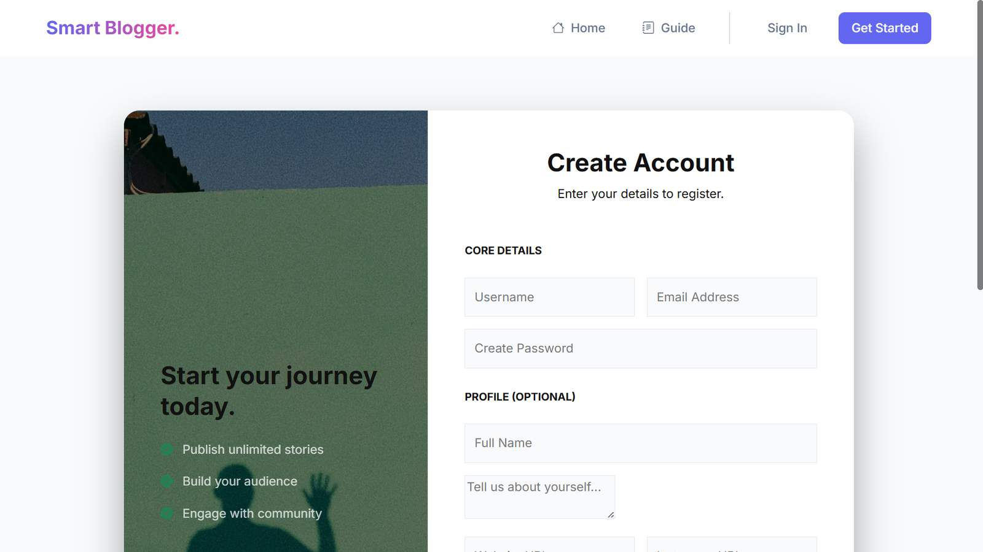
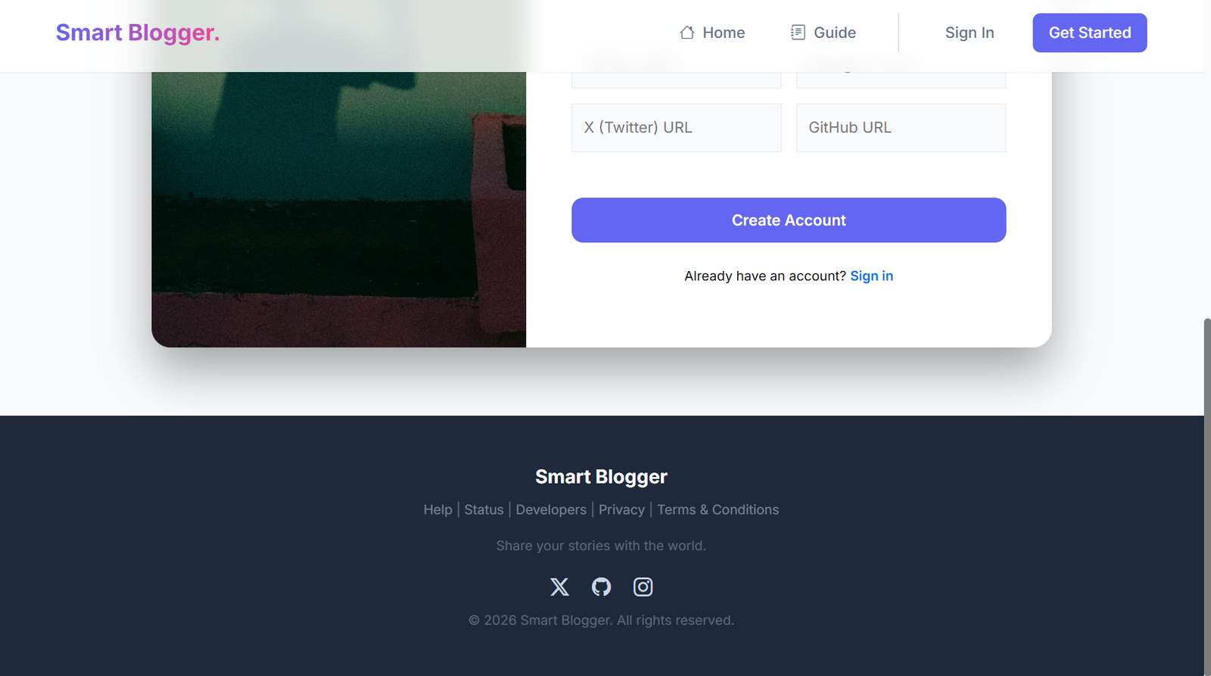
Fig 6.1: Create Account Page

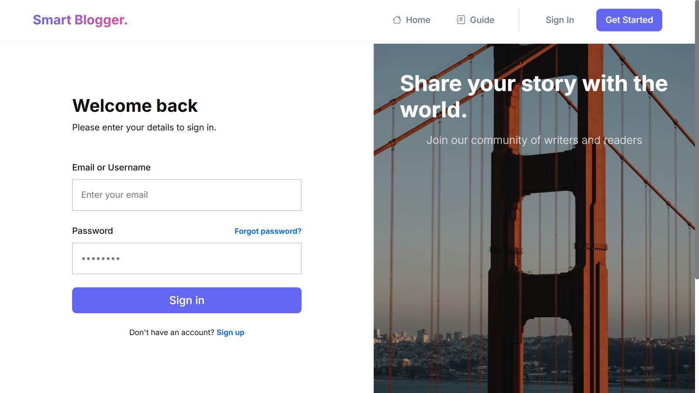
Fig 6.2: User Sign-In Page
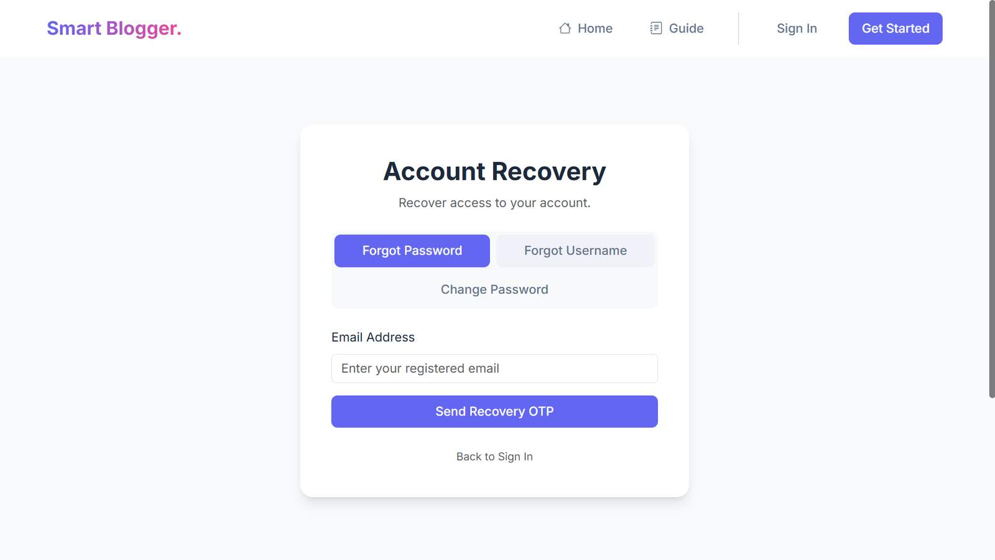
Fig 6.3: Account Recovery – Forgot Password
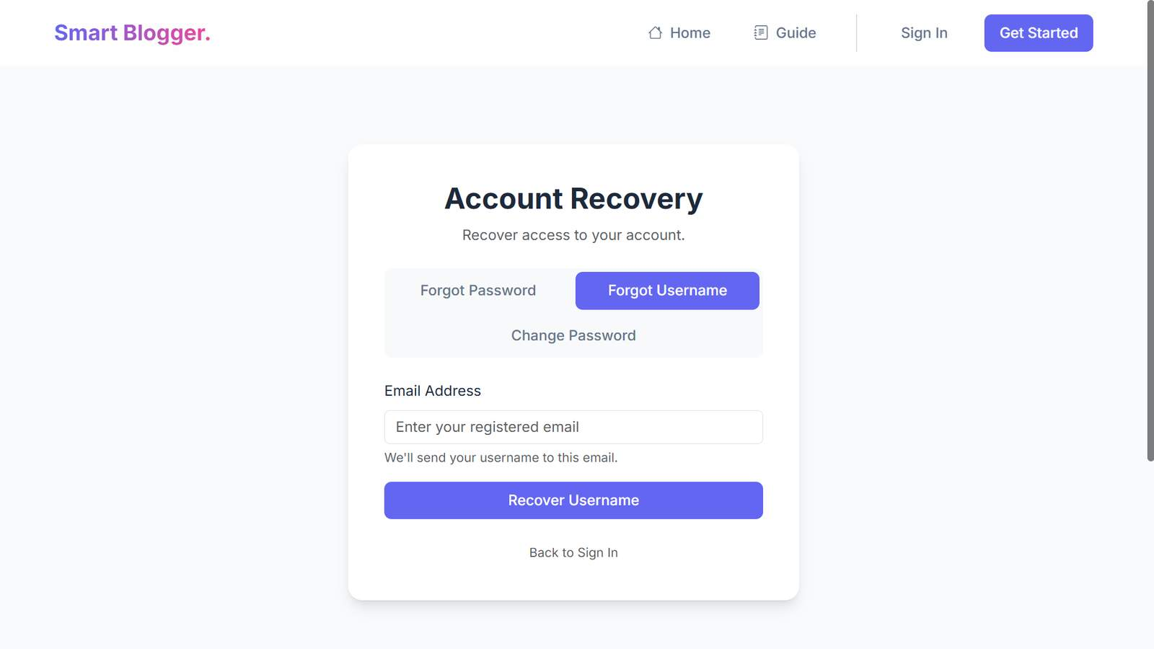
Fig 6.4: Account Recovery – Forgot Username
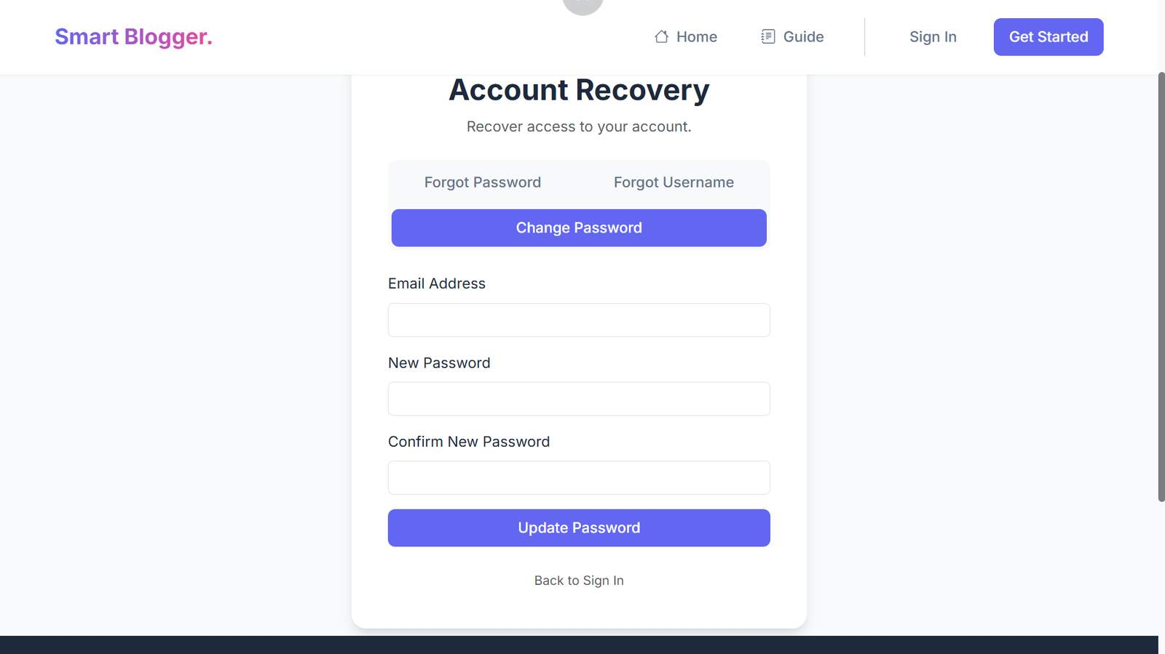
Fig 6.5: Account Recovery – Change Password

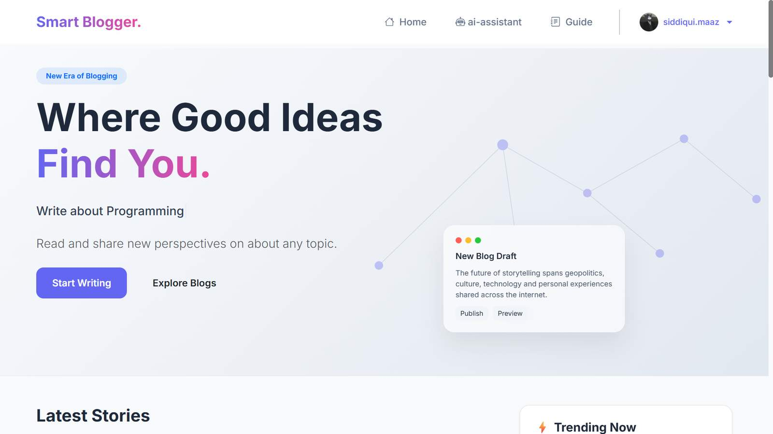
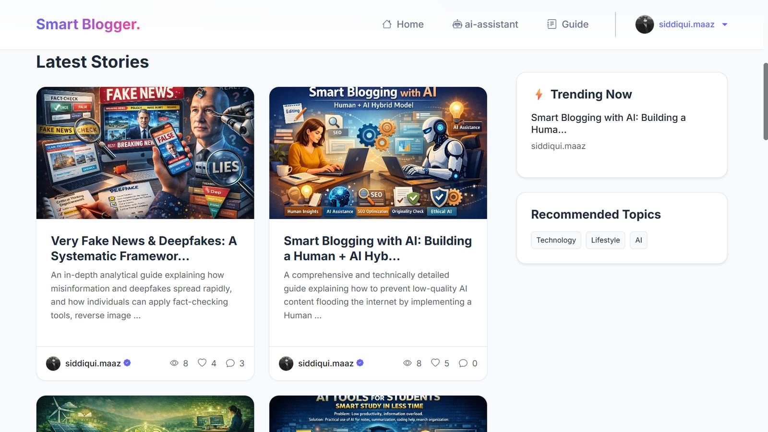

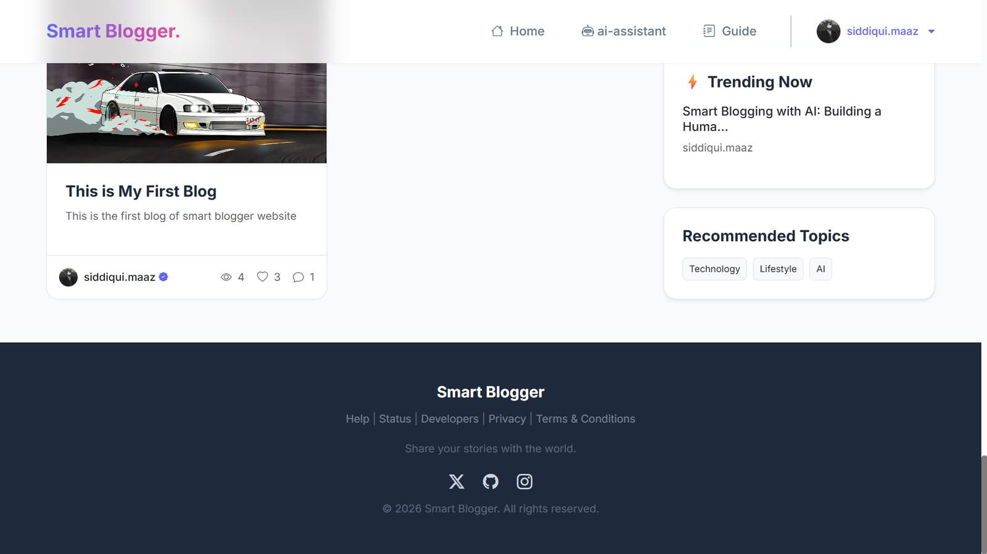
Fig 6.6: SmartBlogger Landing Page
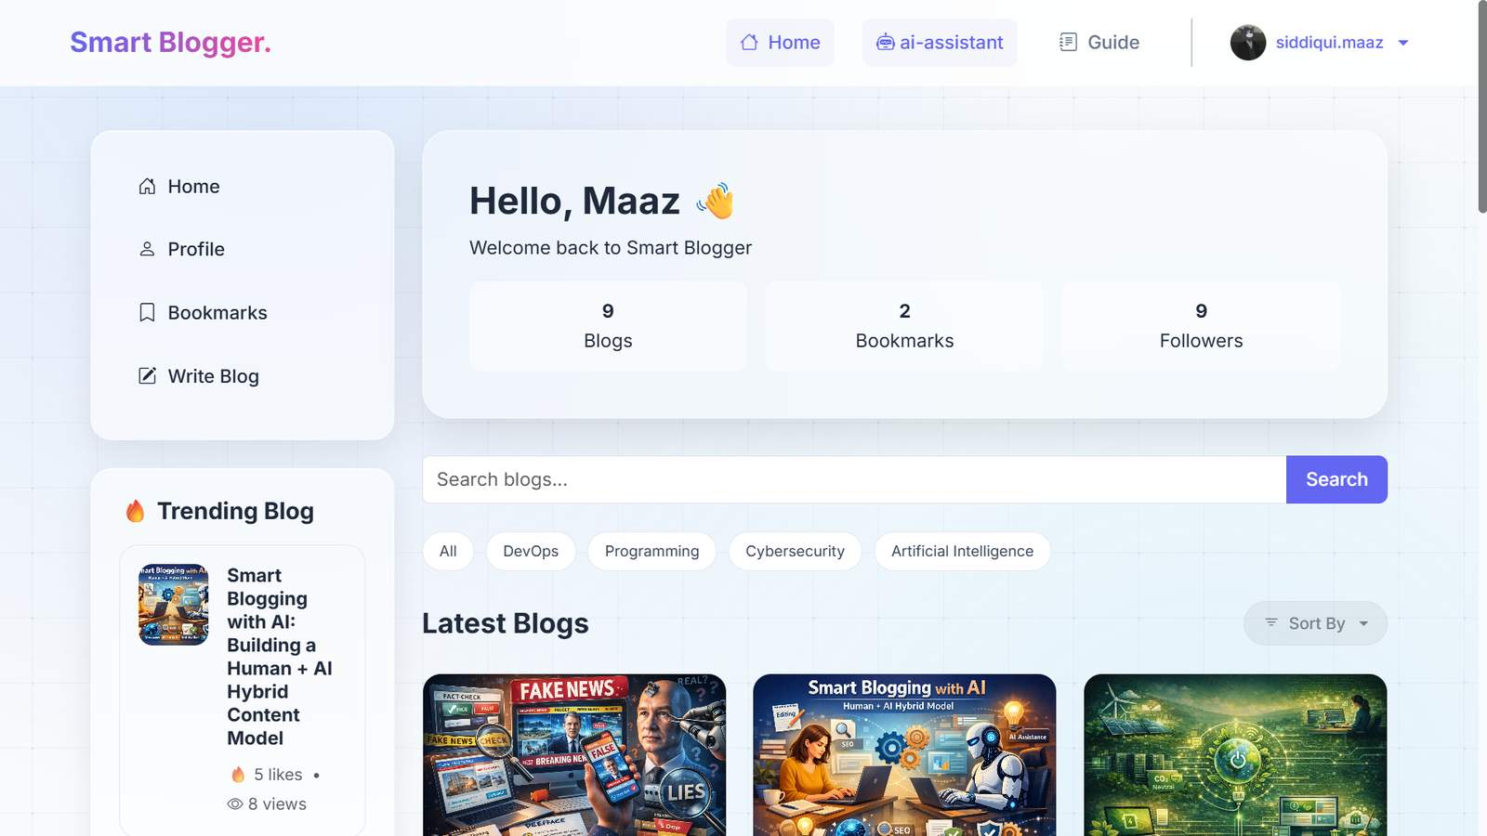
Fig 6.7: Latest Stories and Trending Section
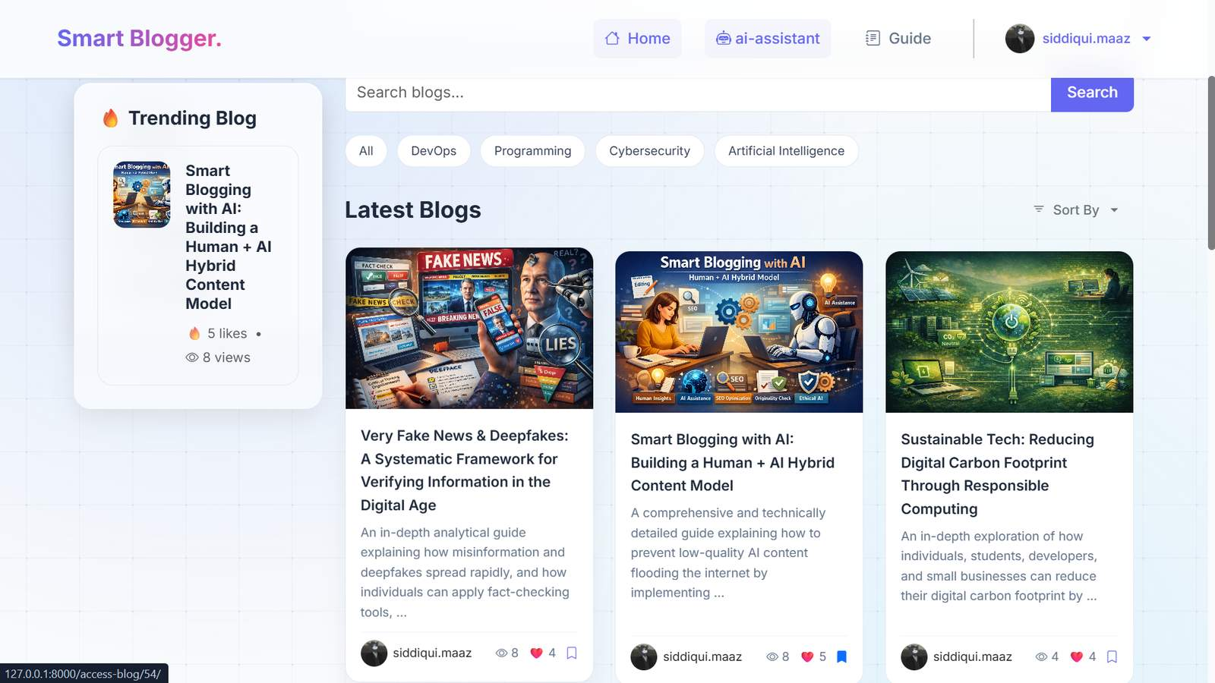
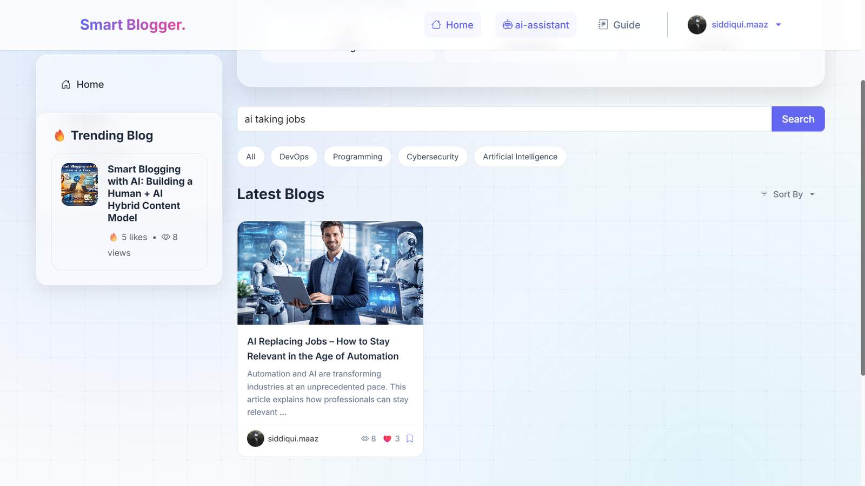

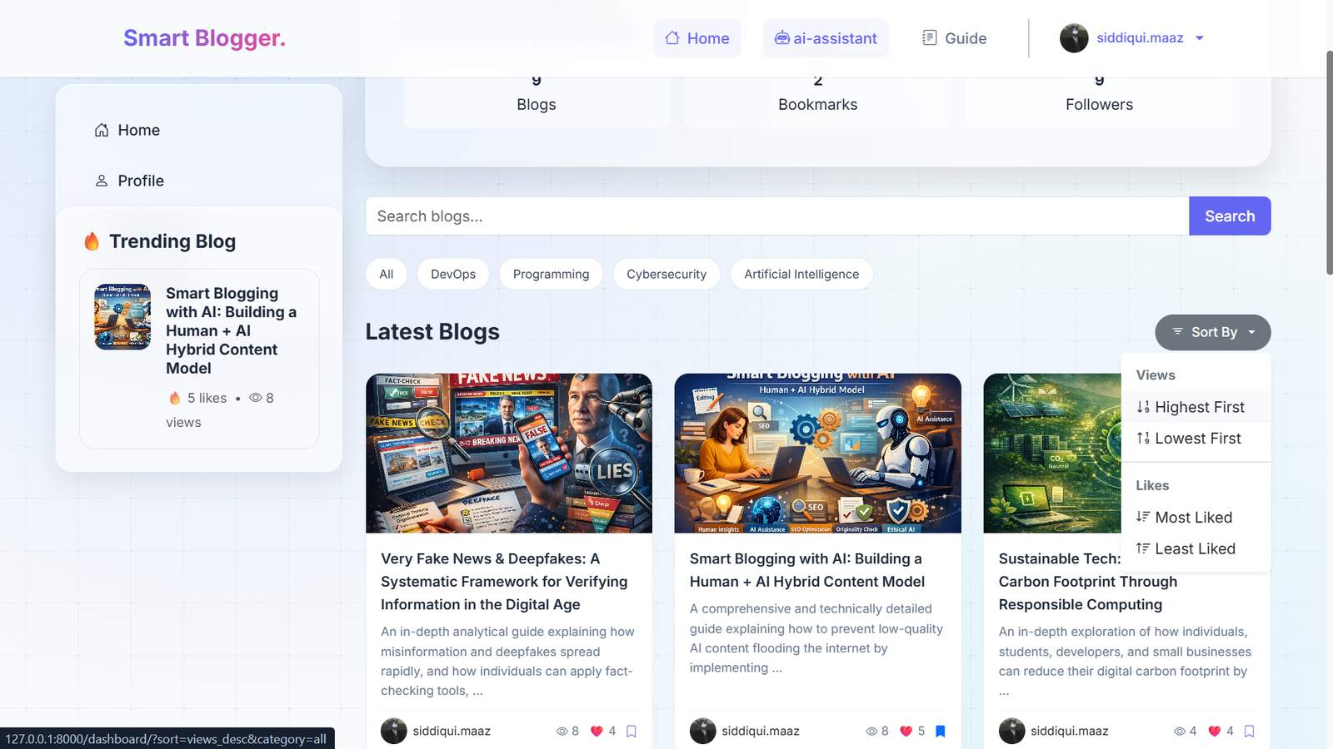
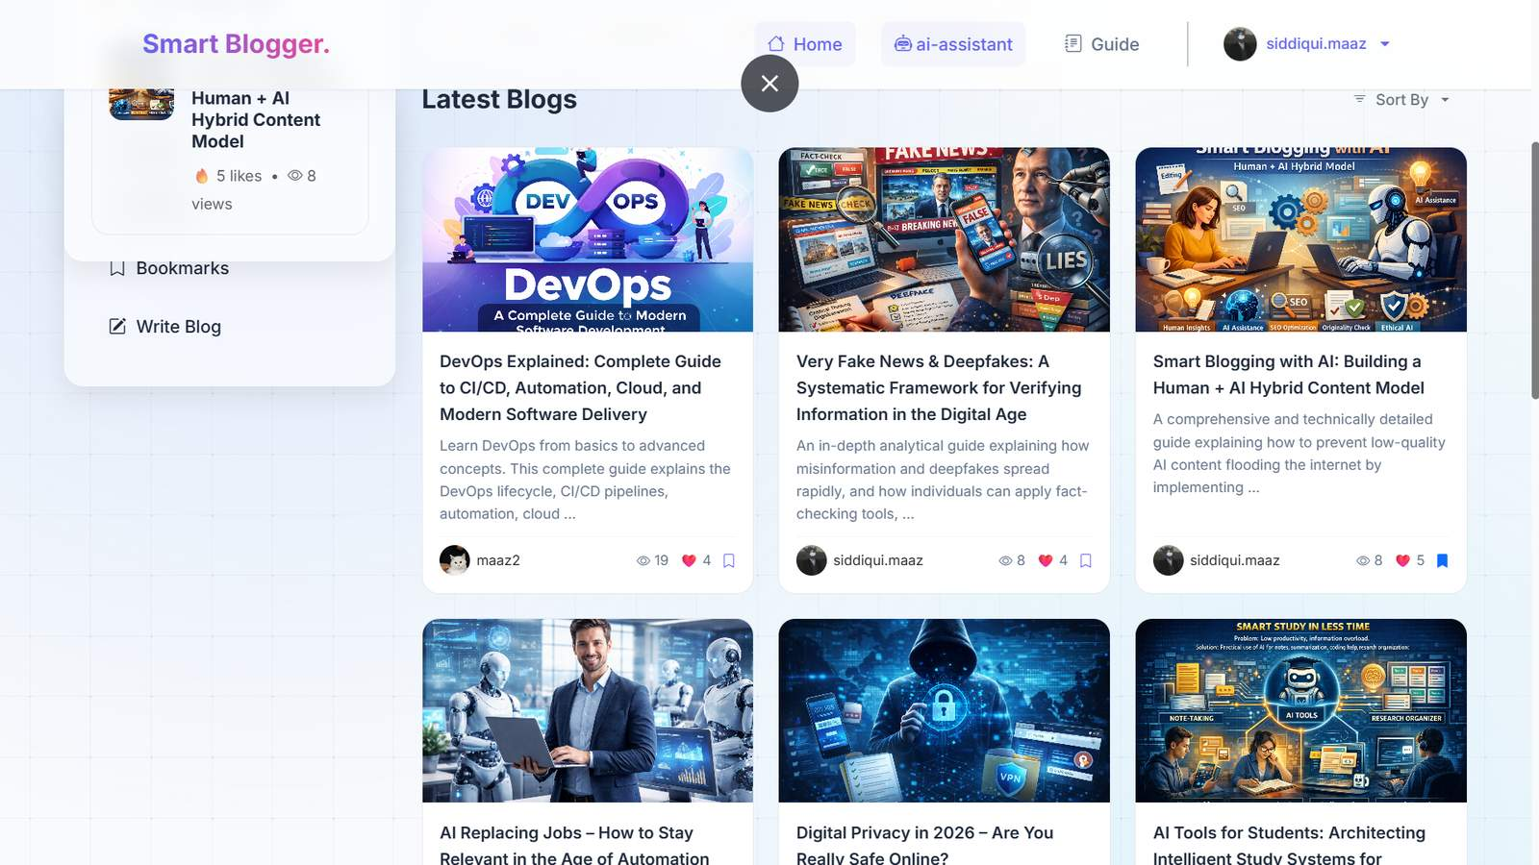
Fig 6.8: Blog Search and Filtering
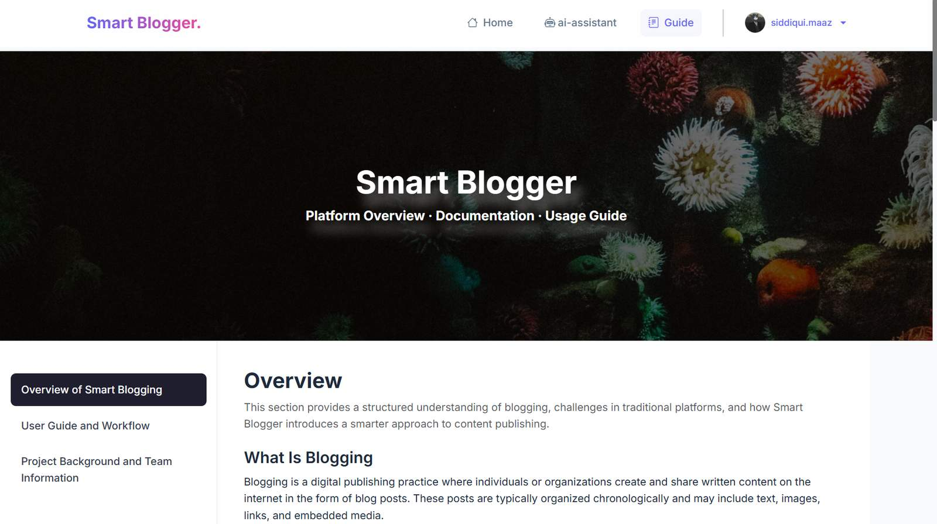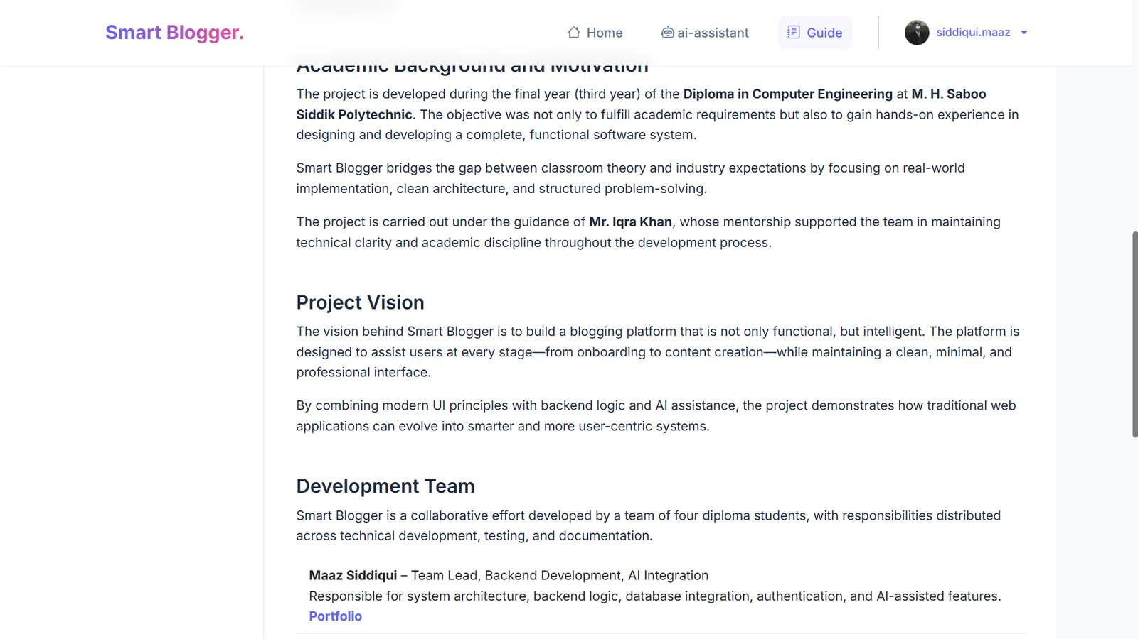
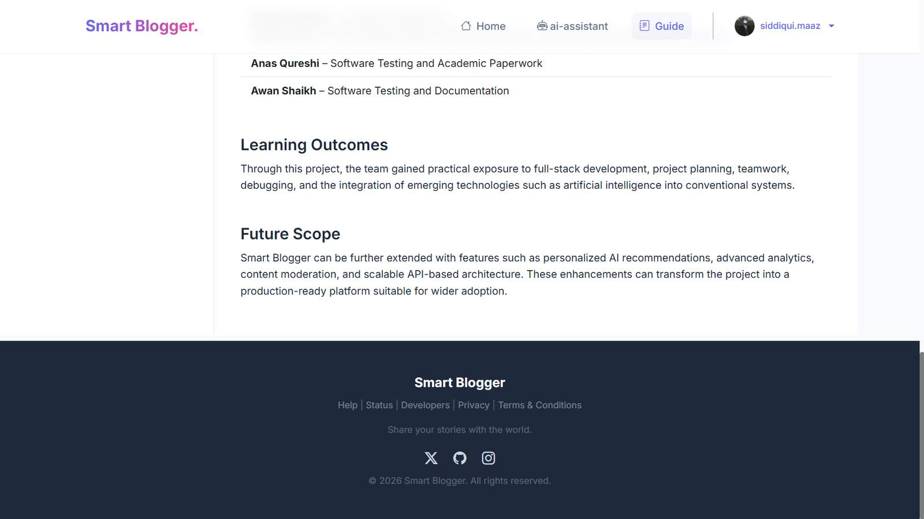
Fig 6.9: User Dashboard Overview
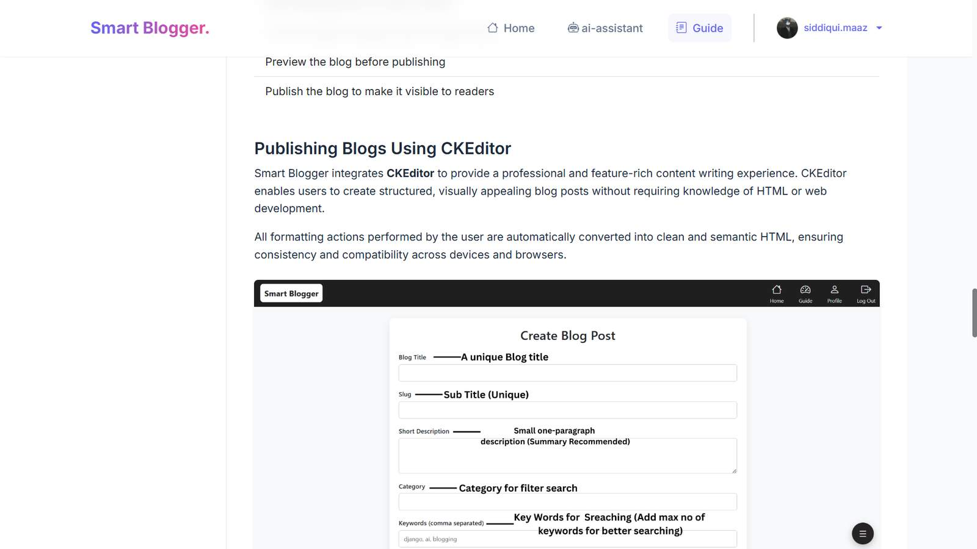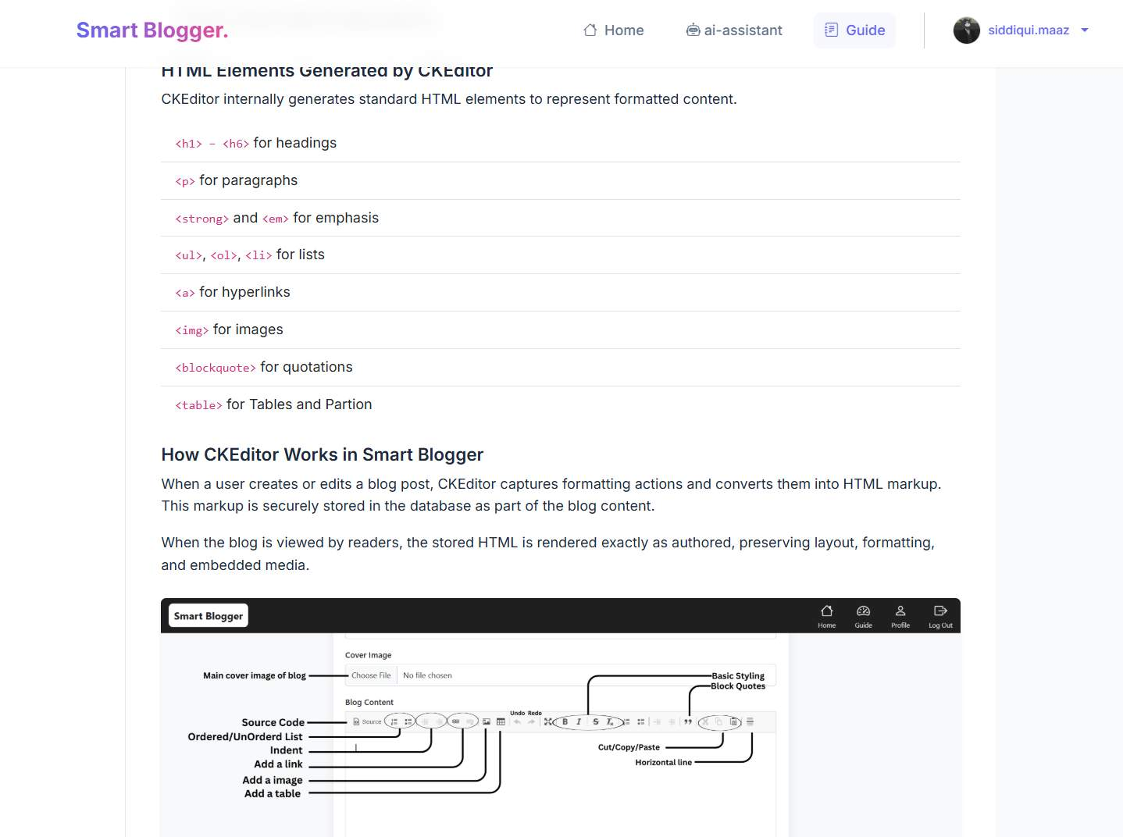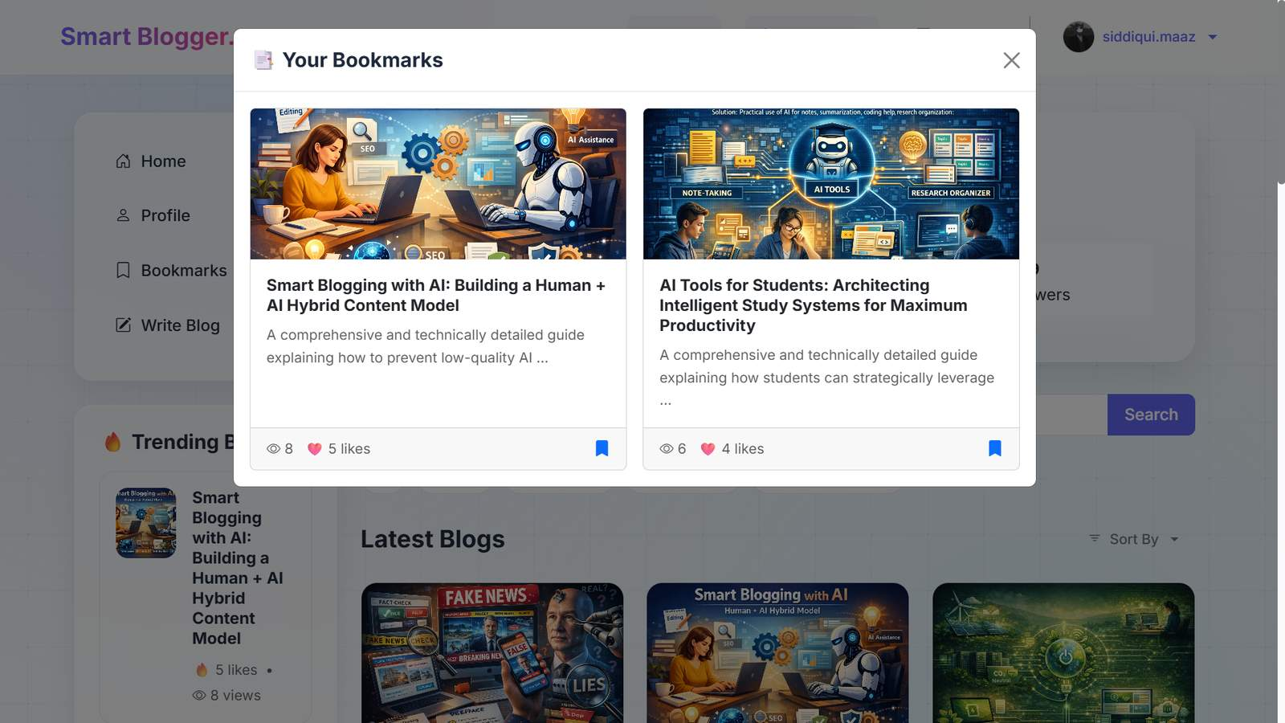
Fig 6.10: User Bookmarks Model

Fig 6.11: Individual Blog Post View
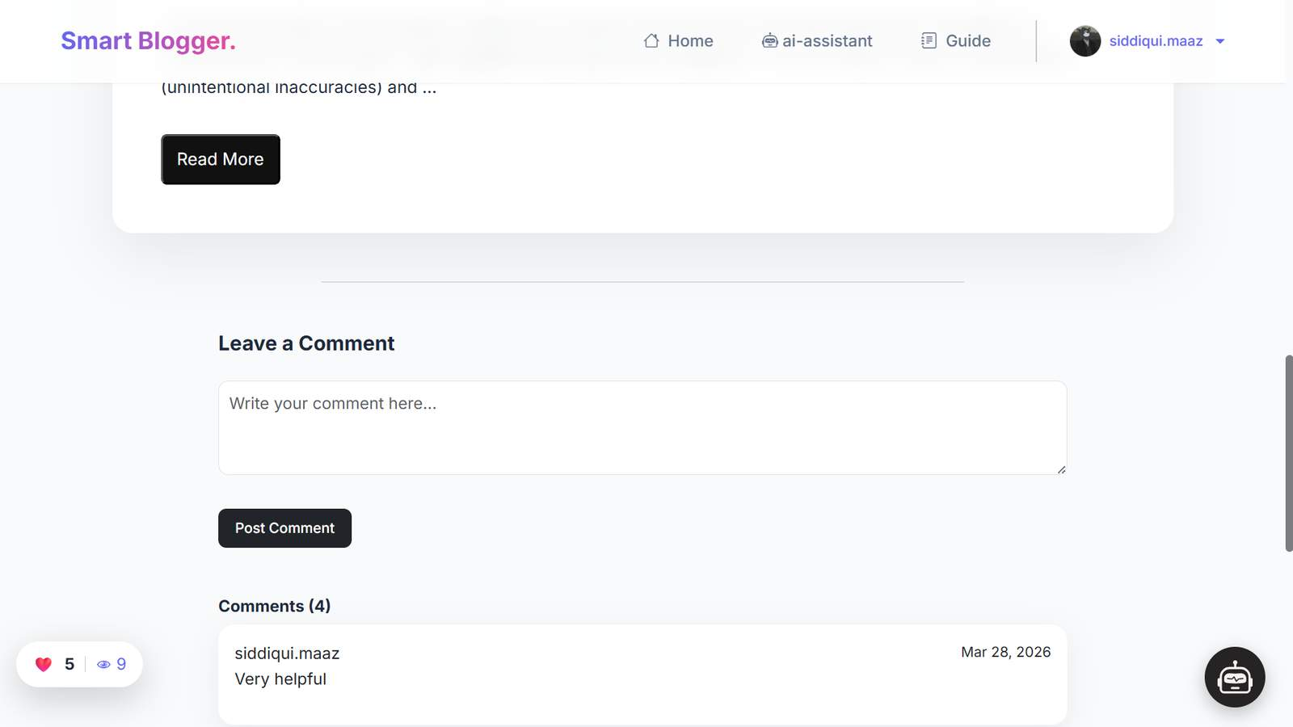
Fig 6.12: Comments Section

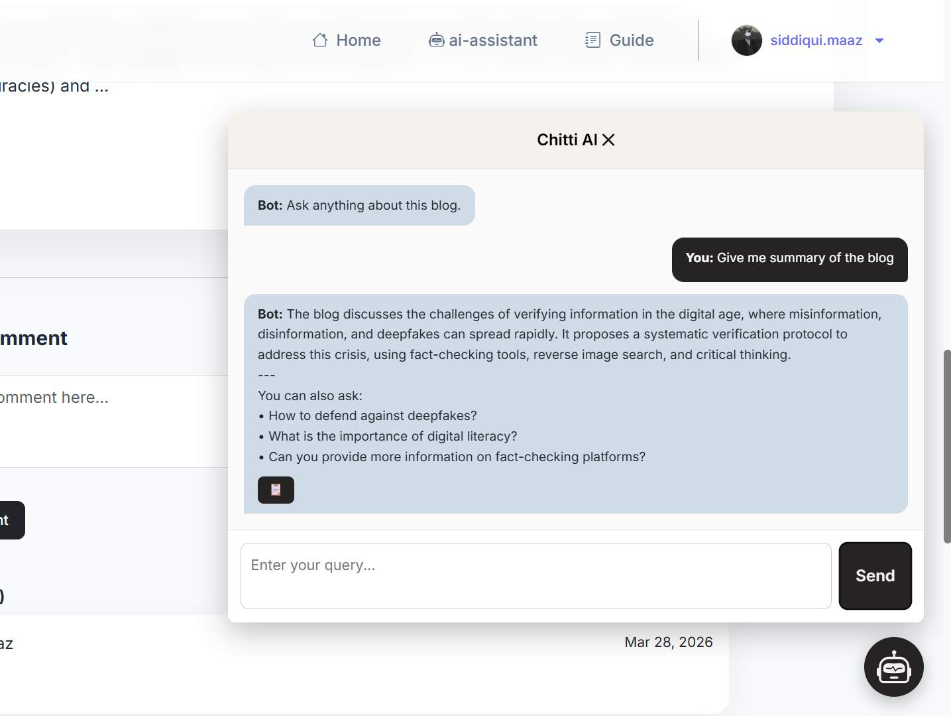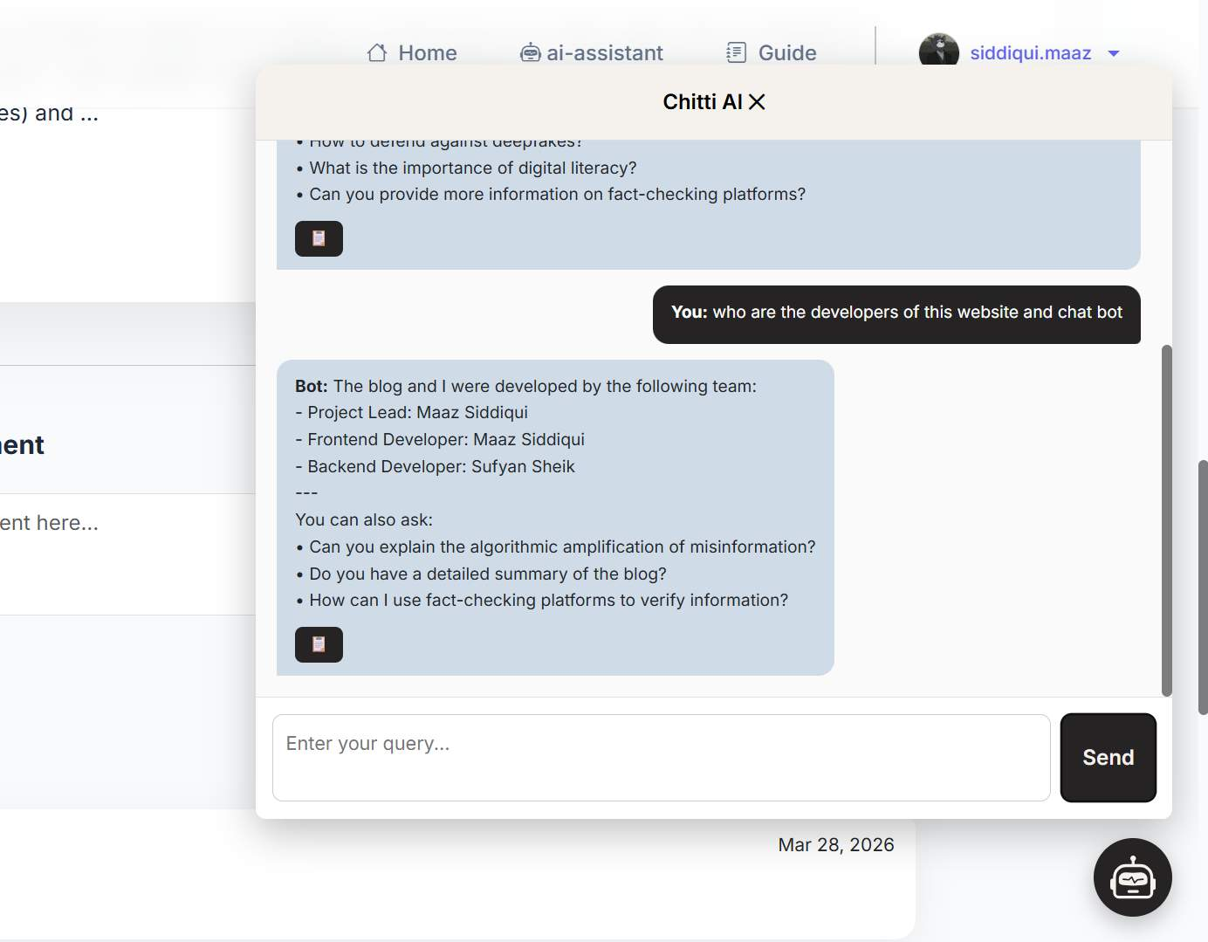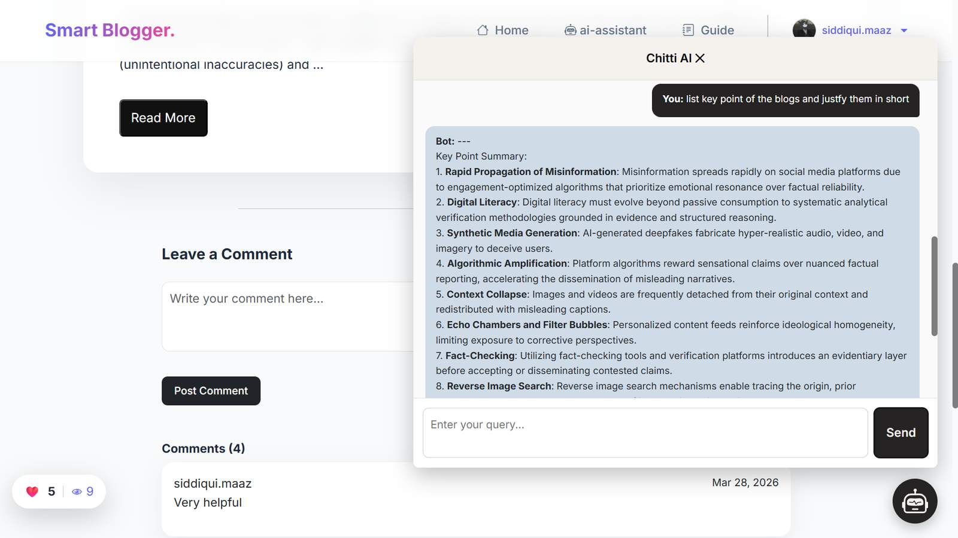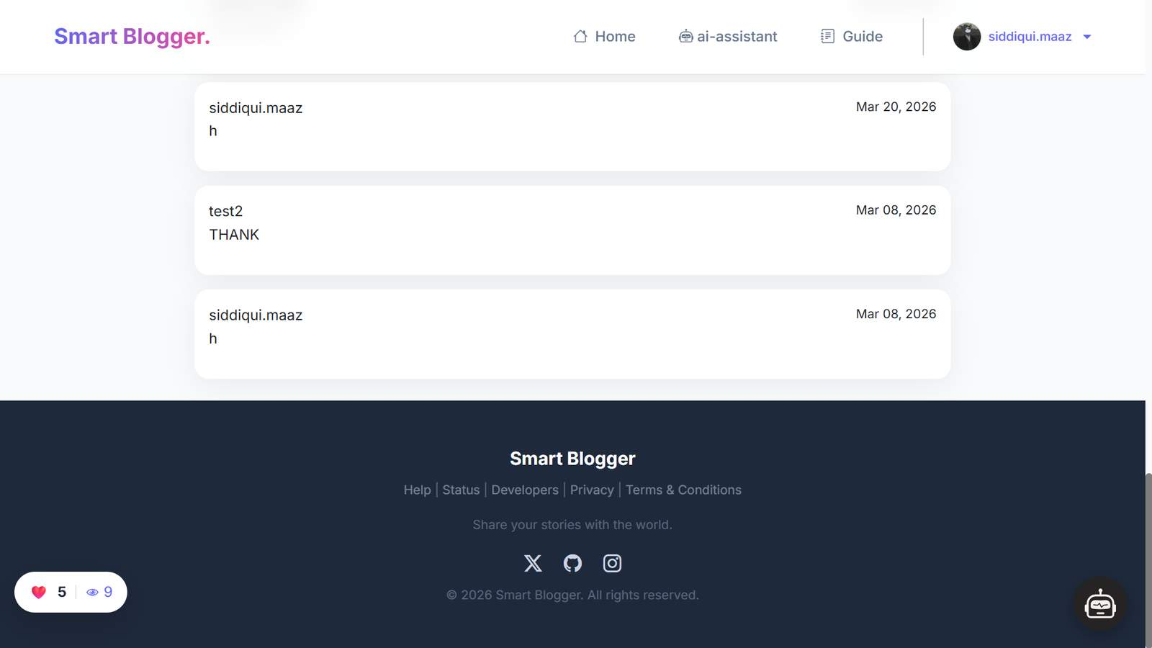
Fig 6.13: Chitti AI Chatbot Integration
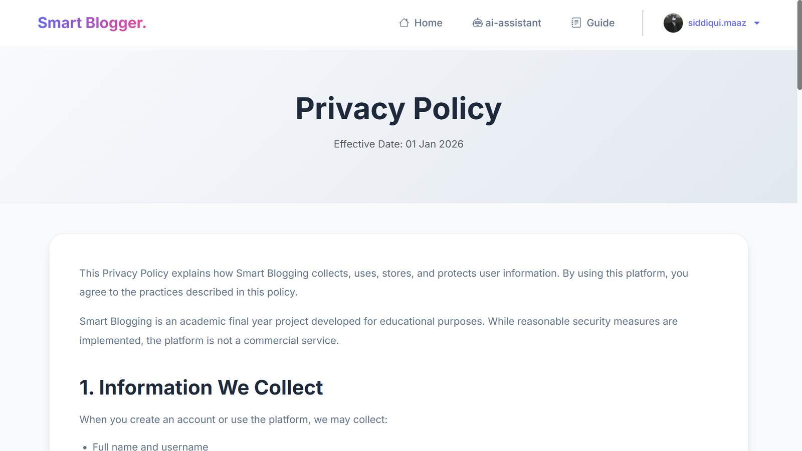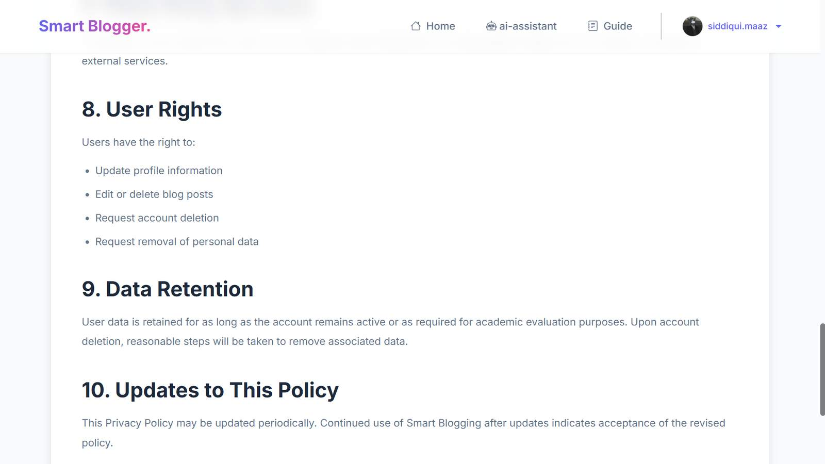
Fig 6.14: Privacy Policy Page
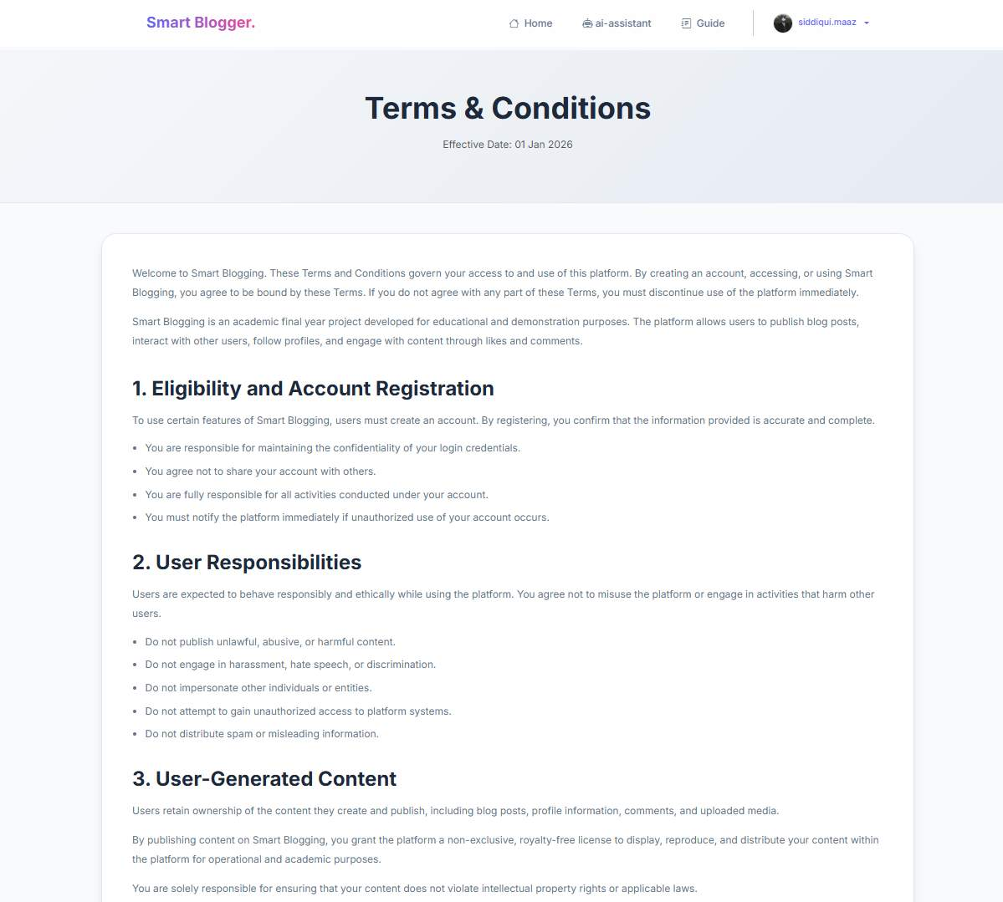
Fig 6.15: Terms & Conditions Page
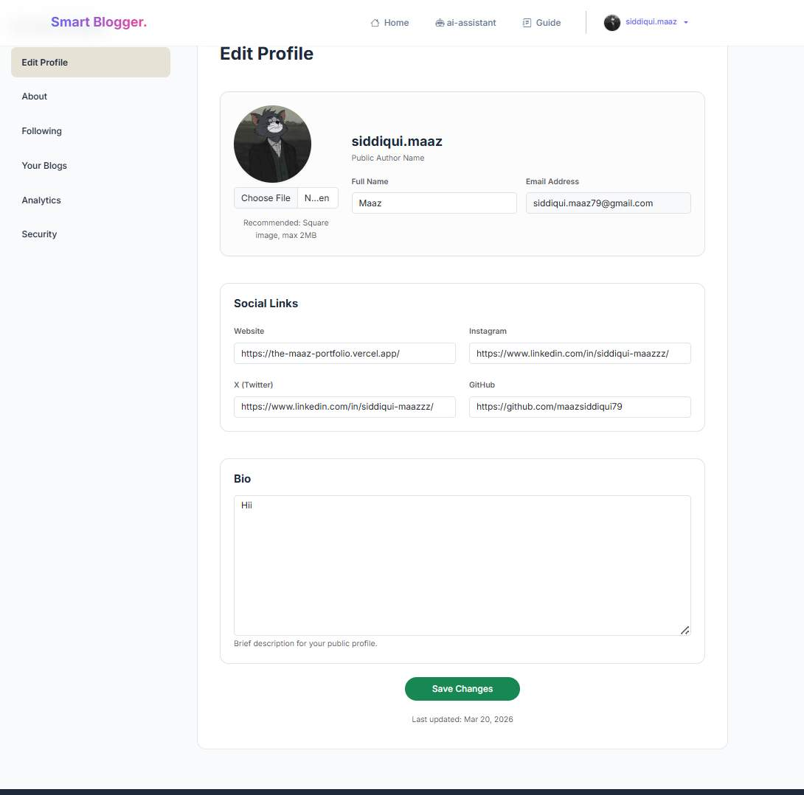
Fig 6.16: Edit User Profile Settings
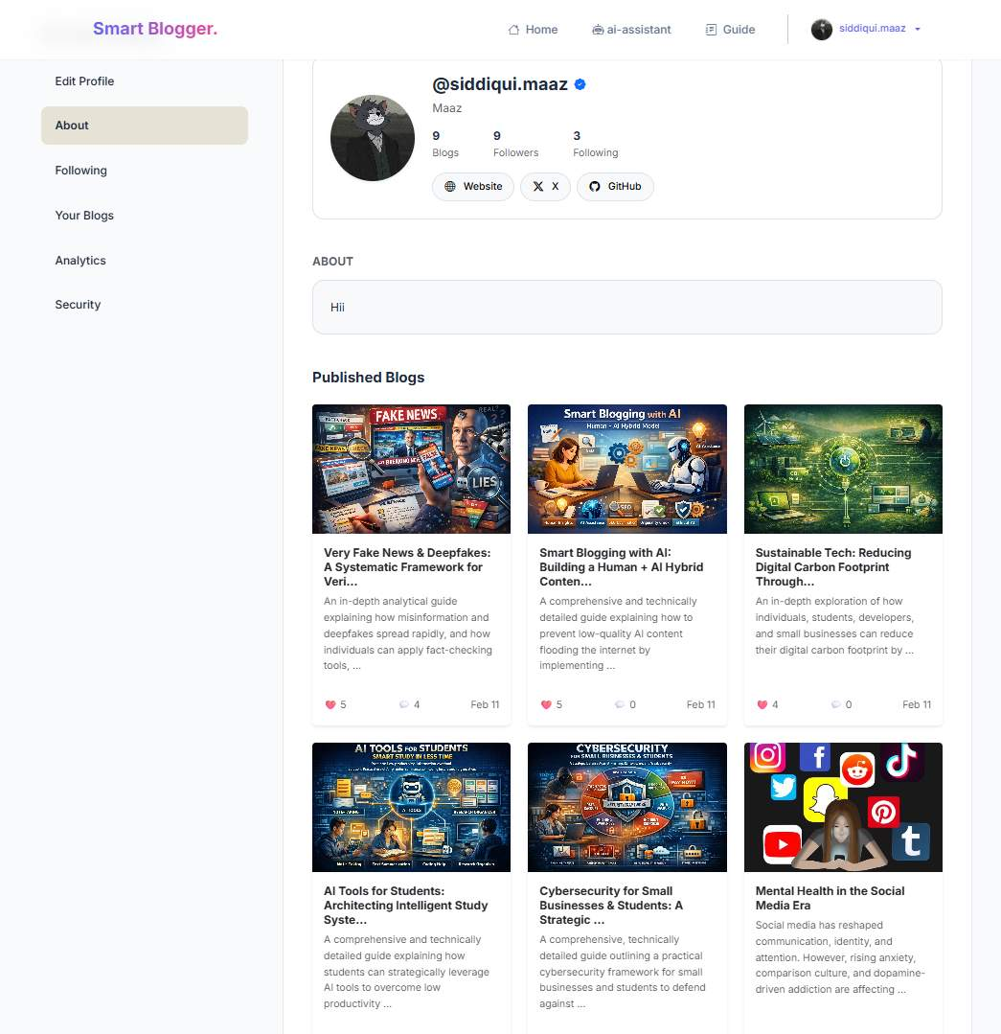
Fig 6.17: Public Author Profile
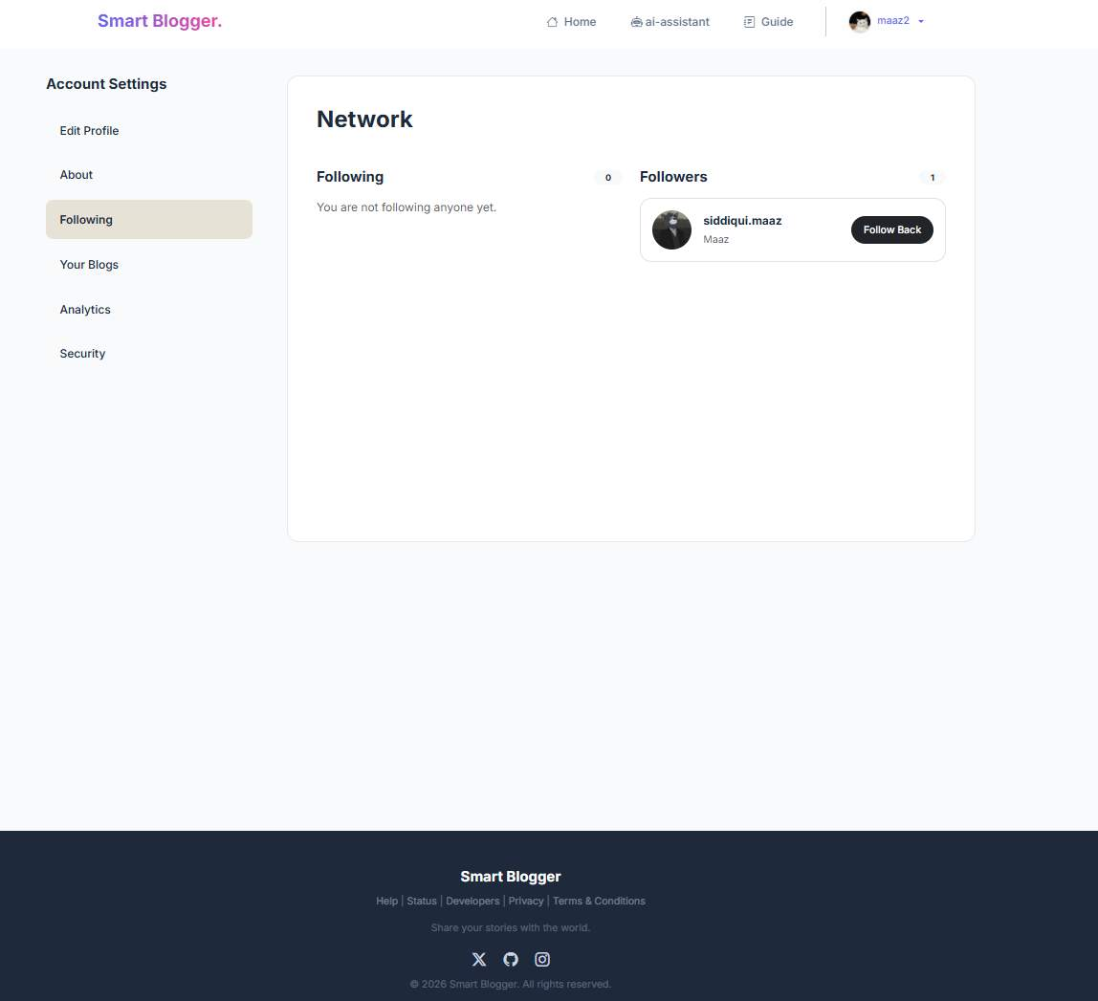

• 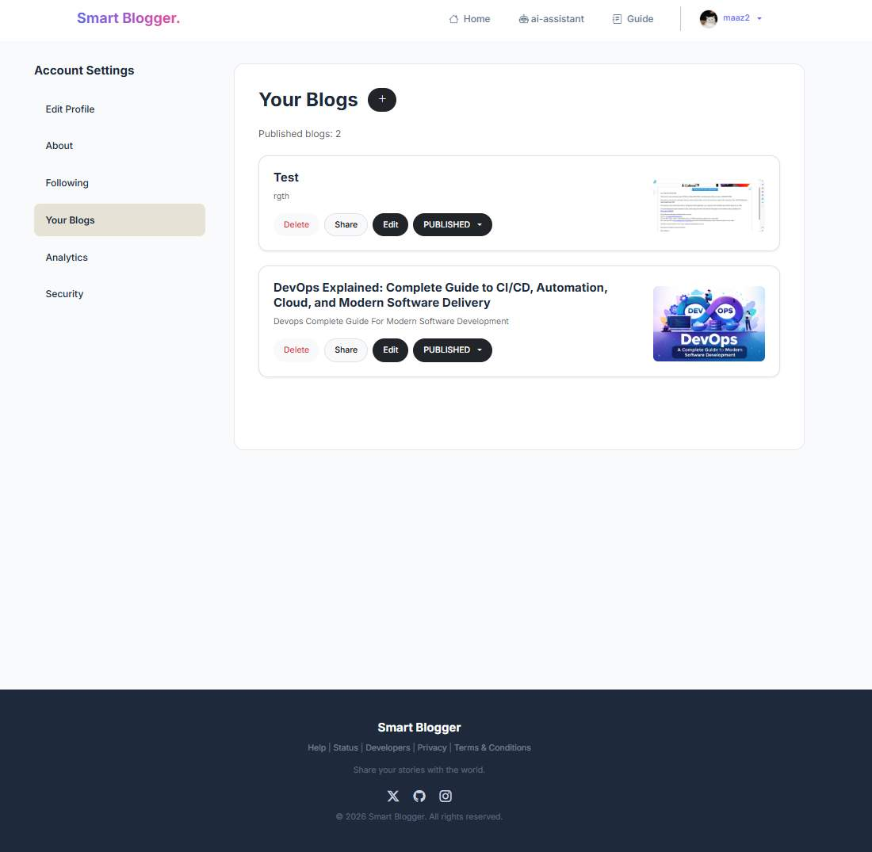

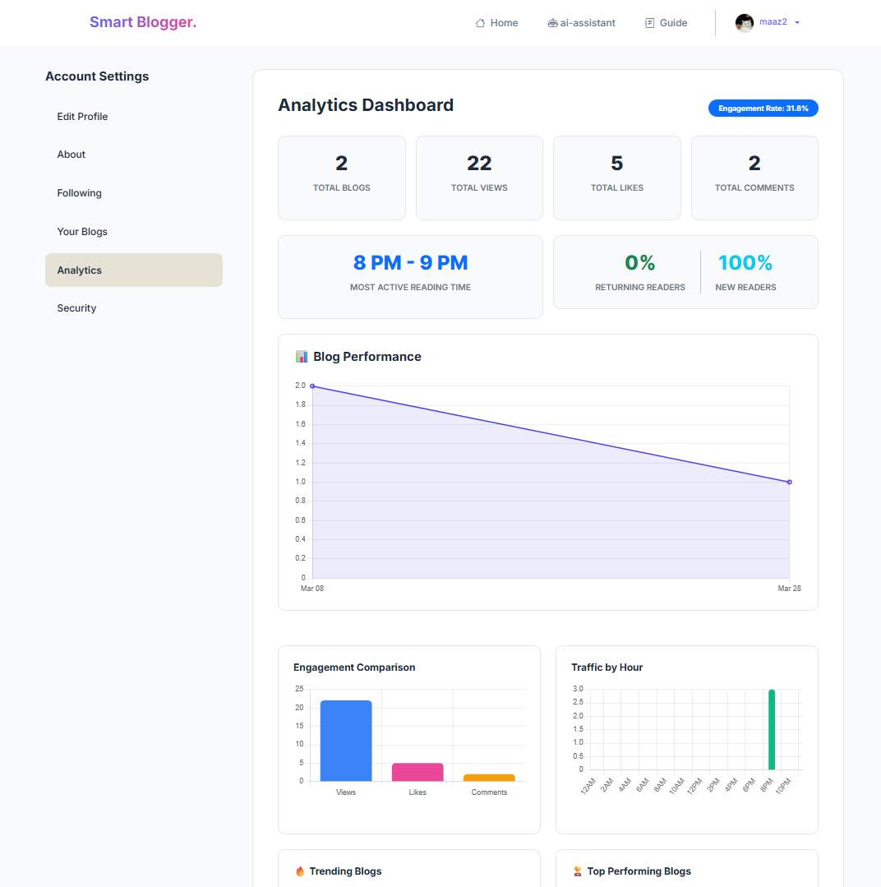

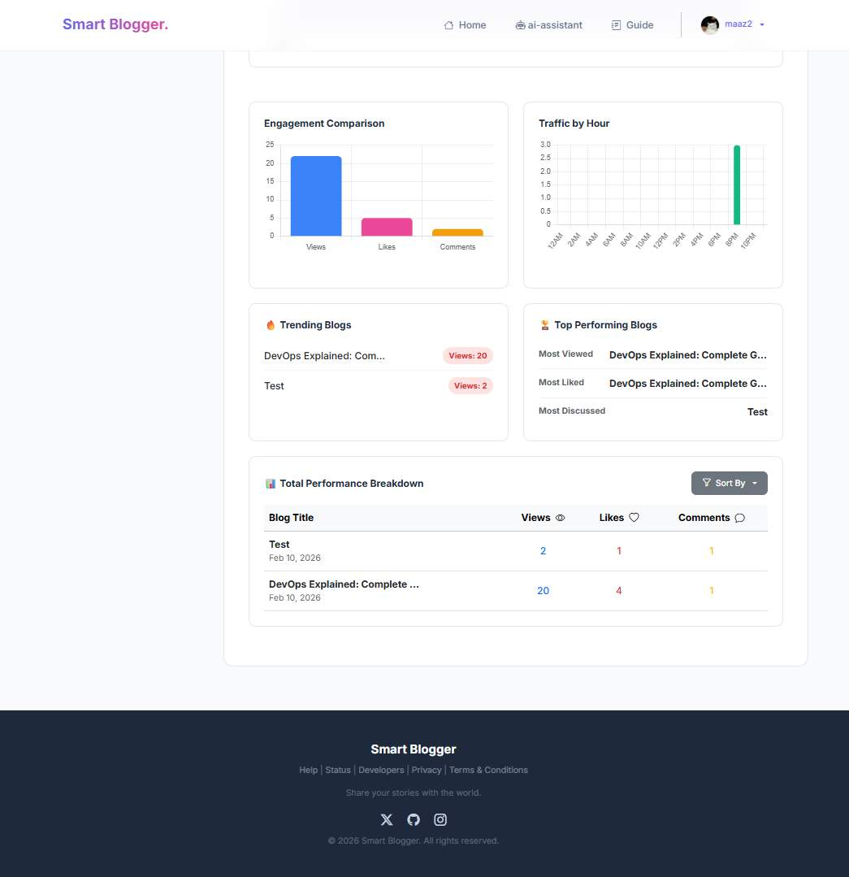
Fig 6.18: User Analytics Dashboard
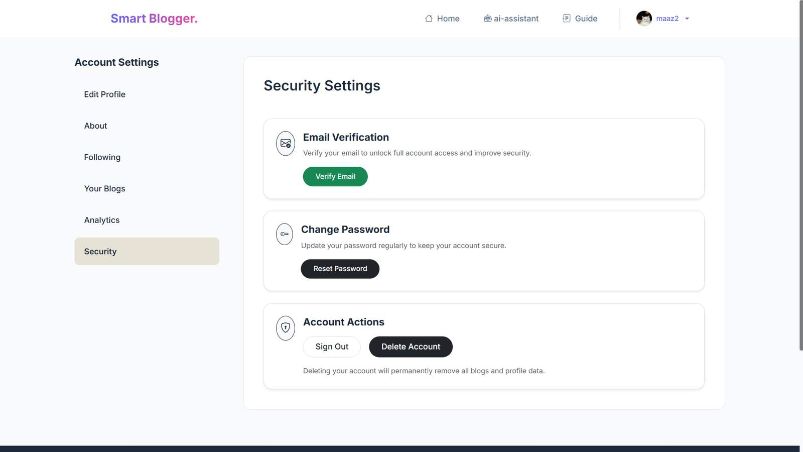

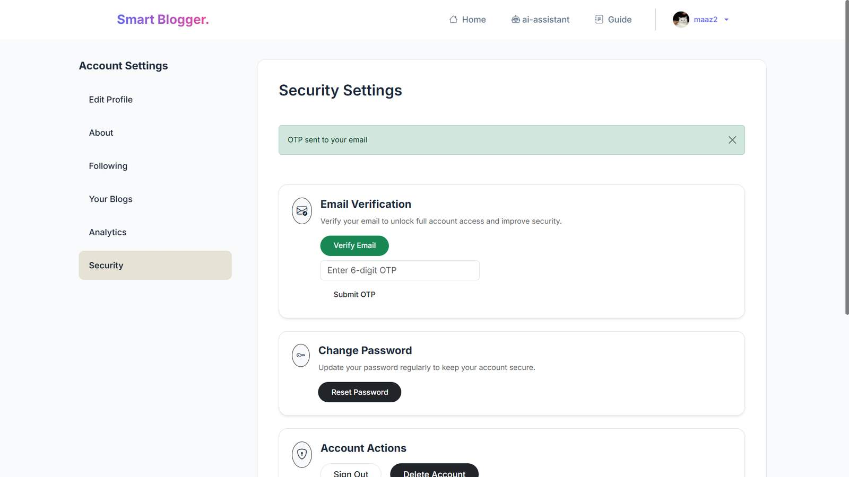
Fig 6.19: Security Settings and Email Verification
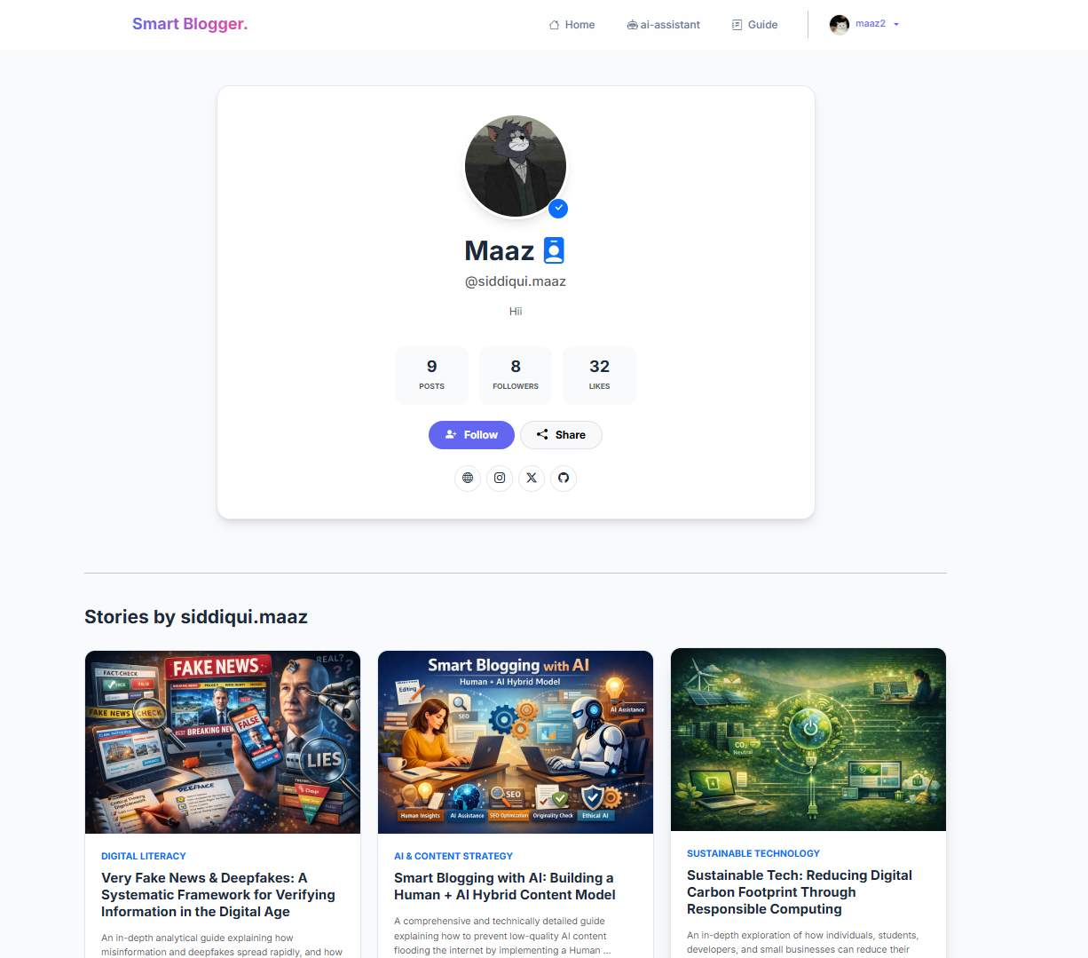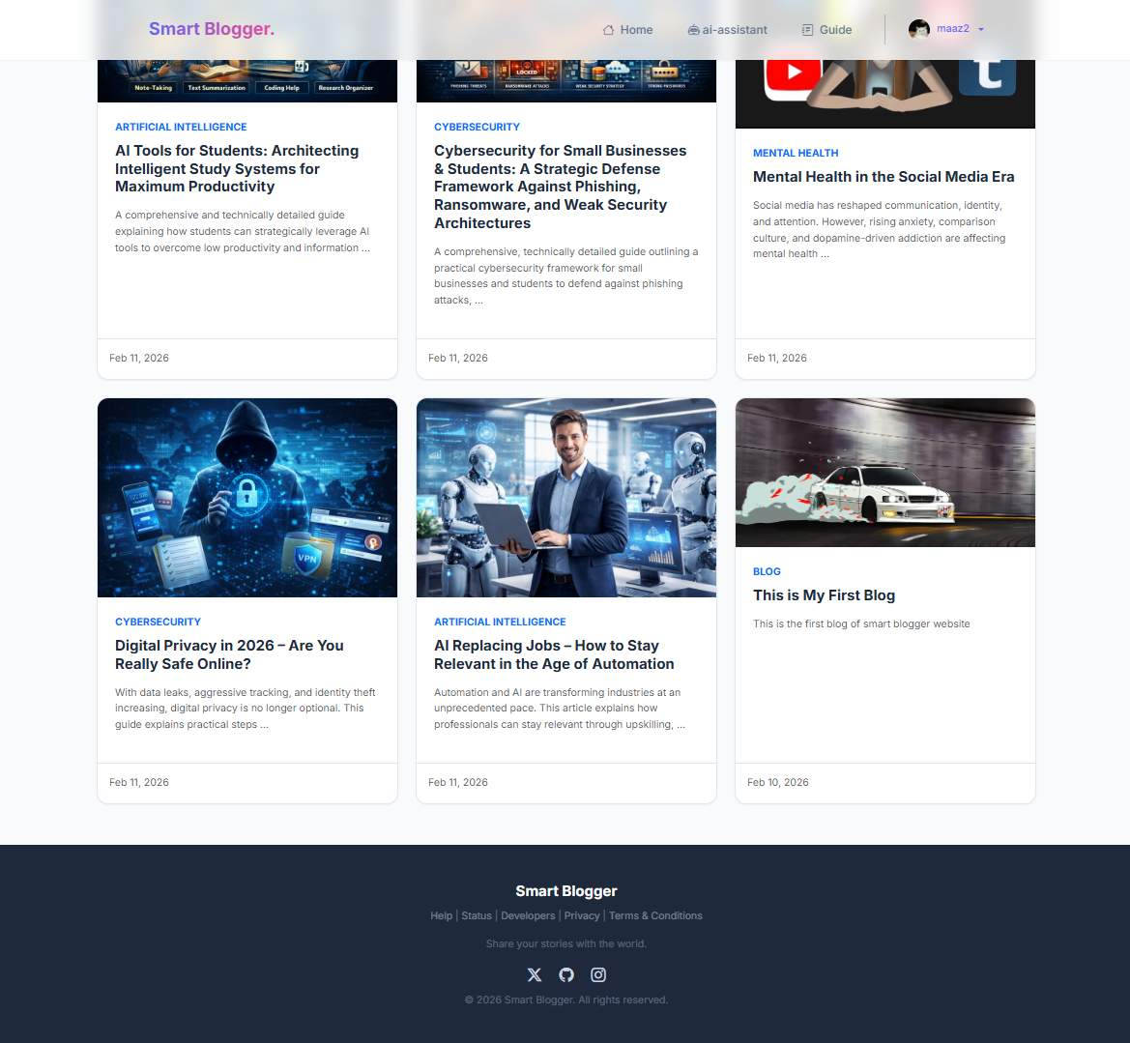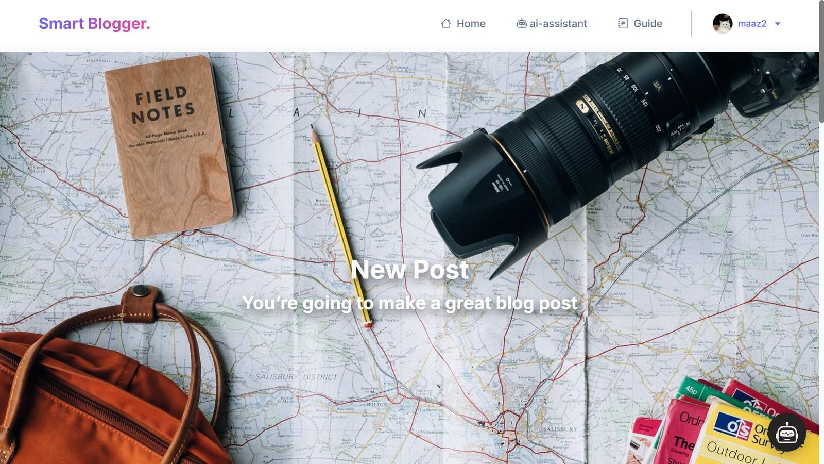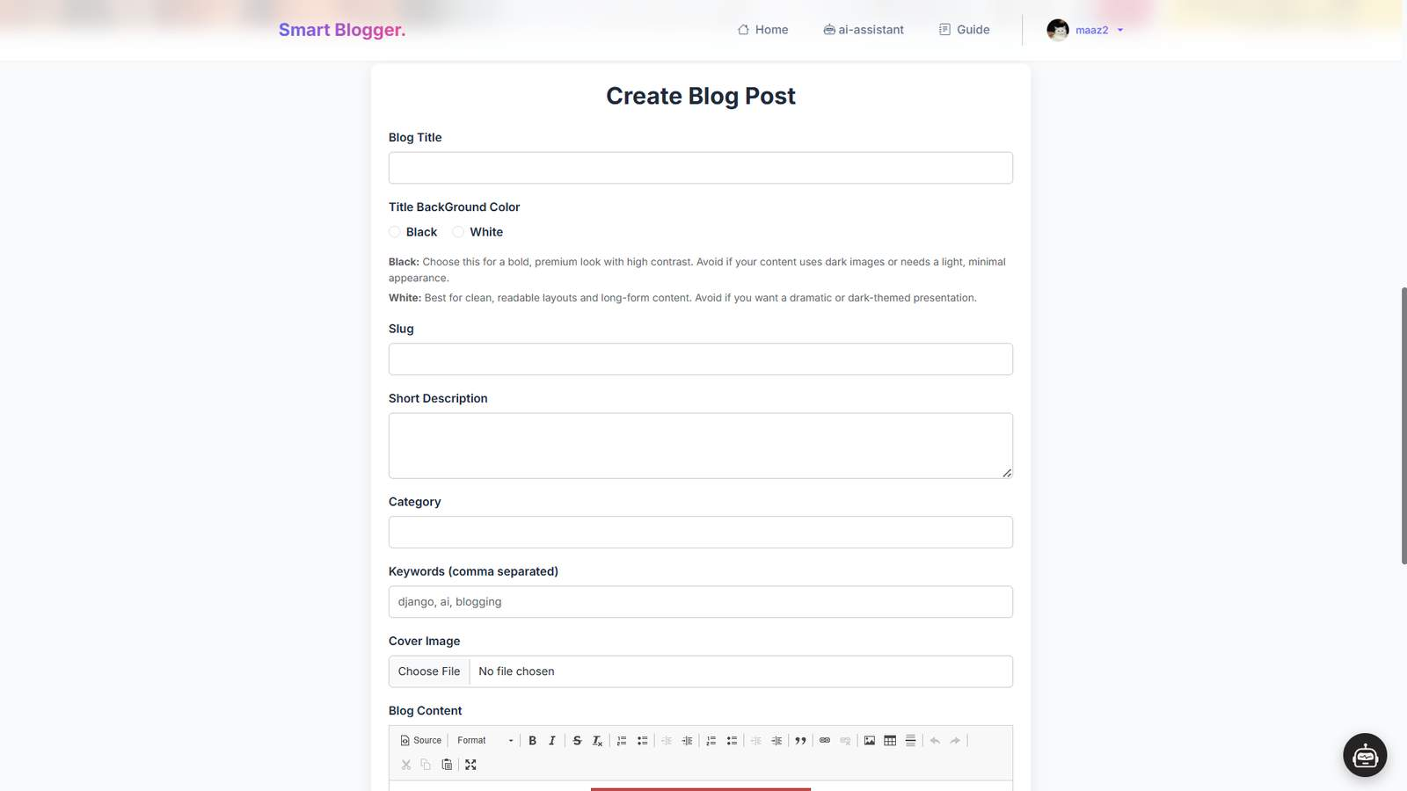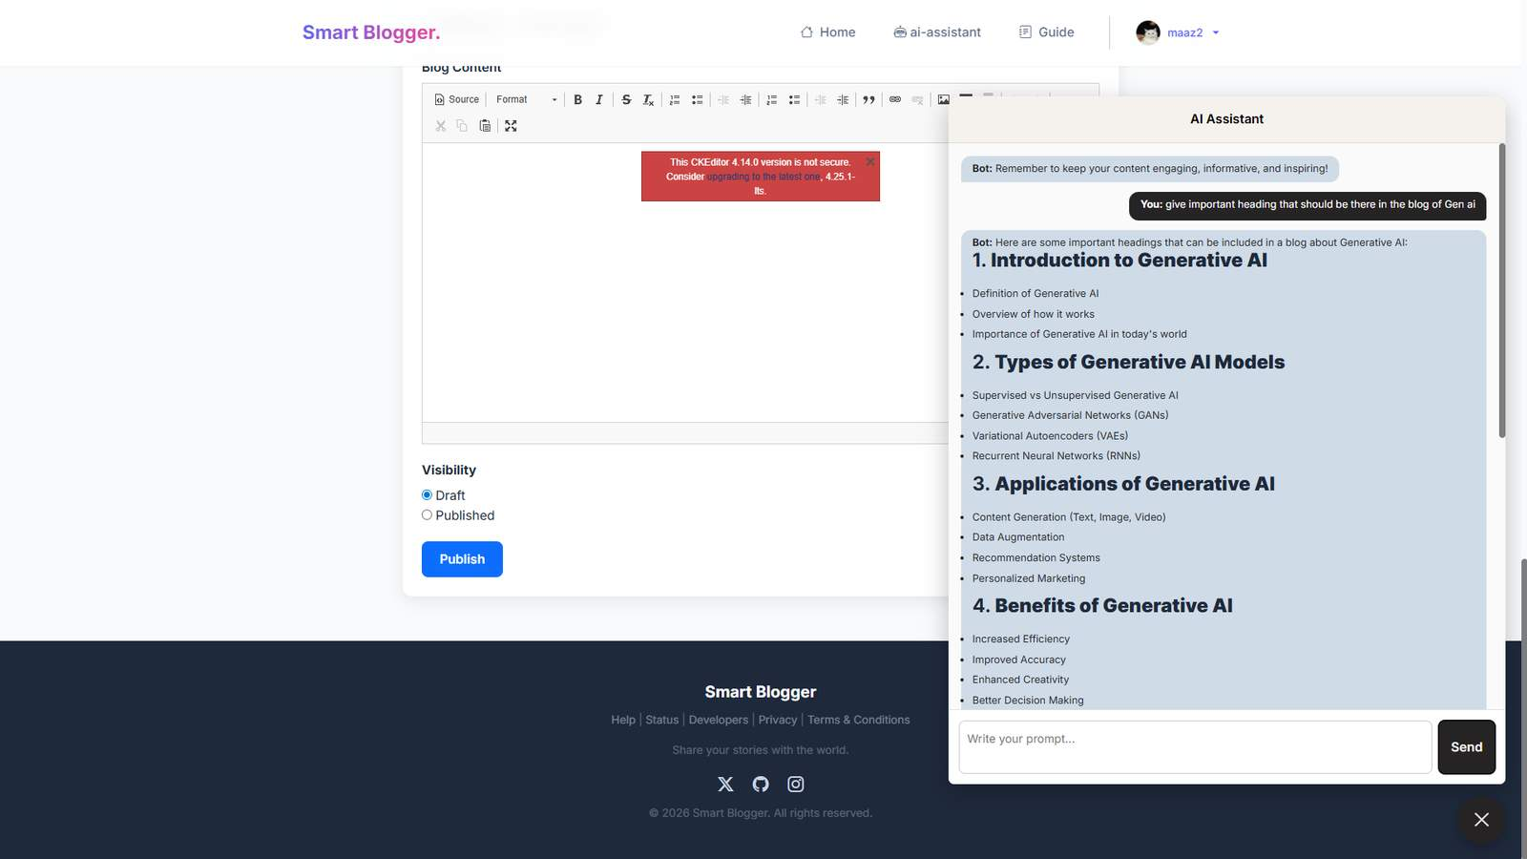
Fig 6.20: Create Blog Post Interface with CKEditor
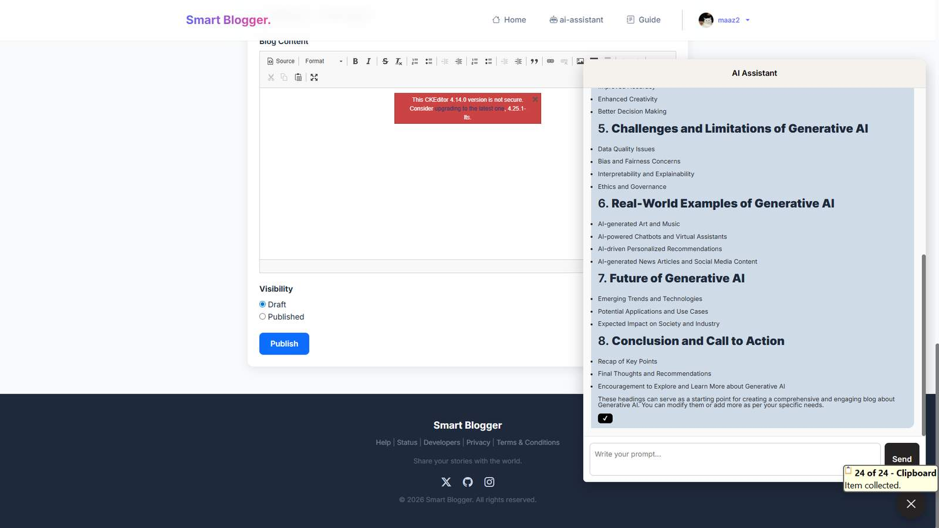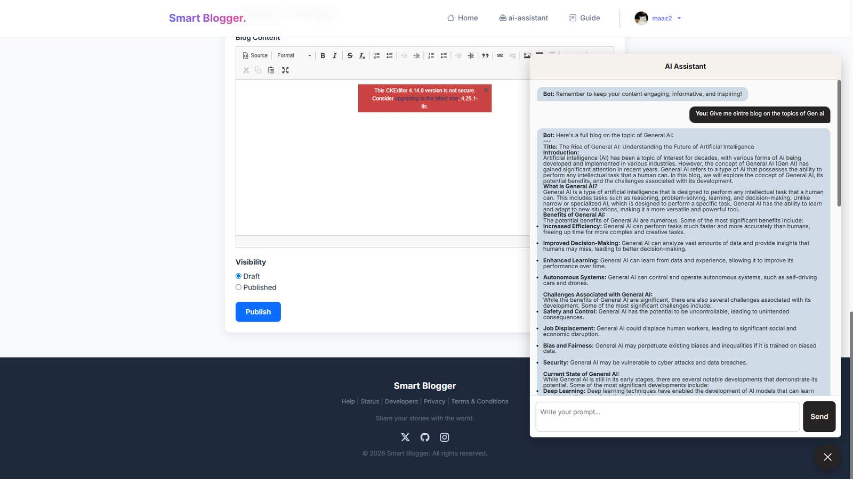

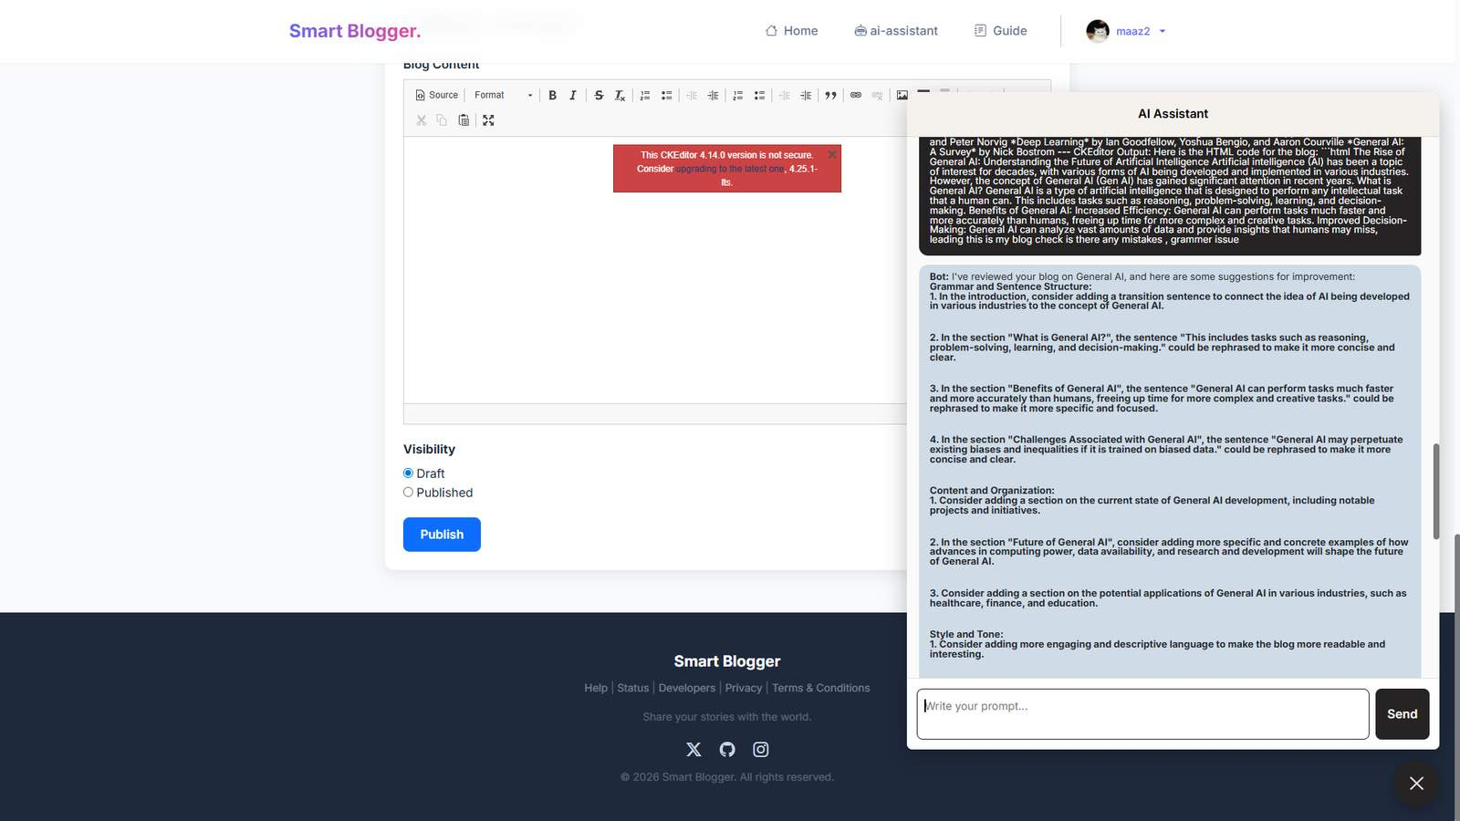
Fig 6.21: AI Assistant Content Suggestions
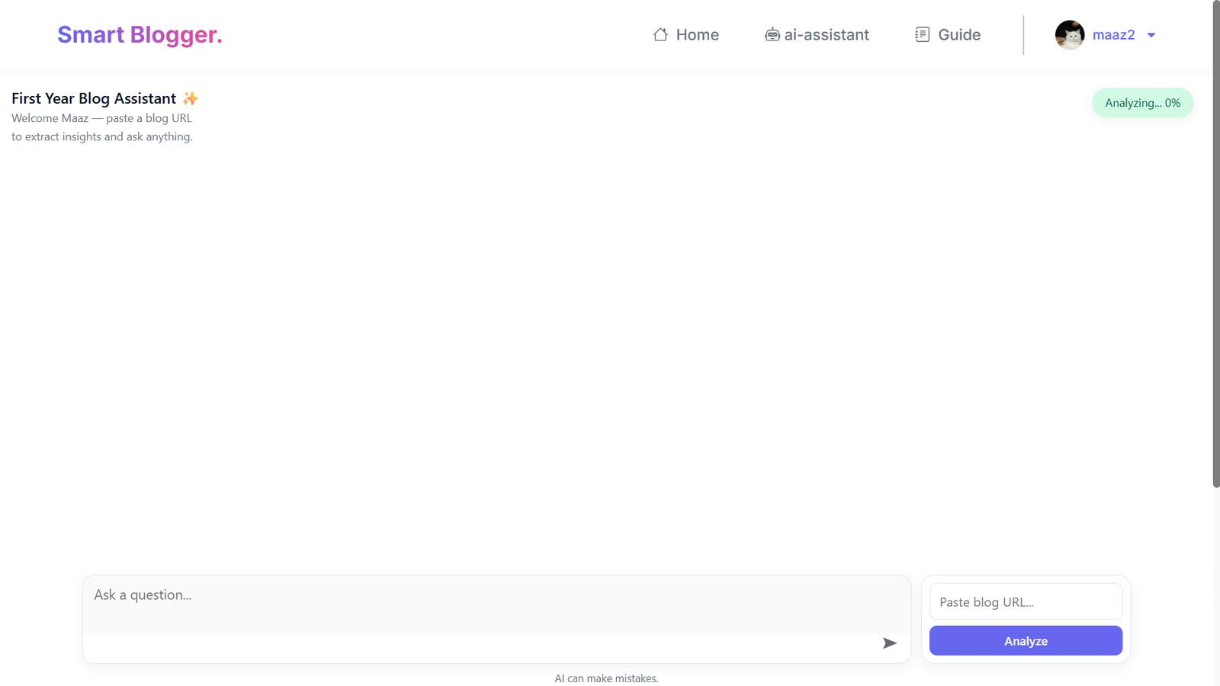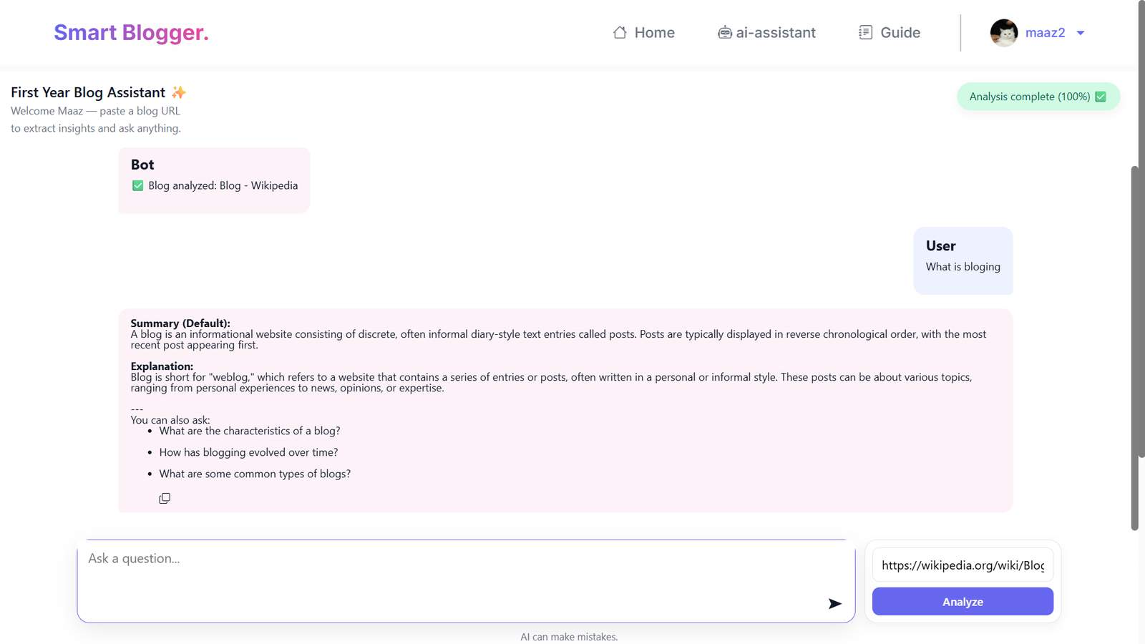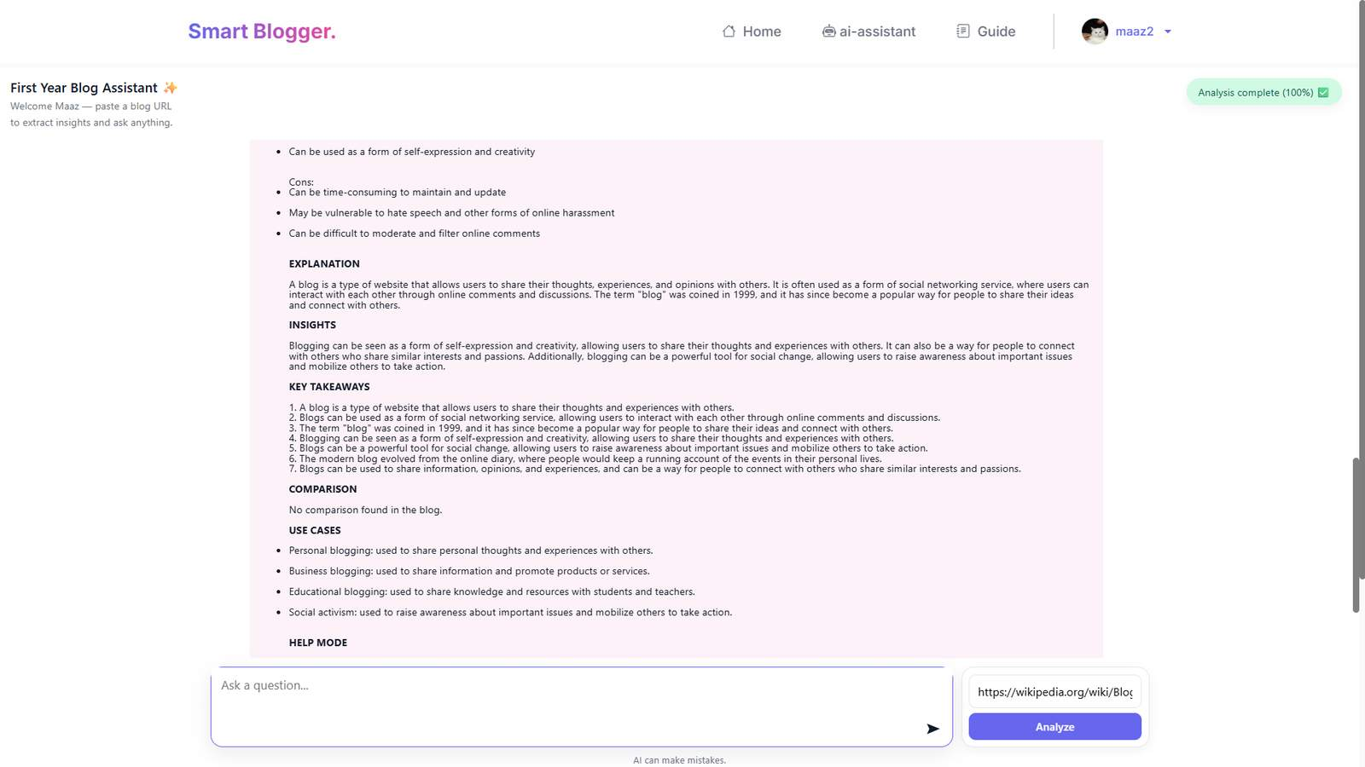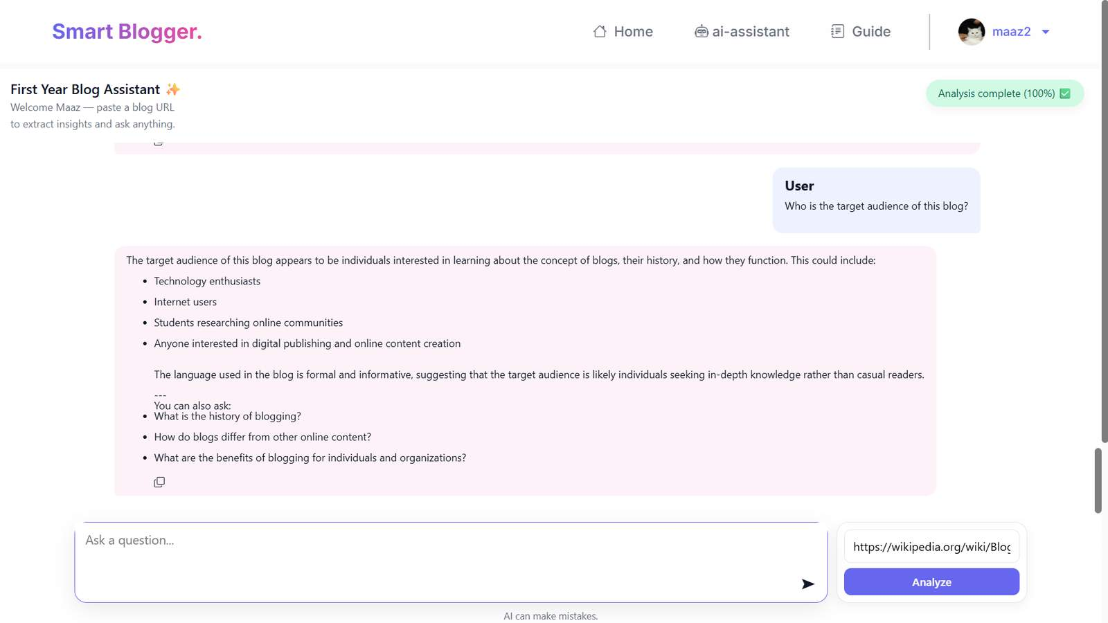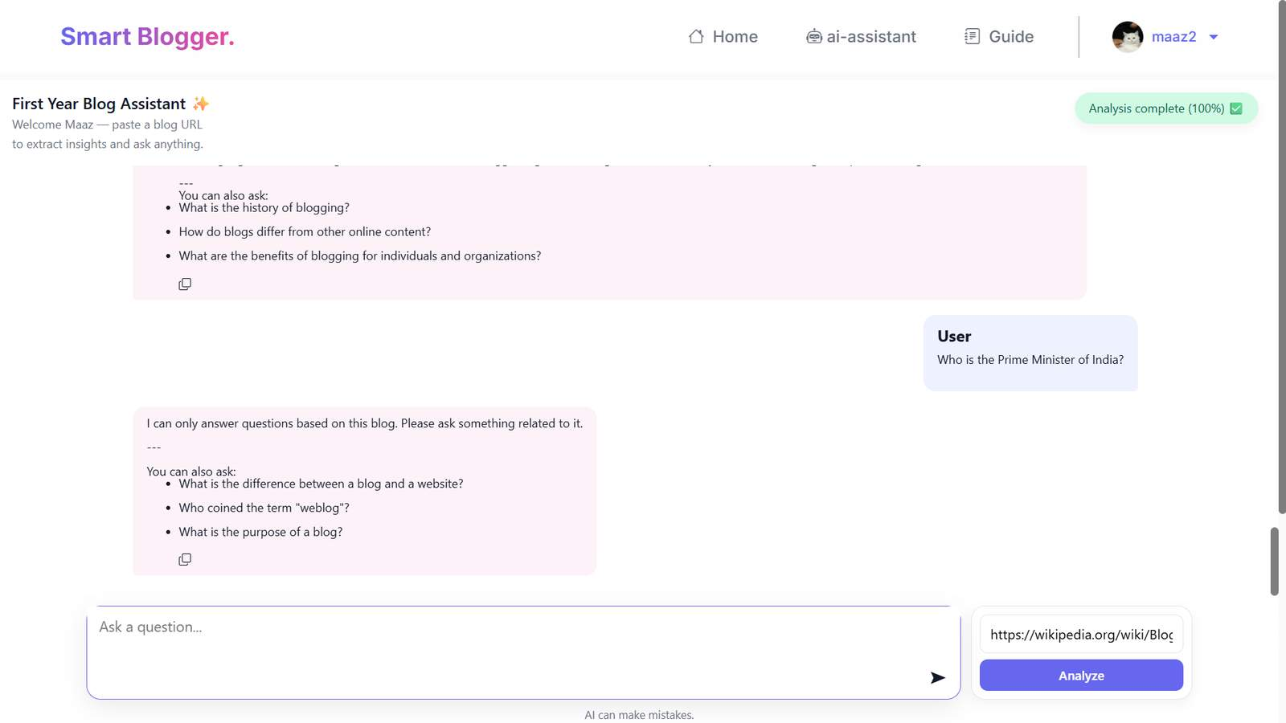
Fig 6.22: First Blog Assistant Tool
6.2 Applications
The proposed system has a wide range of applications in various fields due to its intelligent features and flexible design. It can be used by individuals, educational institutions, professionals, and businesses for different purposes.
- Educational Platforms
Individuals can use the platform for personal blogging to express their thoughts, ideas, and experiences. It provides a space for users to share their opinions, creativity, and daily activities with a wider audience. The interactive features further enhance communication between users.
- Personal Blogging
The system can act as a content-sharing platform where users can publish articles, tutorials, and informative content. It helps in spreading information and ideas across different domains such as technology, education, health, and entertainment.
- Content Sharing Platforms
The system can act as a content-sharing platform where users can publish articles, tutorials, and informative content. It helps in spreading information and ideas across different domains such as technology, education, health, and entertainment.
- Knowledge-Based Systems
The platform can also function as a knowledge repository where valuable information is stored and accessed easily. Users can search for relevant blogs and gain insights on various topics. The AI recommendation system further improves content discovery.
- Professional and Business Use
Professionals can use the platform to showcase their expertise and build their personal brand. Businesses can use blogging as a marketing tool to promote products and services, increase brand awareness, and engage with customers.

Conclusion

CONCLUSION
The project “SMART BLOGGING – AI-POWERED INTELLIGENT BLOG WEBSITE” has been successfully designed and implemented to provide a modern, intelligent, and user-friendly blogging platform. The system effectively addresses the limitations of traditional blogging platforms by integrating advanced features such as Artificial Intelligence, interactive user engagement, and real-time analytics.
Throughout the project, a systematic methodology was followed, starting from requirement analysis, system design, development, testing, and deployment. The use of the Waterfall Model ensured proper planning and execution at every stage. Technologies such as HTML, CSS, JavaScript, Python, and Django helped in building a robust, scalable, and efficient system.
The proposed system successfully fulfills its objectives by providing:
• Efficient blog management system for content creation and control
• Interactive features like likes, comments, bookmarks, and follow system
• AI chatbot for intelligent query handling and user guidance
• Analytics module for tracking blog performance and user engagement
• Secure authentication and data handling
The system enhances both user experience and blogger productivity by offering intelligent recommendations, smooth navigation, and better content discovery. It also ensures reliable performance, fast response time, and ease of use.
From the results obtained, it is clear that the system performs efficiently under normal conditions and meets all the defined requirements. Although some limitations exist, such as basic AI capabilities and lack of mobile application support, these can be improved in future enhancements.
Overall Conclusion Points:
• The system provides a smart and modern blogging solution
• Artificial Intelligence improves interaction and automation
• User engagement is significantly enhanced
• Bloggers get better control and analytics
• The system is scalable and can be upgraded in future
In conclusion, the project successfully demonstrates how Artificial Intelligence can transform traditional blogging platforms into intelligent systems. It provides a strong foundation for future development and has the potential to be expanded into a more advanced and widely used platform in the digital world.

References

References
- Django Software Foundation. Django Documentation. Available at: https://docs.djangoproject.com
- Python Software Foundation. Python Official Documentation. Available at: https://www.python.org/doc/
- SQLite Development Team. SQLite Documentation. Available at: https://www.sqlite.org
- Refsnes Data. W3Schools – Web Development Tutorials. Available at: https://www.w3schools.com
- TutorialsPoint. Django Guide. Available at: https://www.tutorialspoint.com/django/index.htm
- World Health Organization (WHO). Health Systems Report, 2022.
- Abraham Silberschatz, Henry F. Korth, S. Sudarshan. Database System Concepts (7th Edition). McGraw-Hill Education.
- Uttam K. Roy. Web Technologies: HTML, CSS, and JavaScript. Oxford University Press.
- Thomas H. Cormen et al. Introduction to Algorithms (3rd Edition). MIT Press.
- William S. Vincent. Django for Beginners: Build Websites with Python and Django. Amazon Publications, 2021.
- Dr. N. Rajkumar. Hospital Management Using Web Technologies. Journal of Emerging Technologies, Vol. 10, Issue 2, 2023.
- IEEE Xplore Digital Library. Various Conference Papers on Chatbots, NLP, and Educational AI Systems. Available at: https://ieeexplore.ieee.org

Maaz Siddiqui
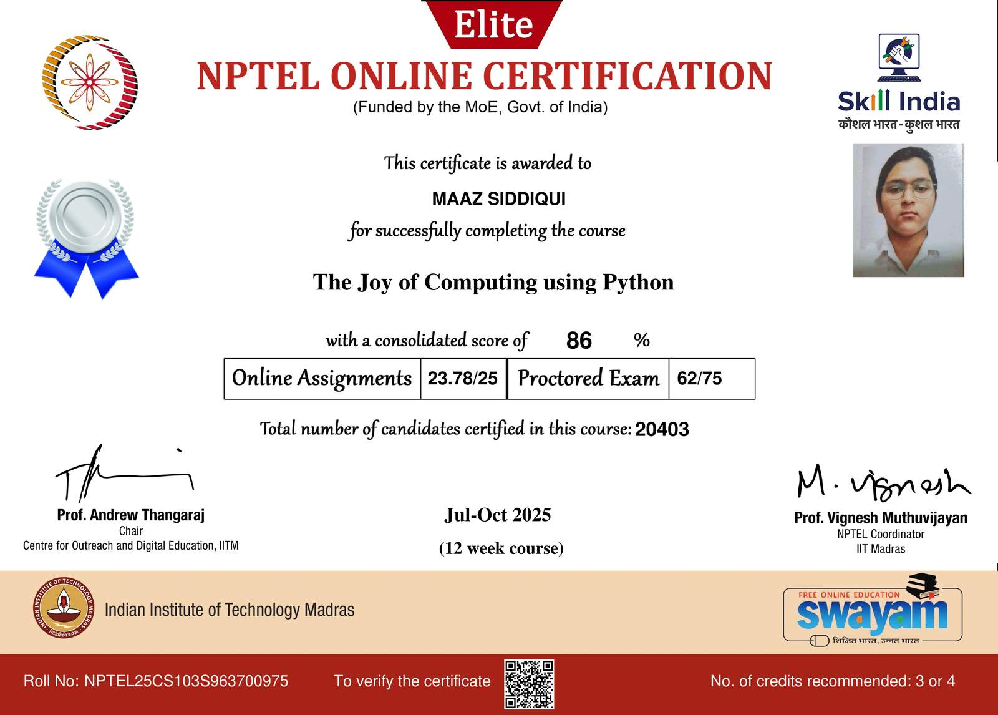




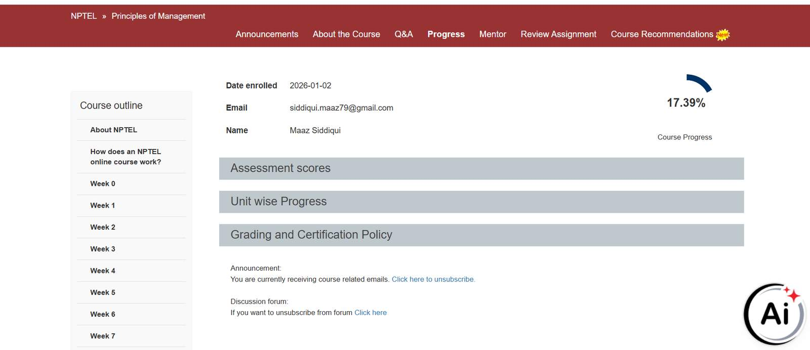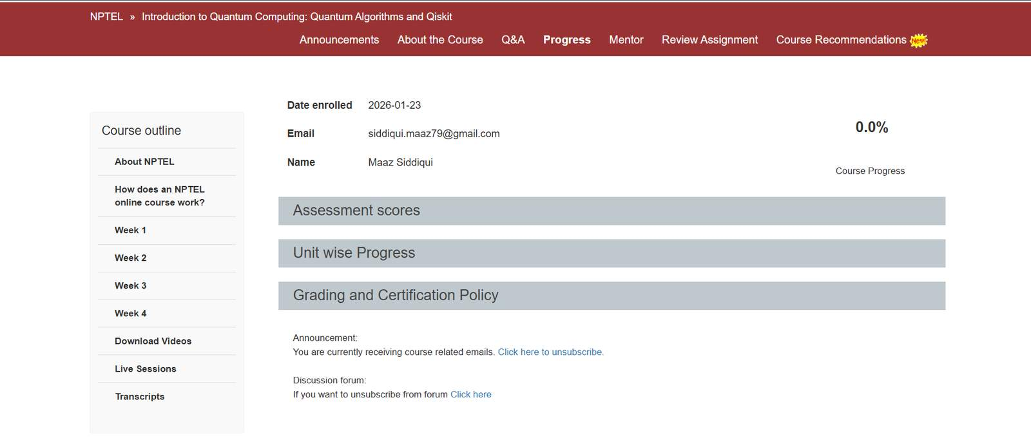

Awan Shaikh
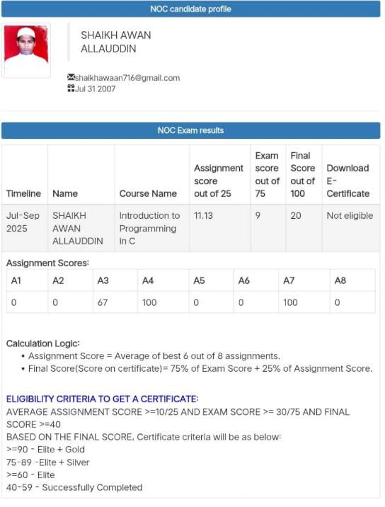



Sufiyan Shaikh

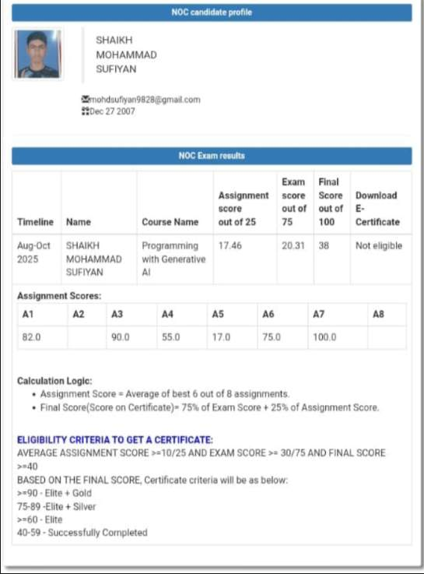

Our Research Work:
